TIME CAPSULE ACTIVITY

I hope you and your families are all safe and well.

We are living through a historical period of time and are experiencing events that have never happened before.

This might sound a little bit frightening, but as long as you are staying sensible and listening to guidance, then it should be seen as an exciting and eye-opening time.
During times like this, there is a fantastic opportunity to record the experience so you can look back on this time at some point in the future.

WHAT YOU NEED:
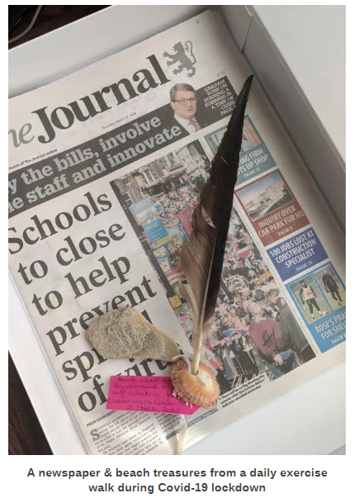
- A suitable box or container for storage
- Lots of memorabilia
- Tape or string to seal
- Bin bag to waterproof
- An attic or secret cupboard for storage!
- Lots of patience (so you don’t open your time capsule too soon)

WHAT TO DO:
- Collect pieces of memorabilia (see list below)
- Place everything safely in the container
- Secure the container with tape or string
- Place it in a bin bag or plastic bag
- Store securely in an attic, basement or secret Harry Potter cupboard
- Wait 10 years... can you do it??
- Open your time capsule in a decade and be amazed at what’s inside!

THINGS (MEMORABILIA) TO INCLUDE
Here’s our list of things your 2020 Coronavirus time capsule could include: –
(It can be as many or as few things on this list – please do not put yourselves at risk to access these items)
- a local paper with Covid-19 headlines
- a 2020 dated coin
- a national newspaper
- a drawing of the family including pets, names, ages etc
- memorabilia from a day in the garden or nature (we’ve just collected a feather and shell from the beach)
- a note from each family member with memorable events from recent times
- photos of today
- a packet of seeds from 2020 (who thinks they’ll grow in 10 years?!)
- a letter to themselves including date, age, friends, feelings, favourite things, worries, future plans etc
- A 2020 postage stamp
- a painted pebble with the date on
- a letter from a grandparent or other family member who doesn’t live with you
- a photo of neighbours applauding the NHS
- children’s handprints to show how much they’ve grown (thanks to reader, Elaine, for this idea)
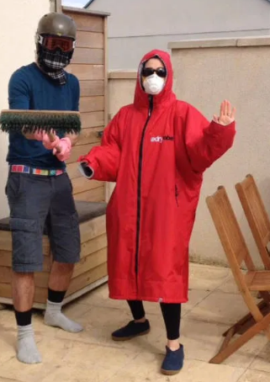
- a couple of bits of clean toilet paper and an anti-bacterial hand wipe for humour!
- a copy of the Government letter about the pandemic
- photos of family members doing crazy things like this:

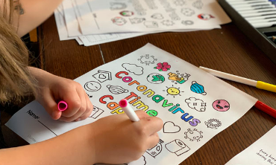
DECORATE YOUR TIME CAPSULE HOWEVER YOU WANT, SEAL IT AND HIDE IT FOR 10 YEARS

