Phase 3 Science - 7D - Ecosystems

INSTRUCTIONS:
This is to support the work you have already completed at school.
Work through each lesson and complete as much as you can. To access the videos and other links you need just click on the blue writing.
There is also a quiz at the end - don’t forget to complete it.

Lesson 1 - Variation
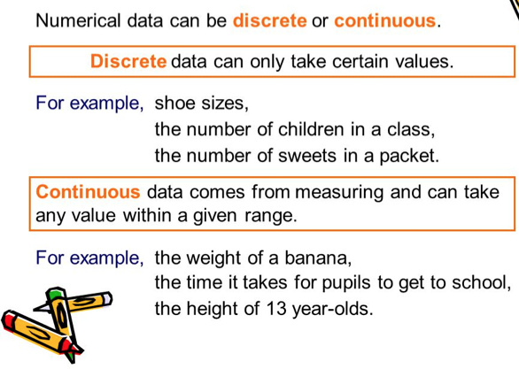

- Sort the following features into discrete and continuous.
nose shape, blood type, eye colour, height, hair colour,
hand span, language, length of lower arm

Discrete | Continuous

A species is a group of organisms that can reproduce with one another to produce fertile young. A hybrid is a species that is not fertile, so cannot reproduce such as the mule. Watch this video to find out more.

- Describe the difference between a species and a hybrid.

Lesson 2 - Adaptations
Click on this link to view the textbook pages for adaptations.
Then answer the questions below.

- Define the term “adaptation”.

- Adaptations are caused by variation and mutation.
What do these two words mean?
Variation –

Mutation –

- These habitats are all different, describe the conditions (temperature, amount of rain, availability of food) of each and suggest a suitable adaptation for animals and plants living there.

Pond  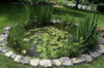 | Desert  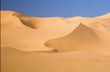
Conditions –  Adaptations – | Conditions –  Adaptations –
Arctic  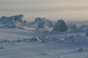 | Forest  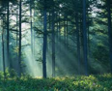
Conditions –  Adaptations – | Conditions –  Adaptations –

- Animals and plants both adapt to be more likely to survive.
Watch this video and make notes on some adaptations found in animals and plants.

Animal Adaptations | Plant Adaptations

Lesson 3 - Daily and Seasonal Change
An environment can change over a day or over a season, meaning animals need to adapt to each of these.
Watch this video to find out more.

- Give an example of a seasonal change and a daily change.

Daily Change | Seasonal Change

- Describe how a hedgehog is adapted to surviving the winter.

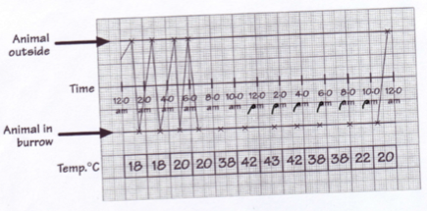
- This mammal was in its burrow from 6am-10pm making it nocturnal, why do you think the temperature makes it an advantage for the mammal to stay inside?

- Why do you think the mammal needs to go outside the burrow?

Lesson 4 - Effects on the Environment

Animals also compete against each other for resources. Watch this video here.
- What are the three main things, which animals compete for?

- Define natural selection.

Another example of something that affects a population is predation, which means when a predator eats a form of prey. Look at the graph below.
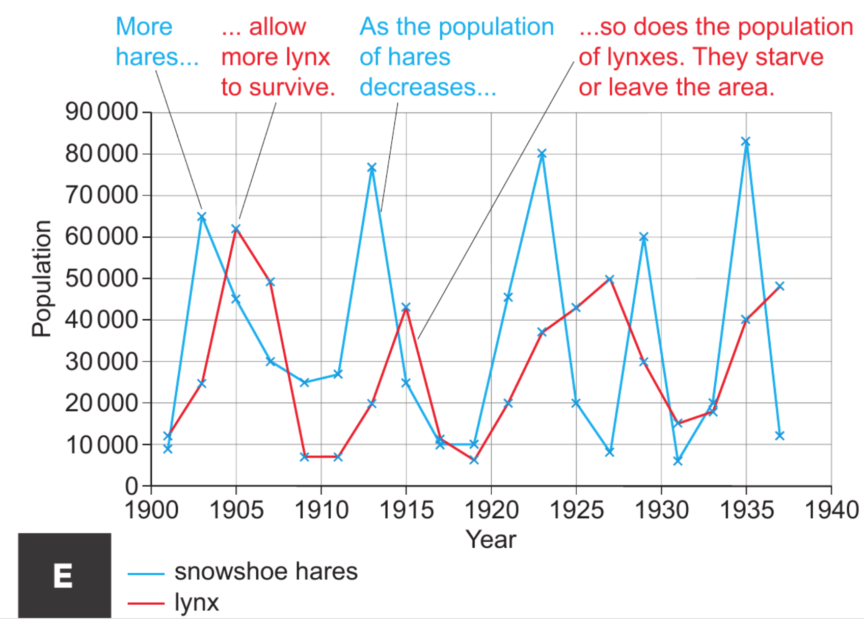
- Which animal is the predator and which is the prey?

Predator |  | Prey

- Suggest one reason why the hare population may increase.

- Suggest one reason why the lynx population may decrease.

Lesson 5 - Transfers in Food Chains

- Watch the attached video to give you an introduction to food chains and the key vocabulary.

- A gardener grows some rose bushes.
- A small green insect called an aphid eats the rose bush leaves.
- Ladybirds are red beetles that like to eat aphids, so they land on the bush and start eating them.
- Swifts are a type of bird that can catch and eat ladybirds. Construct a food chain for these organisms (living things).

 | → |  | → |  | →

- Identify all predators in the food chain.

- Identify all prey in the food chain.

- Sort the organisms from the food chain into producers and consumers.
Producers | Consumers

- Why are the arrows pointing in the direction they are?

- The gardener sprays a special chemical on the roses that kills the aphids.
- What do you think this will do to the number of ladybirds in the garden?
- Explain your answer.
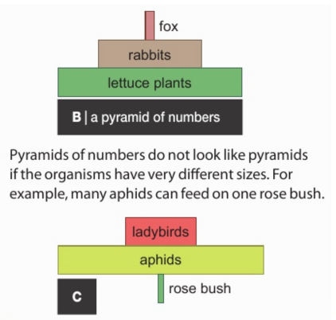
A Pyramid of numbers can be used to show the number of organisms at each stage of a food chain. Due to energy losses at each stage, hundreds of lettuce plants for example would feed a much smaller number of rabbits, which would feed an even smaller number of foxes.

Describe why the pyramid of numbers in C is smaller at the bottom.

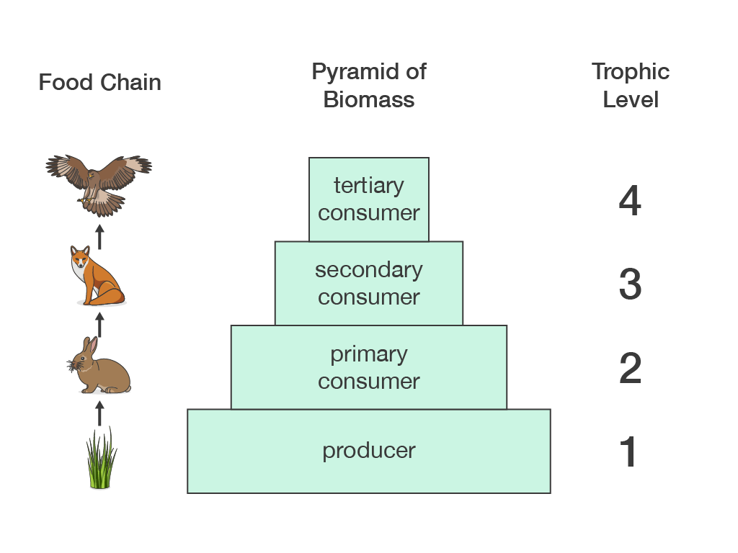
A pyramid of biomass is a more accurate indication of how much energy is passed on at each trophic level. Biomass is the mass of living material in each organism multiplied by the total number of organisms in that trophic level.

Click on this link, which allows you to create your own habitat using a river and explains how pyramids of biomass work.

QUIZ TIME
When you have completed this work have a go at the Ecosystems test by clicking this link
below.
Part 2 7D Ecosystems quiz

