YEAR 7 PHASE 3: English Home-Learning (4th May – 17th May 2020)
WITH SUPPORT
If you are finding some of the work a bit difficult, look at the green below to help and as always, ask your English teacher for help.
Recap: Phase 2
- In Phase 2, you completed a range of activities about King Claudius. Look back at your notes and use them to help you write 4-5 sentences explaining whether you think he is a good or bad king and why.
- Reflect on your two paragraphs you wrote for Task 2 to answer the question “How would a Shakespearean audience have responded to King Claudius based on the previous task?”. How did you find the paragraph? Was it easy, if so why? Was it hard, if so why? If you did find it hard, make sure you tell your teacher or email them a copy so that they can help you.
Fill in your PLC in your Learning Passport (make sure you have filled in your PLC for phase 1 paragraphs too!) Write a WWW and EBI for yourself.
Did you:
  - make a clear point?
  - use evidence (quotations) that linked to your point that you made?
  - mention the technique used in the quote you have used e.g. simile, adjective? If possible, say why Shakespeare used this technique.
- Ensure you are continuing to read every day for at least 20 minutes. Read a novel that is appropriate for your Accelerated Reader Level. If you do not have books at home, you could read novels online at www.bibliomania.com. Audible (https://stories.audible.com/start-listen) has free audio books at the moment so have a look and listen/read something new!
There are also lots of places online to access free books and plays. A list of where to find these is on: https://nothingintherulebook.com/2017/01/10/55-places-you-can-download-tens-of-thousands-books-plays-and-other-literary-texts-completely-legally-for-free/

Phase 3: Reading Tasks
Complete one task per English lesson you would have had each day (four a week including your SPaG lessons). You can complete them in any order and email your English teacher if you are unsure.
Task 1 – Introduction to ‘Alice’s Adventures in Wonderland’ by Lewis Carroll :
Key words:
- Connotation: Feelings/emotions associated with a word but goes beyond the actual meaning.
- Inference: using clues from the text and your own knowledge to read between the lines.
- Deduction: take facts/information based on what you can see/read.
This term you are moving from Shakespeare to ‘Alice in Wonderland.’ Complete the following tasks to build up some predictions for the novel.
- Write the words ‘adventure’ and ‘wonder’ and ‘land’ in the middle of half a page each. Write around the outside all the connotations (things that come to mind, ideas, thoughts, feelings) based on each word. E.g ‘adventure’ = excitement, exploring or danger
- What would you have in your ‘wonderland’? Either draw/list/create your wonderland. Email anything through to your teachers! For example: Think about your five senses: see “bright flowers everywhere”, smell “candy floss”, taste “of sugar in the air”, feel “the grass is soft like a cuddly blanket” and hear “birds singing in tune with each other”.
- Look at the following book covers, Choose your favourite and write down what the cover makes you think of. What clues does it give you about the book? What does it make you want to find out about? (Inference and deduction skills).
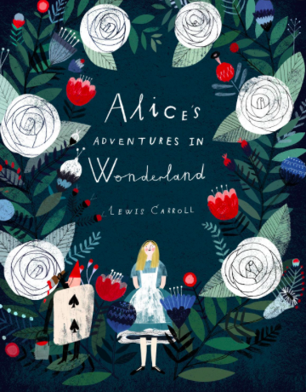
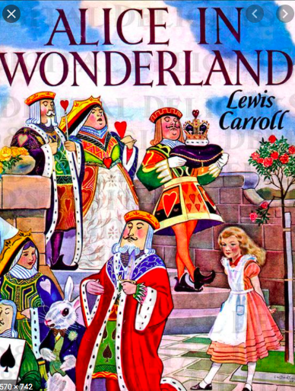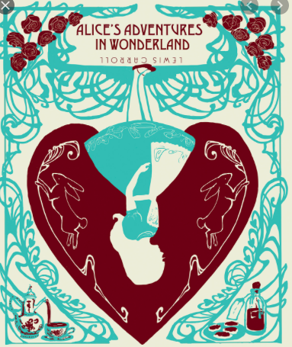
Task 2 – Research the author:
Lewis Carroll was the pseudonym (a made-up name) of Charles Lutwidge Dodgson who wrote ‘Alice’s Adventures in Wonderland’ and many other stories. He used a false name because he was a private man who wanted to write stories without people asking him too many questions about them!

Differentiated extract:
On July 4, 1862, Charles Dodgson, his friend Robinson Duckworth and three children including a girl called Alice, rowed up the Thames from Oxford to Godstow. They had a picnic next to the Thames and then rowed back to Oxford in the evening. Charles Dodgson wrote about it in his diary and said that, while they were out, he told them the fairy-tale of Alice’s Adventures Underground. Alice really liked this story and asked him to write out for her, which he agreed to do.
The above is information about why Charles Dodgson wrote the book.
Using the above, the website and any other extra research you would like to complete, create a fact file about him. Try to include one fact for each:
- Where he lived.
- Who was in his family
- Why he wrote the novel
- What other stories/novels he wrote
- Some interesting facts.
Task 3 – Structural techniques used by Carroll:
- An omniscient (om-ni-si-ent) narrator is the voice in which the story is written that is outside the story and that knows everything about the characters and events in the story.

Write your own definition of the above in your own words. Can you find an example which shows that the book is written by an omniscient narrator in the story as you read? If you are still unsure, try researching what they mean. As we read the novel together, this will make more sense!
Task 4 – First three chapters of ‘Alice’s Adventures in Wonderland’:
- Read ‘Down the Rabbit Hole,’ ‘The Pool of Tears’ and ‘ A Cacus-Race and a Long Tale.’
  - Listen on this link for free with Scarlett Johansson: https://stories.audible.com/pdp/B015D78L0U?ref=adbl_ent_anon_sc_pdp_pc_0
  - Read online: http://www.literatureproject.com/alice/alice_1.htm
  - Buy your own copy of the book for around £3 on Amazon: https://www.amazon.co.uk/Alices-Adventures-Wonderland-Lewis-Carroll/dp/B0857CG8KC/ref=sr_1_9?keywords=alice+in+wonderland+book&qid=1585829043&sr=8-9

Phase 3: Writing/Creative Tasks
Task 1 – Diary of Home Learning:
Complete your next two weeks of diary entries as your ongoing writing task. Ensure you are using exciting vocabulary, thinking about paragraphs and sentence types.
You should write at least one entry a week of at least one A4 page (normal book size). You should have at least 2 entries so far.
Questions to think about and answer:
- What were the Easter ‘Holidays’ like?
- What have you learnt?
- What do you need more help with?
- What have you enjoyed? Not Enjoyed?
- What new skills/hobbies/activities have you done?
- Anything that has worked well to help you to manage your time?
- Anything that you miss?
Task 2 – Beginning of the ‘You in Wonderland Project’:
You are going to start an English Alice Project! How exciting!
- Your task is to complete the activities as you read through the book. Make sure that you are creative, as this is supposed to be something fun and engaging for you as you progress through the novel.
- You can complete the tasks by hand, on the computer or any other way you like! Just check in with your teacher. You may want to create a scrapbook/notebook to keep all of your tasks in.
- Don’t forget: the novel’s genres, the character’s personalities and settings within the novel when completing tasks.
- House points given for marvellous and amazing effort and completion of tasks.

Creative Task:
Who was Alice?
  - What are your first impressions? Do you like her or not and why?
  - How would you describe her (adjectives=describing words like curious)?
  - What do you think are key quotations she says? Why do you think these quotes are important – what do they tell you about her? Try to find at least one!

Toilet Roll Alice: Create a toilet roll version of Alice. If you can’t do this, create a picture of her based on your first impressions, or any other creation of your choice.

