Transition Materials for A Level History
The Tudors:
England, 1485 - 1603

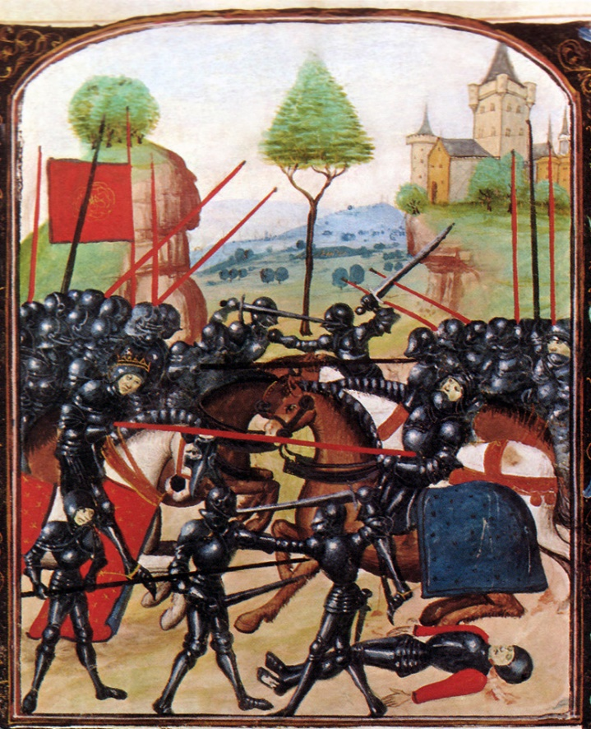
Introduction
It is great that you are considering studying History at A Level.
This pack contains a programme of activities and resources to prepare you to start an A Level in History in September. It is aimed to be used after you complete your GCSE throughout the remainder of the summer term and over the summer holidays to ensure you are ready to start your course in September.

Contents
- Suggestions - materials you might like to read or watch
- Challenge yourself
- Independent Research
- Key vocabulary – subject specific terminology
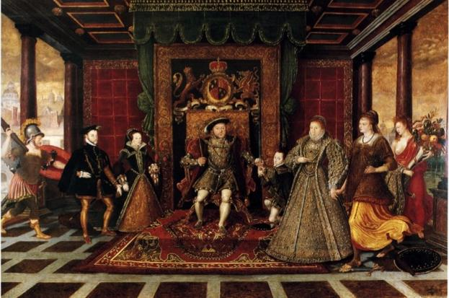

- Tudors: Read / Watch List
READ  - The Cousin’s War Series – ‘The White Queen’, ‘The Red Queen’, ‘The Lady of the Rivers’, ‘The Kingmaker’s Daughter’ and the ‘White Princess’ by Philippa Gregory  - The Winter King’ by Thomas Penn  - ‘Wolf Hall’ ‘Bring up the Bodies’ ‘The Mirror and the Light’ by Hilary Mantel  - The Wars of the Roses by Michael Hicks  - ‘Elizabeth’ by David Starkey  - ‘Six Wives: The Queens of Henry VIII’ by David Starkey  - ‘Wolsey: The Life of King Henry VIII’s Cardinal’ by John Matusiak  - ‘Henry VIII’ by Robert Lacy  - The Hollow Crown: The Wars of the Roses and the Rise of the Tudors by Dan Jones  - Dissolution (Matthew Shardlake 1) and Dominion by C.J. Sansom | WATCH  - The White Queen (2013) see also: https://www.bbc.co.uk/programmes/p018sxqp  - The Winter King  - Elizabeth - Part 1: From The Prison To The Palace (Documentary by Timeline) 4 parts in total  - The Six Queens of Henry VIII - David Starkey, on dailymotion  - Edward VI - The Boy King (Documentary by Timeline)  - Mary I - Bloody Mary (Documentary by Timeline)  - Kings and Queens of England (Episode 3): The Tudors (History Documentary)  - Henry VIII The Most Iconic King of English History  - Henry VIII, The mind of a tyrant (David Starkey)  - The Other Boleyn Girl (2008)  - The Tudors (2007-2010)  - Wolf Hall (2015)  - The Hollow Crown  - https://www.youtube.com/watch?v=dANvIjbtuDk on the Wars of the Roses  - https://www.futurelearn.com/courses/the-tudors

- Valuable challenge suggestions – some are related to History and some are not……
LISTEN  - Visit http://itunes.ox.ac.uk/ and download the app – Oxford University has thousands of podcasts on everything you can imagine – not necessarily history either. Includes introductions to different colleges as well – material also available on http://podcasts.ox.ac.uk/  - Historians talking about a range of topics – new ones added every week at: https://www.historyextra.com/article-type/podcast/  - Podcasts from the Historical Association – a wide range of topics: https://www.history.org.uk/podcasts  - https://www.bbc.co.uk/podcasts?q=history A selection from the BBC  - Try http://www.versushistory.com/about-us.html for a series of podcasts responding to listeners questions – you can get involved  - Radio 4 broadcasts – discussions of ‘Historical themes, events and key individuals from Akhenaten to Xenophon’ https://www.bbc.co.uk/programmes/p01dh5yg?page=2 | DO  - Try https://www.hist.cam.ac.uk/History at Cambridge and virtual classes.  - Complete a FREE university taught online learning course…History related courses: https://www.futurelearn.com/courses/categories/history-courses  - The National Archives at Kew has a lot to offer, visit it or look at what is online: https://www.nationalarchives.gov.uk/  - Visit Hampton Court: https://www.hrp.org.uk/hampton-court-palace/#gs.czj3jr  - The Tower of London …https://www.hrp.org.uk/tower-of-london/#gs.czphod  - https://www.shakespearesglobe.com/ Shakespeare’s plays and the Globe  - https://www.goldenhinde.co.uk/ - a really interesting visit  - Walk around London and see the Tudor sites: https://www.awaywithmaja.com/10-tudor-places-to-visit-in-london/  - https://www.history.org.uk/ The Historical Association – join it!  - https://twitter.com/search?q=%40historyextra&src=typd%E2%8C%A9=en-gb: Start tweeting…..

- Independent Research
- Create a timeline outlining the key events in the Wars of the Roses. What happened at the battle of Bosworth, 1485?
- Research Edward IV - Put together 10 key points about his reign
- Research Richard III. How did he become king? What can you find out about his reign? Does Richard deserve his reputation? Research the Princes in the Tower. What do you think happened to them?
- Create a family tree of the Tudors. Add images.
- Create an A3 information sheet, with facts and images, of the following British monarchs: Henry VII, Henry VIII, Edward VI, Mary I and Elizabeth I.

Suggested websites:
- http://www.britannica.com/event/Wars-of-the-Roses
- https://www.youtube.com/watch?v=dANvIjbtuDk
- http://www.richardiii.net/9_1_wotr.php
- http://www.historyextra.com/article/military-history/12-facts-wars-roses
- http://shakespeare.mit.edu/richardiii/full.html
- http://www.sparknotes.com/shakespeare/richardiii/
- https://www.youtube.com/watch?v=ZH7CKzhCyyA
- http://tudorhistory.org/monarchs/
- http://www.royal.gov.uk/HistoryoftheMonarchy/KingsandQueensofEngland/TheTudors/TheTudors.aspx
- http://tudorhistory.org/
- http://tudortimes.co.uk/
- http://www.englishmonarchs.co.uk/plantagenet_12.htm
- https://www.historic-uk.com/HistoryUK/HistoryofEngland/The-Wars-of-the-Roses/
- https://www.bbc.com/bitesize/guides/zbtg87h/revision/2
- http://www.bbc.co.uk/bitesize/ks3/history/uk_through_time/religion_through_time/revision/3/
- https://www.britroyals.com/tudortree.asp (if you click on each monarch you get a fact file)
- https://www.youtube.com/watch?v=SB_OThWd-eA

- Glossary
Act of Succession
Anticlericalism
Act of Attainder
Bond
Borough
Burgess
Clergy
Consubstantiation
Convocation
Council of the North
Courtier
Crown lands
Dearth
Debasement
Demesne
Diocese
Dispensation
Enclosure
Excommunication
Extraordinary revenue
Factional rivalry
Feudal dues
Freehold
Gentry
Glebe
Great Chain of Being
Groom of the stool
Heretic
Huguenot
Humanism
Iconoclasm
Intercession
Jousting
Justice of the Peace
Laity
Lollard
Lord Chancellor
Magnate
Marches
Mercenaries
Noble
Ordinary taxation
Papal Bull
Papal Legate
Patronage
Peasant
Peerage
Purgatory
Puritanism
Real wages
Regent
Regicide
Reeve
Renaissance
Reformation
Retaining
Royal Prerogative
Sheriff
Statute
Subsidy
Subsistence crisis
Sumptuary Laws
Sweating sickness
Tithe
Tourney
Transubstantiation
Villein
Wardship
Yeoman

