Writing
Recipe

During the lockdown I have been enjoying lots of ‘comfort food’. Comfort food is satisfying and often contains lots of carbs! What food do you enjoy? Please share a recipe. If possible, take a photo and post it on the class stream (Wednesday P3). I hope to learn a few new recipes! Yum!

Features of Procedural Writing:
- Number or use bullet points
- Use action verbs at the beginning of sentences
- Clarify using adverbs
- Choose your verbs carefully

Useful Vocabulary:
Cut, slice, chop, mince
Bake, fry, steam, stir-fry, boil
Carefully, gently, quickly, immediately
meanwhile, at the same time,

Follow the format:
- Title (what are you making?)
- List of ingredients
- Procedure
- Photo (if possible, attach onto Wednesday P3, or email me!)

Example:
BLT with a Fried Egg
(I like this for brunch when I wake up late!)

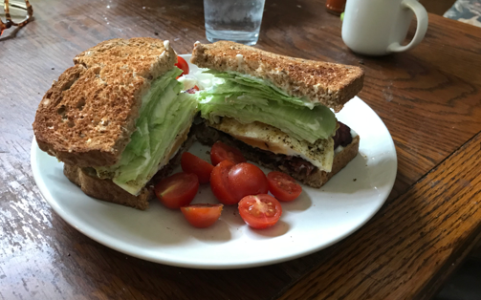

Ingredients

2 slices whole grain bread
5 strips streaky bacon
1 egg
iceberg lettuce
mayonnaise
sliced or small cherry tomatoes

Procedure

- First, fry the bacon until crispy. When done, set cooked bacon on paper towel to absorb excess oil.
- Pour off oil from fry pan and wipe clean with paper towel.
- Crack one fresh egg and gently fry until mostly cooked through. The yolk should remain a bit soft.
- Meanwhile, toast bread.
- Spread both slices of toast with plenty of mayonnaise.
- Top one slice of the toast with bacon strips until the bread is covered.
- Gently set fried egg on top of bacon.
- Place a generous portion of fresh, crunchy iceberg lettuce on top of the other slice of toast.
- Carefully put together to form a sandwich.
- Press down gently to release a bit of runny, yellow yolk.
- With a sharp serrated knife, cut sandwich in half.
- Serve with a few cherry tomatoes or slices of vine tomato.
- Remember to provide a napkin—it’s a bit sloppy!

Vegetarian/Halal Option

Use avocado instead of bacon!

