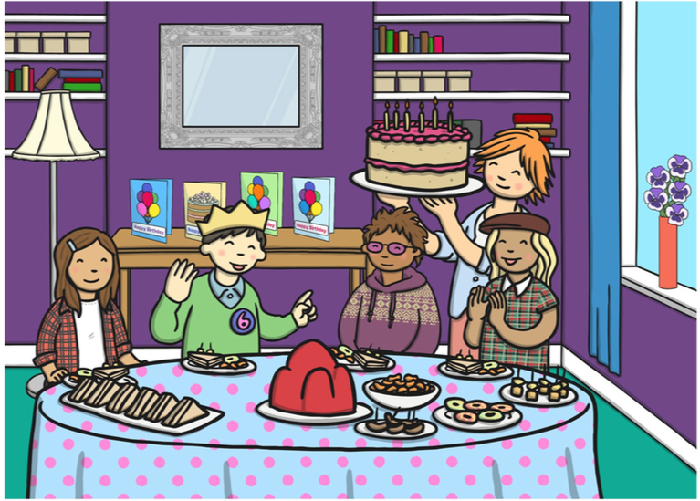

Descriptive Paragraph

Write a FULL paragraph describing what you see in the picture. Use adjectives (describing words) and underline them!

Example:

Today is the young boy’s birthday. He is wearing a blue shirt and a green jumper. I think he is six years old because……

