Preparing for University

Introduction

This booklet is designed to help you prepare for the next stage of your education. You will find that you need to prepare yourself mentally and practically for your first term.

Some aspects of studying at university are very different from school or college and this booklet should give you a general idea of what to expect as well as activities and suggestions to help you understand study skills to ease the transition process.

There are a number of approaches to learning. The first one starts with you and you recognising your own learning preferences. How do you enjoy learning? You need to take responsibility for you own learning, it is no one else’s responsibility, you are doing this for you. Make sure you are ready for every stage of your study, be prepared, be determined and have self-confidence, trust in your own intelligence. You have already come so far and had success. Look at learning as an adventure, small children learn extraordinary amounts without even trying. Simply through playing, observing, having fun, role playing and being relaxed about their surroundings helps them learn quickly. If they fail, they do not dwell on it, they dust themselves off, get right back up and start again. Adults can learn in this way too if they allow themselves.

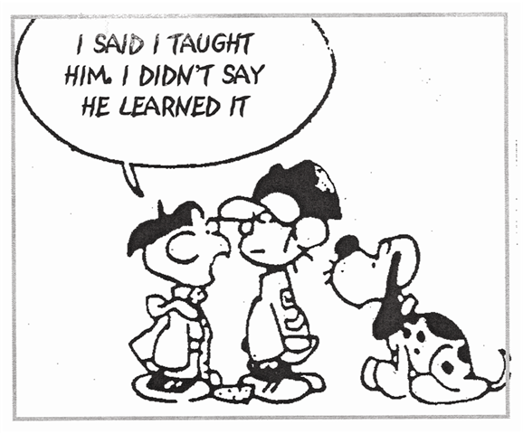
This Photo by Unknown Author is licensed under CC BY-NC

What is expected from you?

As a university student you will be expected to have a number of personal characteristics. To help you cope with the new environment, try to adapt quickly to new people and surroundings, survive in large groups and be flexible.

Independence

This means you need to be able to stand on your own two feet as such. There is always help around, you just need to find out where it is. – student services, Student Union, first year tutor, counsellors. Make sure you know where they all are.

Self-motivation

You will need this in abundance, you will be expected to work on your own a great deal, try pairing up with others that could help motivate you and organise study sessions.

Ability to recognise and set your won goals

You may see this as pointless, but it gives you a focus, if you aim for an E grade you are likely to achieve it or even less, so aim high in your goals and if you do not reach it the first time, try and try again.

Ability to organise your time

You are used to having a timetable, but University life can be very different, lectures maybe at different times on different days, it maybe that you do not have a lecture until 4pm in the afternoon and nothing else all day. Keep track of your time, know when and where you should be, know when work has to be handed in, there are no flexible deadlines at University like at school. Make sure you have a planner, whether it be on your device or handwritten, pencil in study time as well as social time.

It’s terrible, the Lecturers expect you to tell the mall the answers, do they even know it themselves?
How successful was the 1944 Education Act?

Things you can do before you start.

- Set up a general information file. Have a separate file with all the general information you are sent from the university, this could be things like regulations, sources of support, appeals and grievances procedures, student clubs and facilities. Ensure you read all this information and highlight key points.

- Read the literature you are sent. This could be handbooks, subject guides, when the term begins you will be very busy, but this information is essential. Look out for essential dates, registration, enrolment, induction, tutor meetings, term dates, add them all to your planner.

- Familiarise yourself with libraries. Find out where the university library and even where the local library in the town is. They have a wealth of information that you will need and you will be spending some time there.

- Local books shops. Find out the books you need for your course, research online to see if you can buy them second hand. You will be expected to reference from them, reading them now will give you a head start.

- Start to develop your study skills. Writing is important, keep up by writing short notes from the subject books. Keyboard skills, practise typing at speed. Time yourself, see if you can improve on your time. Reading is an essential study skill. Read quality Newspapers and jot down the key points, practise writing just key words rather than full sentences. Learn to scan read documents to pick out key areas. Finally get used to sitting and studying, proofread your own work for mistakes and make improvements.

- Equipment. Have everything you need for the course and if you are staying away from home. Make a list of everything you think you will need and begin to box it up. Label and keep things organised.

Self-Evaluation

Current skills and qualities

 | People |  | Activities
 | Ability to get on with people from different backgrounds |  | Creativity, design and layout
 | Ability to see and understand other people’s point of view |  | Ability to see the whole picture
 | Dealing with the general public |  | Classifying and organising information
 | teamwork |  | Being good at debate
 | Managing other people |  | Making decisions
 | Teaching and training others |  | Managing change and transition
 | Negotiating |  | Setting priorities
 | Helping others to arrive at decisions |  | Working out agendas
 | Being sensitive to others’ feelings |  | Organising work to meet deadlines
 | Caring for others |  | Staying clam in a crisis
 | Ability to read other people’s body language |  | Facilitating meetings
 | Dealing with others by telephone |  | Reading complex tasks
 | Ability to cope with difficult people |  | Word processing
 | Speaking clearly and to the point |  | Computer literacy
 | Being able to take direction from others |  | Working with numbers
 | Courage to speak out against injustice |  | Selling
 |  |  | Problem solving
 |  |  | Practical things

- Reasonably good
- Very good
- Excel at

TAKING AND MAKING NOTES

It is a good idea to practise taking notes, as this is going to be a skill you will need when attending Lectures.
Note-taking is an important part of studying. It enables you to engage with a text or Lecture, formulate your ideas and record your thought process. In particular, note-taking enables you to review a lecture and revise for exams. Unless you possess exceptional recall, you would soon forget the content of a book or lesson: it is your notes which enable you to access the information and your response to it at a later stage.
There is no right or wrong way to make notes - only the way that works for you.

- Taking notes – you will need to be able to take notes from speech in the form of:
- a lecture
- a film or DVD
- a radio programme or audio recording

- Making notes – you will need to make notes either before a lecture as preparation, during a lecture e.g. from a PowerPoint presentation, or after a lesson as a follow-up. You will be expected to make notes from:
- a handout
- academic books
- other research or source material, e.g. internet
- your own lesson notes
- Journals

Taking notes from speech
In University and college, you will be expected to record information in a lesson as the lecturer speaks. For many students this is a difficult process as they have not been trained to do so and find that the teacher speaks too quickly for them to write everything down. Some lecturers, aware of the problem, give out interactive handouts containing the framework of the lesson so that you can focus your listening and fill in missing words or examples. Others give out the full text of the lecture, in this case it is a good idea to highlight the important points and annotate the text so that you can make your own notes later. You may also find the lecture places the power point on an internal portal, so you can access at a later date, however, be mindful these will be very limited.

Making notes
There is no one best method for making notes, but it is worth considering the following.

What do you need to note?
- Do you really need this information? If so which bits?
- Will you really use it? When and how?
- Have you noted similar information already?
- What questions do you want to answer this information?

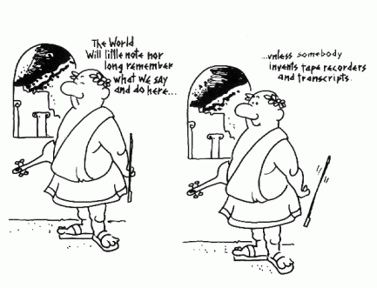
Have a go now
Select a passage from a book and make notes on the main points of what you read – remember if it is your book you can highlight it, but you will borrow many books from the library, so will need to make notes.
This Photo by Unknown Author is licensed under CC BY-NC-ND

One method for making notes
- Put your pen down – so you won’t be tempted to copy out the full book
- Read – to answer your questions
- Identify and sum up the main ideas (hear them in your own words)
- Jot down one or two words to remind you
- Note exactly where information comes from (referencing)
- Note real names and quotations exactly as they are written (references)
- Leaves some space to be able to add to later.

Nuclear notes/patterned notes

These can be very good as they have open ended information, and morea can be added without disturbing the flow. This allows you to easily make links and see how information relates to each other. Some say this is the same way the brain organises information, so it is then easier to recall information later.

If you want more information about mind mapping from the inventor of the term (Tony Buzan) visit his www.thinkbuzan.com/ (Links to an external site.)

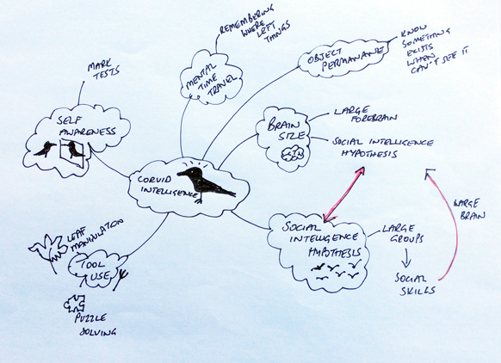

Illustrated notes
Some people are more visual and illustrating notes with lots of drawings and doodles can help with engagement, understanding and recall.
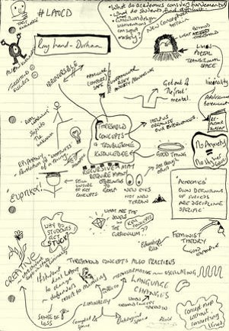
As you can see from the example, there is still a lot of text, but this is illustrated with images that the person associates with what is being said. The idea is that it is using different parts of the brain. The more of the brain that is called into action, the more likely you are to remember and understand what you are reading.

Linear notes

This is the most common form of note taking that people use.id involves creating an outline of the lecture using headings and subheadings, key words and many abbreviations, some people colour code as well or underline in colour.

Find your own shorthand, there are some suggestions below

e.g. | For example,
i.e. | (Latin: id est) that is
etc. | (Latin: et cetera) and the rest
& | and
ut | (Latin) in order that
cf. | compare
no. | number
ch. | chapter
C | century
c. | (Latin: circa) around, about
+ | plus
- | minus
^ | Insert, omitted
~ | approximately
@ | at
N.B. | (Latin: nota bene) note well, take note
< | Less than
> | More than
= | equals
w/o | without
∴ | therefore
b/c | because
exc. | except
fig. | figure
w/ | with
B4 | before
v. | very
opp. | opposite

There are lots of apps now available to help you with lecture notes - including ones that sync your notes with audio recordings of the lecture. Just search for lecture notes in your app store.

Why not check out https://canvas.hull.ac.uk/courses/30746 it has loads of ideas and has been written by students for students.

Plagiarism

As you can imagine this is the most important thing you need to avoid. Many places use a checking device called TURNITIN. You will need to familiarise yourself with this and submit your work through ti before you submit it to ensure it passes the plagiarism check. https://www.turnitin.com/regions/uk

Plagiarism is the using of work of others without acknowledging your source of information or inspiration.
This includes:

- Using words more or less exactly as they have been used in articles, lectures, television programmes, books or anywhere else.
- Using other people’s ideas or theories without saying whose ideas they are
- Paraphrasing what you read or hear without stating where it comes from in a reference.

Even if you change words or sentences you have borrowed or put them in a different order, the result is still plagiarism. It is treated very seriously, and your work is usually disqualified resulting in a fail.

A good investment book is https://www.amazon.co.uk/s?k=cite+them+right+2019&crid=2V47W94NI5ANU&sprefix=cite+the%2Caps%2C164&ref=nb_sb_ss_sc_3_8 –

https://www.citethemrightonline.com/

REFERENCE REFERENCE REFERENCE

Very interesting essay, it sounds exactly like my lecture
Um – yeah – well you do make it sound easy and put things very well.

