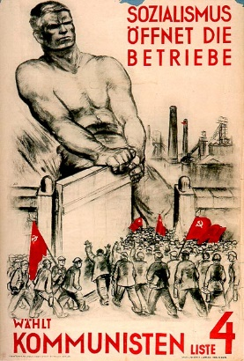
The Appeal of Communism
The KPD gained…

In the 1920’s the KPD had concentrated on…

After 1929…

They set up…

They also attempted…

The Red Front Fighters league…

Some areas…

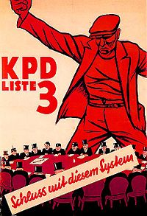

What were some of the KPD demands?

Ultimately what did the KPD want, and how were they going to achieve this?

Strengths | Weaknesses

Why were the Nazis more successful than the communists?

