English Literature Transition Home Learning: ‘A Streetcar Named Desire’

- Research and compile your findings on the play’s context:
- 1940s New Orleans – the place, the background, the culture and any social contexts;
- 1940S America and any relevant historical context;
- Other, influential American writers and texts from around this period, especially any who may have influenced Williams;
- Tennessee Williams – his works and his background;
- The genres of tragedy and melodrama and their generic conventions;
- Theatrical context – such as new plastic theatre and expressionism.

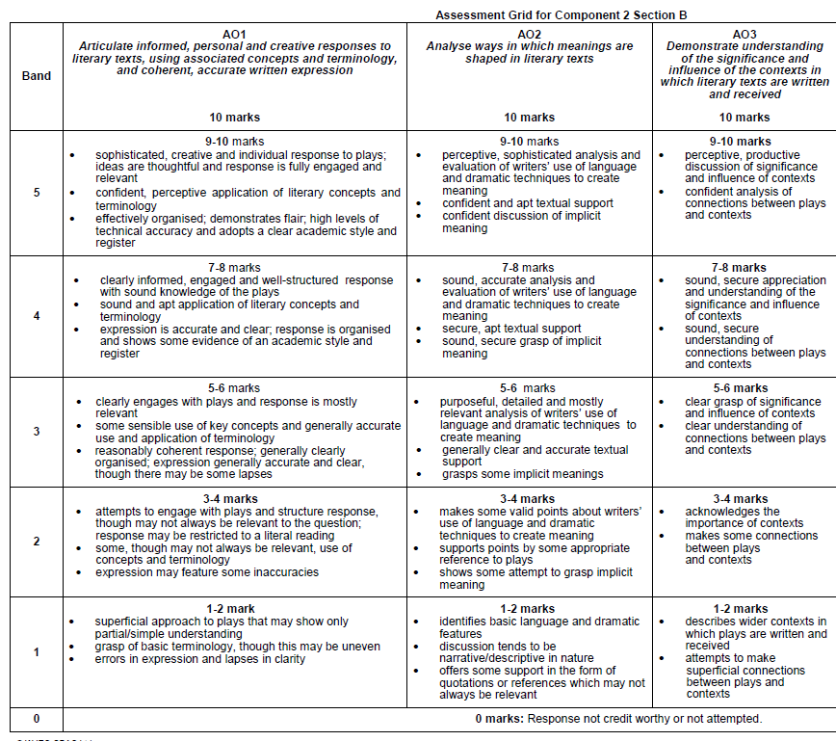
- Write a paragraph about your first impressions of Blanche. SEND IT TO MISS DOWNTON TO READ. The first three AOs (there are five at A Level) are included on the mark scheme below to help you include all necessary ingredients. You will only be expected to cover AO1 to 3 at this point:

