Year 10 Science Phase 4 work
Review work phases 1 to 3
You have three different tasks to complete and then we would like you to hand them in on google classrooms. You will need to email your teacher if you do not know how to do this.
Aim: To review the work that you have completed in phases 1 to 3
Access to the online text book - https://www.pearson.com/uk/learners/secondary-students-and-parents.html

Task 1 – C8
Part A – C8a & C8b
- The diagram below gives information about acids and alkalis. Complete the sentences and table that follow using the words in the box at the bottom of this sheet.
increasing pH, increasing alkalinity,
containing excess OH– ions
alkalis

0 | 1 | 2 | 3 | 4 | 5 | 6 | 7 | 8 | 9 | 10 | 11 | 12 | 13 | 14
decreasing pH, increasing acidity,
containing excess H⁺ ions

acids

Acids and alkalis are types of _________________. Acids, which have a pH of __________ than 7,
contain excess___________ ions. ________________, which have a pH of more than 7, contain
excess _________________ions. Universal indicator turns ________, orange or yellow in acids
and _______________ or purple in alkalis. Other indicators are different colours in acids and alkalis.
Indicator | ___________________ | phenolphthalein | methyl orange
colour in acid | red | ___________________ | red
colour in alkali | blue | pink | __________________

- Complete the following descriptions of acid solutions using the words in the box at the bottom of the page.
Hydrochloric acid is a s _ _ _ _ _ acid and ethanoic acid is a w _ _ _ acid. Strong acids
completely d _ _ _ _ _ _ _ _ _ into ions in solutions. Weak acids only p _ _ _ _ _ break up
into ions. A c _ _ _ _ _ _ _ _ _ _ _ solution contains lots of solute compared to the volume of
solvent. A dilute solution contains s _ _ _ _ amounts of s _ _ _ _ _ compared to the volume of
solvent.

Part B – C8c & C8d

- Complete the word and symbol equations for the formation of cobalt sulfate from cobalt oxide.

- CoO + H₂SO₄ ___________ + __________

- _____________ oxide + sulfuric _____________ cobalt sulfate + water

2. The preparation of cobalt sulfate, as described in question 1, presents some particular hazards. Match each hazard symbol with its correct label from the box below.

- corrosive dangerous to the environment explosive
- flammable irritant toxic

  a _______________________ |   b _______________________ |   c _______________________

- Write the formulae for the following acids and alkalis. Use the formulae in the box below to help you.

a hydrochloric acid d phosphoric acid
b nitric acid e sodium hydroxide
c sulfuric acid f calcium hydroxide
HCl | H₃PO₄ | NaOH | HNO₃ | H₂SO₄ | Ca(OH)₂
- Write the formulae for the following salts. Use the formulae in the box below to help you.
a sodium chloride e calcium chloride
b sodium nitrate f calcium nitrate
c sodium sulfate g calcium sulfate
d sodium phosphate h calcium phosphate
NaCl | CaSO₄ | Na₂SO₄ | CaCl₂ | NaNO₃ | Na₃PO₄ | Ca(NO₃)₂ | Ca₃(PO₄)₂

Part C – C8e & C8f
- Cross out the incorrect word in each sentence.
- Acids are a source of hydrogen | hydroxide ions in solution.
- Alkalis are a source of hydrogen | hydroxide ions in solution.

2. Label the diagram below with the names of the apparatus used in titration.
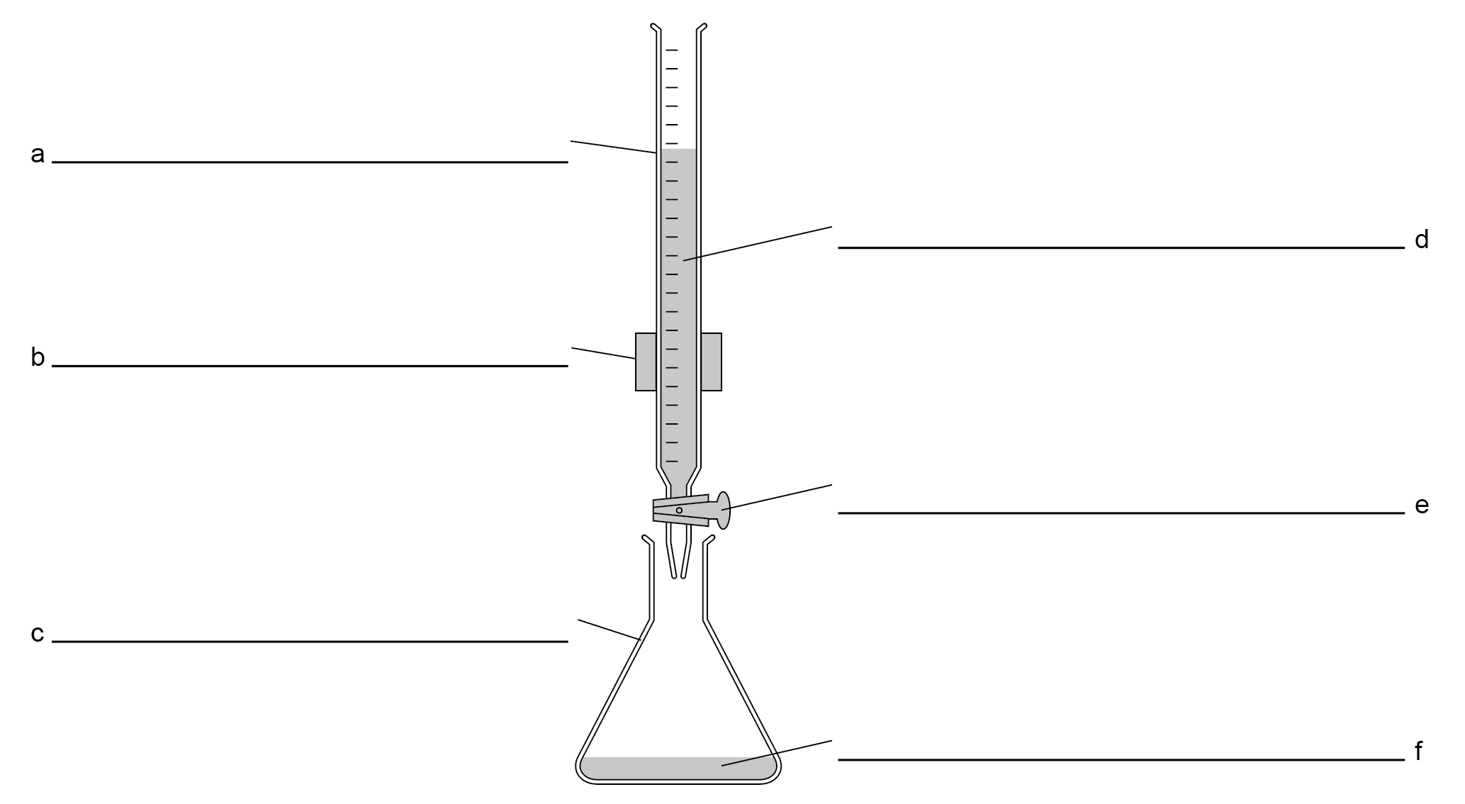

3. Complete the equation below to show what happens during neutralisation.
H⁺(aq) + OH–(aq) →

4. State the type of reaction modelled by the correctly completed equation in question 3.

- Answer the questions by selecting the appropriate metals from the box.
copper iron magnesium potassium silver sodium
- Select a metal that reacts steadily with dilute acids.
- Select a metal that does not react with dilute acids.
- Select a metal that reacts violently with dilute acids.
- The general equation for the reaction between a metal and an acid is
metal + acid → salt + hydrogen
Zinc reacts with dilute sulfuric acid, H₂SO₄.
- Write the word equation for this reaction.

- Complete the balanced equation for this reaction.
Zn + H₂SO₄ → __________________ + __________________
- Describe what is seen during this reaction.

- The general equation for the reaction between a metal carbonate and an acid is
metal carbonate + acid → salt + water + carbon dioxide
Zinc carbonate, ZnCO₃, reacts with dilute sulfuric acid.
- Write the word equation for this reaction.

- Write the balanced equation for this reaction.

- Describe what is seen during this reaction.

- Describe how to show that the gas formed is carbon dioxide.

Part D – C8g

The box below shows the solubility of some substances in water. Use this to help you answer the questions.
- All common sodium, potassium and ammonium salts are soluble.
- All nitrates are soluble.
- Most chlorides are soluble except those of silver and lead.
- Most sulfates are soluble except those of lead, barium and calcium.
- Most carbonates and hydroxides are insoluble except those of sodium, potassium and ammonium.
1. To prepare an insoluble salt, you need two solutions containing soluble salts:
- one solution must contain a soluble salt of the metal ion
- the other solution must contain a soluble salt of the non-metal ion.
You are going to work out how to make the insoluble salt barium sulfate, BaSO₄.
a. Give the name of a soluble compound containing barium
b. Give the name of a soluble salt containing sulfate.
c. Write the word equation for the reaction between the two substances you have chosen in a and b.

Task 2 – Phase 2 consolidation

Answer the questions in the boxes provided they are all related to the work that you completed in phase 2.

Q1.
Colistin is an antibiotic used to treat infections in the bloodstream.
Some bacteria are resistant to Colistin.
Explain how these bacteria have become resistant to Colistin.
(4)

Q2.
Figure 3 shows the activity of the enzymes pepsin and trypsin at different pH levels.
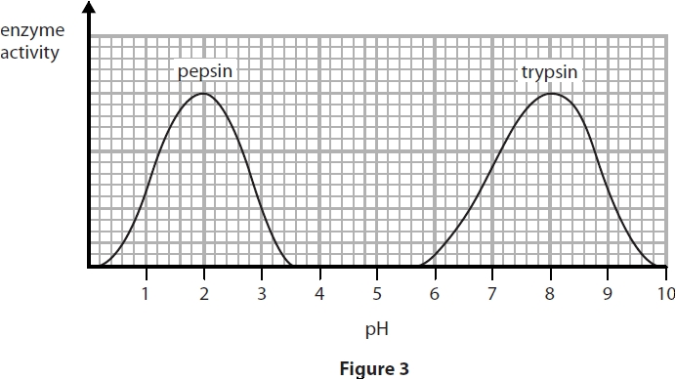

(i) Describe the trend in the graph for the enzyme trypsin.
Use data from the graph to support your answer.
(4)

(ii) State the optimum pH for the enzyme pepsin.
(1)

(iii) Pepsin only works effectively in the stomach.
Describe the conditions in the stomach that allow pepsin to work effectively.
(2)

Q3.
Describe the roles of the enzymes involved in digestion.
(6)

Q4.
Magnesium has an electronic configuration of 2.8.2.
Oxygen has an electronic configuration of 2.6.

Explain, in terms of their electronic configurations, how magnesium and oxygen atoms react to form the ionic compound magnesium oxide, MgO, and include a description of the structure of solid magnesium oxide.
(6)

Q5.
Some properties of four solids, A, B, C and D, are shown in Figure 3.
The solids, in no particular order, are copper carbonate, copper oxide, magnesium metal and sodium hydroxide.
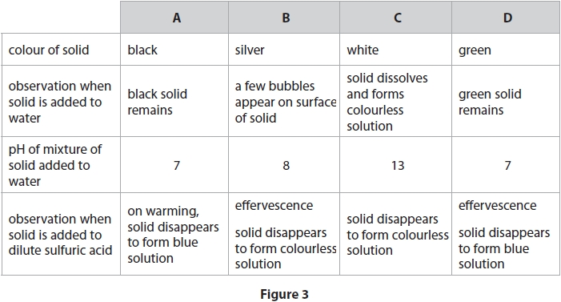
Identify the solids A, B, C and D, explaining how the information in Figure 3 supports the identification of each solid.
(6)

Task 3 – Phase 3 consolidation

Answer the questions in the boxes provided they are all related to the work that you completed in phase 3.
Q1.
A student investigated mitosis in the root tip of a garlic plant.
(i) Explain why the student used the tip of the root.
(2)

(ii) The student squashed the root tip on a microscope slide to spread out the cells.
The slide was placed on the stage of a microscope.
Describe how to use the microscope to obtain a clear image of the cells.
(2)

(iii) The student could not see the chromosomes inside the cells.
State what can be added to the root tip squash to make the chromosomes visible.
(1)

Q2.
Mitosis and meiosis are processes that produce new cells.
Compare the outcomes of mitosis and meiosis.
(3)

Q3.
The blood group of a person is determined by their genotype.
Describe how a person inherits the blood group AB.
(2)

Q4.
Gregor Mendel investigated the genetics of peas.
He did not know about genes but showed that inherited characteristics can be dominant or recessive.
(a) Explain how Mendel used homozygous tall and homozygous short pea plants to show that the tall allele is dominant to the short allele.
(2)

(b) Figure 16 shows a drosophila fruit fly.
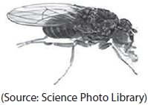
Figure 16
The brown body colour of a drosophila fruit fly is dominant to black body colour and is not sex-linked.
Explain how Gregor Mendel could have used a brown drosophila fruit fly and a black drosophila fruit fly to show that brown body colour is dominant to black body colour.
(6)

Q5.
Chlorine and carbon

(a) Chlorine has an atomic number of 17.
Chlorine-35 and chlorine-37 are two isotopes of chlorine.
(i) Complete the table to show the numbers of protons, neutrons and electrons in each of the isotopes.
(2)
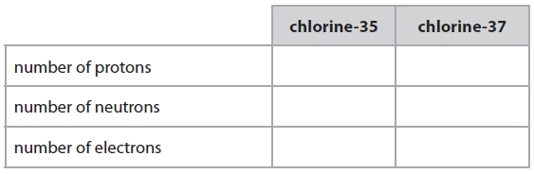
(ii) A normal sample of chlorine contains only chlorine-35 and chlorine-37 atoms.
Explain why the relative atomic mass of chlorine is 35.5
(2)

(c) The diagrams show the arrangements of carbon atoms in diamond and in graphite.
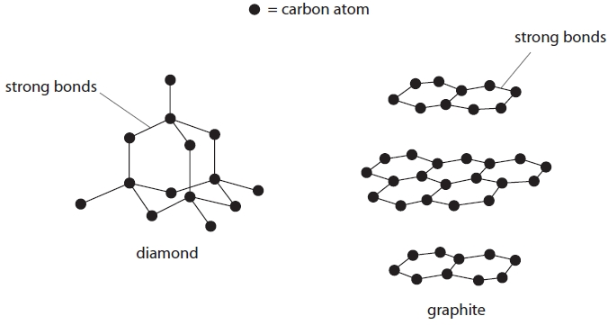
Compare a use of diamond with a use of graphite, explaining each use in terms of the bonding and structure. In your answer you should use information from the diagrams.
(6)

Q6.
Here is some information about the periodic table.
In the periodic table elements are arranged in rows and columns.
The position of an element in the periodic table depends on its atomic structure.
Elements with similar chemical properties are found in the same parts of the periodic table.
Identify different parts of the periodic table and explain how the position of an element in the periodic table is linked to its chemical properties and atomic structure.
(You are provided with an outline of the periodic table below and you may use this to help your answer.)
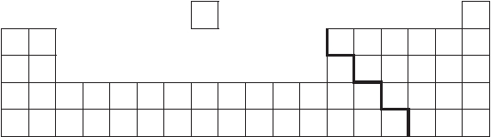
(6)

Q7.
A car, travelling at 20 m/s, with just the driver inside takes 70 m to stop in an emergency.
The same car is then fully loaded with luggage and passengers as well as the driver.
Explain why it will take a different distance to stop in an emergency from the same speed.
(6)

Q8.
Another rocket has a total mass of 90 g when it takes off. The acceleration of the rocket when it takes off is 3.3 m/s².
(i) Calculate the resultant force on the rocket when it takes off.
(2)
resultant force = ........................................................... N

