Year 9 Science Phase 4 work
Review work phases 1 to 3
You have three different tasks to complete and then we would like you to hand them in on google classrooms. You will need to email your teacher if you do not know how to do this.
Aim: To review the work that you have completed in phases 1 to 3
Access to the online text book - https://www.pearson.com/uk/learners/secondary-students-and-parents.html

Task 1 – P1
Part A – P1a

Answer the following questions.

- Al and Ben started at A and travelled north to B. Then they turned east and went to C, then south to D and then travelled west back to A. The distance in a straight line between A and C is 500 m.  - When they were at point B they had travelled a  distance of metres.  Their displacement from point A was  metres north.  - When they were at point C they had travelled a  distance of metres from point A.  Their displacement from point A was  metres at a bearing of 53º east of north. | 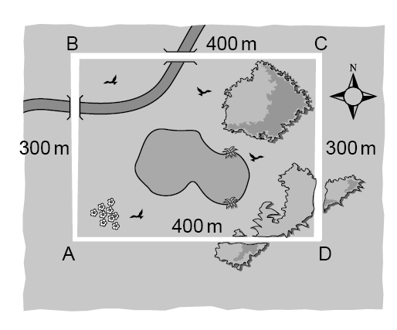
- When they were at point D they had travelled a total of metres from point A.
Their displacement from point A was metres (north/south/east/west).
- When they were back at point A they had travelled a total of metres.
Their displacement from point A was metres.

- Al walked at a constant speed of 1.5 m/s. Ben jogged at 3 m/s. Complete the table to show Al's velocity for each part of their journey.
 | Al's velocity | Ben's velocity
A to B | 1.5 m/s north
B to C
C to D
D to A |  | 3 m/s west
- The table below shows some things that can be measured. Tick the boxes to show if each one is a vector or a scalar quantity.
Quantity | Vector | Scalar
- force
- weight
- mass
- acceleration
- displacement
- speed
- distance
- energy

Part B – P1b

Answer the following questions. You may need to do your workings out on paper.

A peregrine falcon flies at 50 m/s for 7 s. How far does it fly?

- The boxes on the right show two equations linking speed, time and distance. Which one do you need to use to answer the question above? | A speed =
- Fill in the numbers below and then work out the answer.  = ×  = m | B distance = speed × time

- The four graphs below are all drawn with the same scales. They show different speeds. Write the speed under each graph, choosing numbers from the box on the right.
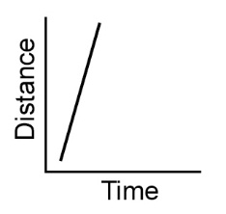 | 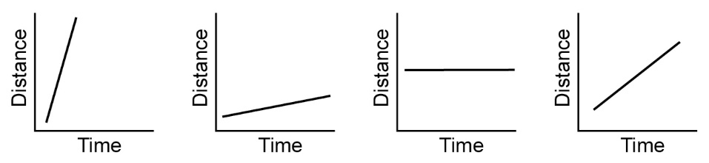 | 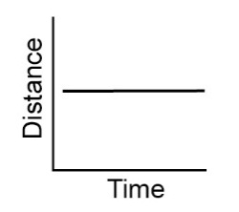 |  |  | 0 m/s  2 m/s  4 m/s  6 m/s
speed = | speed = | speed = |  | speed = | 0 m/s  2 m/s  4 m/s  6 m/s
- An athlete runs 100 m in 20 s. Calculate their speed.

speed = m/s

Part C – P1c

Answer the following questions. You may need to do your workings out on paper.

- Complete the following sentences using words from the box. You can use each word once, more than once or not at all.
Speed is a quantity and velocity is a quantity.  quantities have both a size and a .  The two objects on the right both have the same . They have different  , because one is moving in the opposite direction to the other. This is  shown by the sign.  Acceleration is a change in , so it is also a quantity.  An acceleration in the same direction as an object is moving will make a moving  object . An acceleration in the opposite direction to the movement of an  object will make the object ( ). An acceleration of  will not change the velocity of an object. | 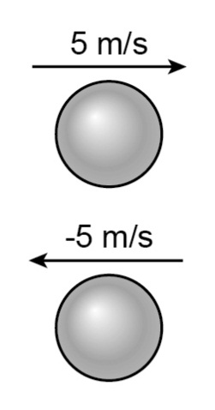
decelerate direction magnitude minus scalar slow down
speed up vector velocities velocity zero

- A car travelling at 40 m/s comes to a halt in 8 seconds. What is the car’s acceleration and how far does it travel while it is stopping?

- The box on the right shows the equation for calculating acceleration.  - Use the information in question S2 to complete the table. |  | a =
- Calculate the value of (v – u).

- Calculate the acceleration.

Symbol | represents… | value in question | unit
a | acceleration | ??
v
u
t |  | 8 | s

- The box on the right shows the equation relating velocities, acceleration and distance. Use your answers to question 2 to fill in the gaps below, and then work out the answer. | x =
x =

distance = _____________ m

Part C – P1d

- How do you compare accelerations on a velocity/time graph?

- How can you calculate acceleration from a velocity/time graph?

- How can you use a velocity/time graph to work out the total distance travelled?

Task 2 – Phase 2 consolidation

Answer the questions in the boxes provided they are all related to the work that you completed in phase 2.

Q1.
Colistin is an antibiotic used to treat infections in the bloodstream.
Some bacteria are resistant to Colistin.
Explain how these bacteria have become resistant to Colistin.
(4)

Q2.
Figure 3 shows the activity of the enzymes pepsin and trypsin at different pH levels.
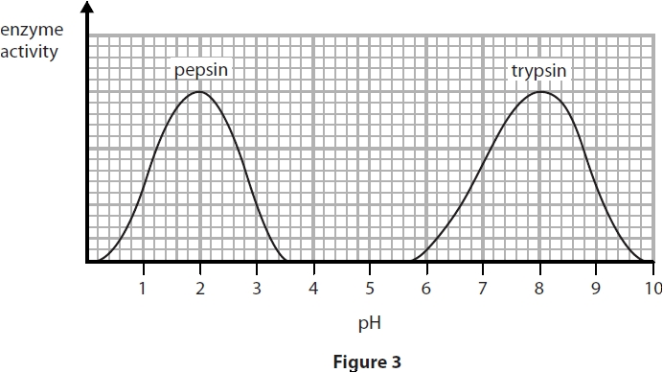
(i) Describe the trend in the graph for the enzyme trypsin.
Use data from the graph to support your answer.
(4)

(ii) State the optimum pH for the enzyme pepsin.
(1)

(iii) Pepsin only works effectively in the stomach.
Describe the conditions in the stomach that allow pepsin to work effectively.
(2)

Q3.
Describe the roles of the enzymes involved in digestion.
(6)

Q4.
Magnesium has an electronic configuration of 2.8.2.
Oxygen has an electronic configuration of 2.6.

Explain, in terms of their electronic configurations, how magnesium and oxygen atoms react to form the ionic compound magnesium oxide, MgO, and include a description of the structure of solid magnesium oxide.
(6)

Q5.
Some properties of four solids, A, B, C and D, are shown in Figure 3.
The solids, in no particular order, are copper carbonate, copper oxide, magnesium metal and sodium hydroxide.
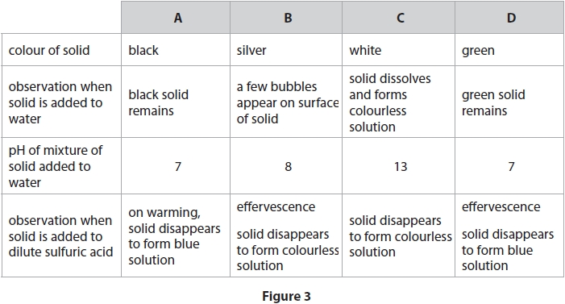
Identify the solids A, B, C and D, explaining how the information in Figure 3 supports the identification of each solid.
(6)

Task 3 – Phase 3 consolidation

Answer the questions in the boxes provided they are all related to the work that you completed in phase 3.
Q1.
A student investigated mitosis in the root tip of a garlic plant.
(i) Explain why the student used the tip of the root.
(2)

(ii) The student squashed the root tip on a microscope slide to spread out the cells.
The slide was placed on the stage of a microscope.
Describe how to use the microscope to obtain a clear image of the cells.
(2)

(iii) The student could not see the chromosomes inside the cells.
State what can be added to the root tip squash to make the chromosomes visible.
(1)

Q2.
Mitosis and meiosis are processes that produce new cells.
Compare the outcomes of mitosis and meiosis.
(3)

Q3.
The blood group of a person is determined by their genotype.
Describe how a person inherits the blood group AB.
(2)

Q4.
Gregor Mendel investigated the genetics of peas.
He did not know about genes but showed that inherited characteristics can be dominant or recessive.
(a) Explain how Mendel used homozygous tall and homozygous short pea plants to show that the tall allele is dominant to the short allele.
(2)

(b) Figure 16 shows a drosophila fruit fly.
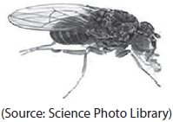
Figure 16
The brown body colour of a drosophila fruit fly is dominant to black body colour and is not sex-linked.
Explain how Gregor Mendel could have used a brown drosophila fruit fly and a black drosophila fruit fly to show that brown body colour is dominant to black body colour.
(6)

Q5.
Chlorine and carbon

(a) Chlorine has an atomic number of 17.
Chlorine-35 and chlorine-37 are two isotopes of chlorine.
(i) Complete the table to show the numbers of protons, neutrons and electrons in each of the isotopes.
(2)
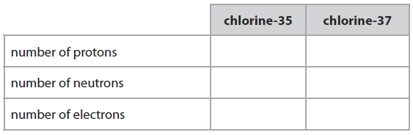
(ii) A normal sample of chlorine contains only chlorine-35 and chlorine-37 atoms.
Explain why the relative atomic mass of chlorine is 35.5
(2)

(c) The diagrams show the arrangements of carbon atoms in diamond and in graphite.
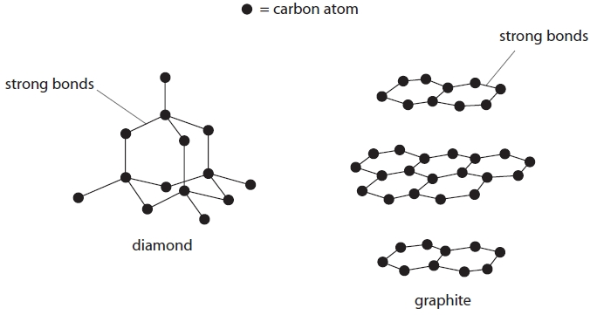
Compare a use of diamond with a use of graphite, explaining each use in terms of the bonding and structure. In your answer you should use information from the diagrams.
(6)

Q6.
Here is some information about the periodic table.
In the periodic table elements are arranged in rows and columns.
The position of an element in the periodic table depends on its atomic structure.
Elements with similar chemical properties are found in the same parts of the periodic table.
Identify different parts of the periodic table and explain how the position of an element in the periodic table is linked to its chemical properties and atomic structure.
(You are provided with an outline of the periodic table below and you may use this to help your answer.)
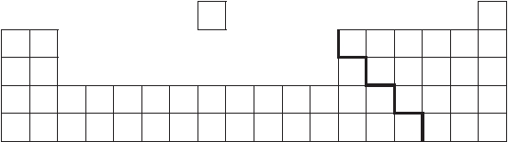
(6)

