Year 8 Quiz
This quiz is designed to test your knowledge of the previous two phases of work. If you aren’t sure of an answer, then look back through the work you have already completed to help you find the answer. Please have a go at every question. I look forward to seeing what you have learnt.

- Give a definition of weather

- Give a definition of Climate

- Most of our weather occurs in the:
- Ground
- Air
- Water
- Troposphere (the lowest layer of the Earth’s atmosphere)

- Which of these objects could be used to measure weather (there is more than one correct answer)
- Weather balloon
- Weather station on Land
- A ruler
- Planes
- Set of scales
- Satellites

- Someone who studies the weather is called a:
- Paleontologist
- Meteorologist
- Weather physician
- Orthodontist

- Weather is:
- The conditions of the atmosphere, that changes daily
- The average weather conditions over time
- The conditions predicted by a weather person
- How much rain a place gets in a year on average

- Which two of these statements relate to CLIMATE?
- The Sahara desert is hot and dry
- Today there was 3ml of rain in Hounslow
- The UK has a temperate climate
- Today in Brentford it is going to be warm and sunny

- Which of these could be a negative impact of weather:
- Crop damage
- Flooded sports grounds
- Delayed or cancelled flights
- Delays in post
- All of the above.

- Why is it important to shield thermometers in a special shelter called a “Stevenson screen”? (there is more than one correct answer)
- Because they might break
- Stevenson screens are raised off the ground so that air temperature and not ground temperature is measured
- So animals do not eat the thermometers
- The stevenson screen is painted white so it reflects heat

- True of False
- Wind Vanes measure the direction the wind is blowing.

- True of False
- Campbell stokes recorder records the amount of rain each day

- True of False
- A rain gauge accurately measures all precipitation including rain, sleet, hail and snow

- True of False
- Barometers measure the weight of rainfall

- Which Climate zone is the UK in?
- Tundra
- Desert
- Tropical rainforest
- Polar
- Mediterranean
- Mountain ranges
- Temperate

- True or False:
- a polar climate has temperatures which are usually below freezing and is covered by snow and ice throughout the year

- True of False:
- Temperate climates are very hot and dry

- True of False
- Mediterranean climates have long, warm, dry summers and wet winters

- True of False
Arid climates have four distinct seasons

- Which of these is not a type of precipitation?
- Wind
- Rain
- Snow
- Sleet
- Hail

- Which type of climatic zone experiences hot and wet conditions all year?
- Tropical
- Desert
- Mountain

- Latitude is:
- How many people live in a place
- How far a place is from the equator
- Distance from sea or coastal areas
- How high a place is

- Places near the equator have:
- More rain
- Higher temperatures
- Larger populations
- Polar bears

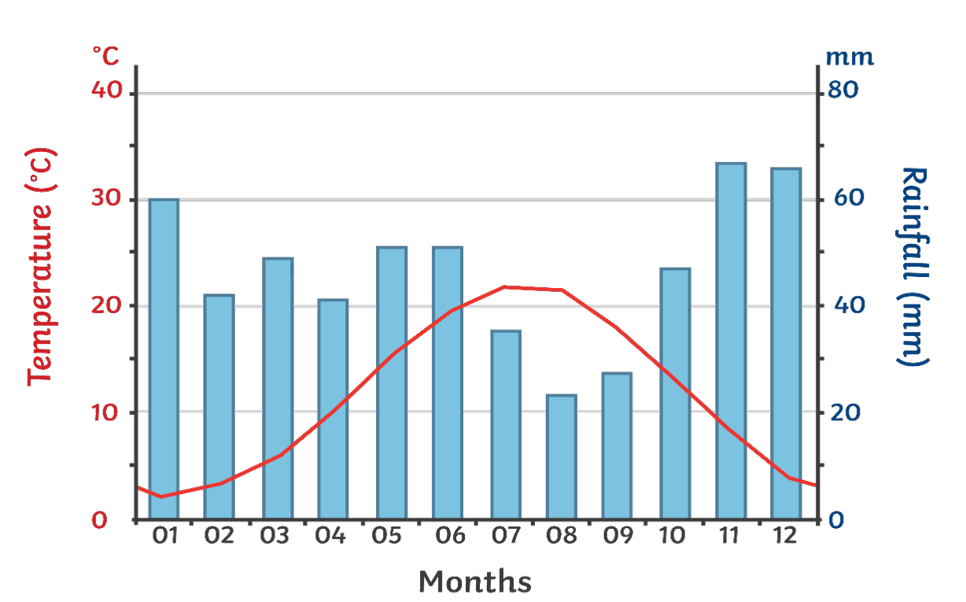
This is a climate graph, use this to answer the following three questions.
- The blue bars on the climate graph represent:
- Daily temperature
- The amount of snow
- The amount of sleet
- The amount of rainfall

- The red line graph represents:
- Rainfall
- Temperature
- Humidity
- Peoples satisfaction with the daily weather

- How do ocean currents affect the UK’s climate? Choose the most correct response.
- They don’t. The UK doesn’t have a very big coastline.
- The North Atlantic drift brings warmer water to the west coast of the UK warming the air temperature by several degrees
- The North Atlantic drift brings cold water and temperatures to the UK.
- The ocean currents make the east of the UK warmer.

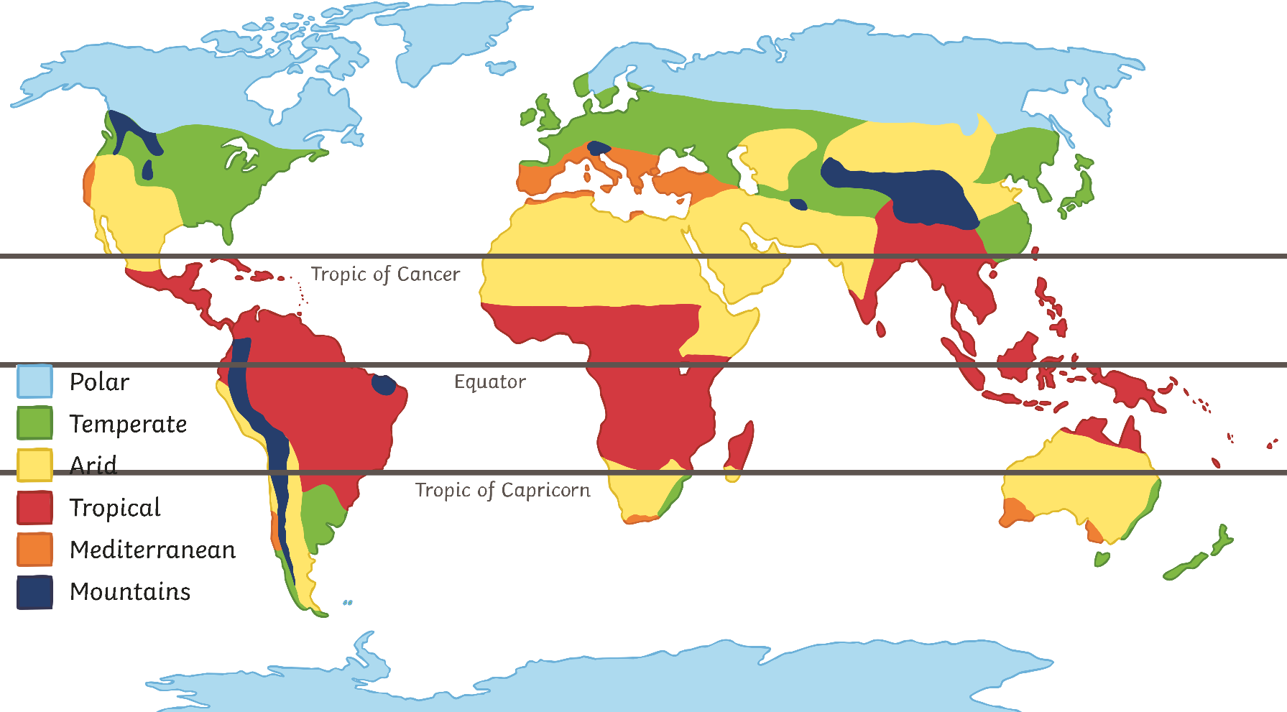Use the map to help you answer these questions: (will insert above each question).
- Which of these countries is more likely to be in an ARID environment?
- China
- Russia
- USA
- Algeria

- Which of these countries is likely to experience higher rainfall than Egypt:
- Namibia
- United Arab Emirates
- India
- Italy

- Which type of weather is measured in millibars?
- Temperature
- Rainfall
- Pressure

- Weather can include (click all correct answers)
- Wind direction
- Time zones
- Average rainfall
- Rainfall
- Air pressure

- Select the correct statement below:
- In winter the Northern Hemisphere is tilted away from the sun so the temperatures are lower
- In winter the Northern Hemisphere is tilted toward the sun so temperatures are lower.
- In winter, the Northern Hemisphere is tilted away from the sun so temperatures are higher
- In winter the Northern Hemisphere is tilted toward the sun so temperatures are higher.

- Prevailing winds effect the UK’s climate because (Select all correct statements)
- Polar winds are cool and wet, and this brings cool wet air to the West
- The South East receives tropical Mediterranean winds that make it the hottest part of the UK
- Artic winds bring cold, dry wind to the North
- Tropical maritime winds are the warmest, bringing warm and wet weather to the South.

- Distance from the sea can affect temperatures because (select the correct response/s):
- In summer the land is cooler than the sea.
- In winter the sea is warmer than the land, which means some coastal areas are kept warmer than inland areas.
- In summer the sea is cooler than the land, which makes coastal areas cooler than inland areas by the cool sea breeze.
- The sea will always make coastal areas colder.

If you are downloading this from the website please now send an email with your completed quiz to your Geography teacher.

