Year 7 Science Phase 4 work
Review work phases 1 to 3
You have two different tasks to complete and then we would like you to hand them in on google classrooms. You will need to email your teacher if you do not know how to do this.
Aim: To review the work that you have completed in phases 1 to 3
Resources you might need:
- Access to the online text book - https://www.pearson.com/uk/learners/secondary-students-and-parents.html
- KS3 bitesize - https://www.bbc.co.uk/bitesize/subjects/zng4d2p

Task 1 - 7H
Part A
Answer the following questions in the boxes provided.
1. What is all matter made of?

2. Describe the difference between an element and a compound.

3. What are the common properties of metals?

4. What are the common properties of non-metals?

5. Describe what happens in a chemical reaction.

Part B
1. Read the following passage then answer the questions which follow.
‘When the shiny lithium metal is heated and lowered into a container of green chlorine gas, a chemical reaction occurs. The lithium appears to burn and a white solid forms on the sides of the container. The white solid is lithium chloride.’
- Name the elements and the compound described in the above passage.
Elements:
Compound:

- Describe one difference in property between the elements and the compound they form.

- What evidence is there for a chemical reaction occurring?

2. Read the following passage then answer the questions which follow.
‘When shiny sodium metal is heated in a gas jar of green chlorine gas it reacts by burning brightly with a yellow flame. When the reaction is finished a white solid is seen forming on the side of the gas jar.’
- Which two phrases in the above passage suggest that a chemical reaction has occurred?

- Why is the mixture heated at first?

- What is the name of the white solid that was formed?

Part C
Earth’s elements
Read each statement in the table below.
Decide whether they apply to elements, mixtures or compounds and complete the table by placing a YES in the correct box or boxes.
Note that some statements could apply to more than one category.
 | Statements | Element | Mixture | Compound
1 | contain a single chemical
2 | found in the periodic table
3 | are made up of atoms
4 | include air, soil and sea water
5 | contain only one type of atom
6 | pure oxygen is an example
7 | contain more than one type of atom
8 | contain different substances that are not joined together
9 | can be solids, liquids or gases
10 | include water, salt and carbon dioxide
11 | contains only atoms that are not joined together
12 | pure water is an example

Extra challenge - Explain why it is important to try to recycle metals rather than make new metals from raw materials.

Task 2
Part A – Space

1. In the box below write five facts about the space project that you completed.

2. What did you find most interesting about the space project?

3. Go to this link https://spaceplace.nasa.gov/menu/science-and-technology/ click on GPS and the quest for Pizza.
Write what you found out in the box below.

Part B - 7D

- Choose two of the animals below.
- For your chosen animal, carry out some research and in the boxes provided below write a fact file on your chose animal:
- the habitat it lives in
- what the environment of this habitat is like
- what adaptations this animal has for surviving in this habitat.
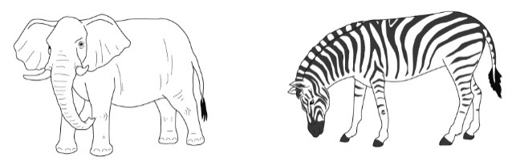
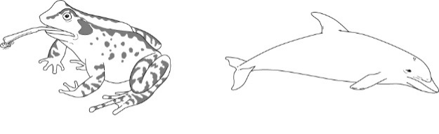

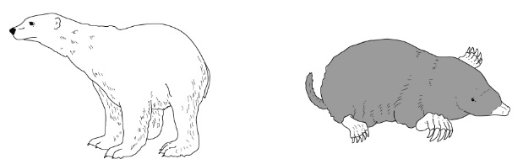

Animal 1 | Animal 2

Extra challenge – Read the article about tardigrades and write down in the box below what you find the most interesting. Explain how tardigrades are linked to space and adaptations. https://www.sciencefocus.com/nature/amazing-facts-about-tardigrades-the-worlds-toughest-animal/

