Sentence Writing

Look at the picture and write 10 sentences about what you see. Remember to use colour words! ** Don’t forget capital letters and full stops.

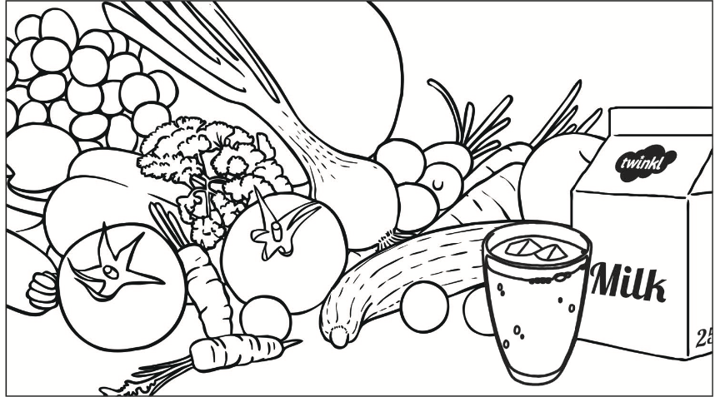

Example:

This is very healthy food.
I like to eat healthy food.
There is a yellow lemon.
There are two _______ _______.

Challenge sentence:
Milk contains calcium, which is good for your bones.

