Writing Picture Prompt 2
Five Senses Writing

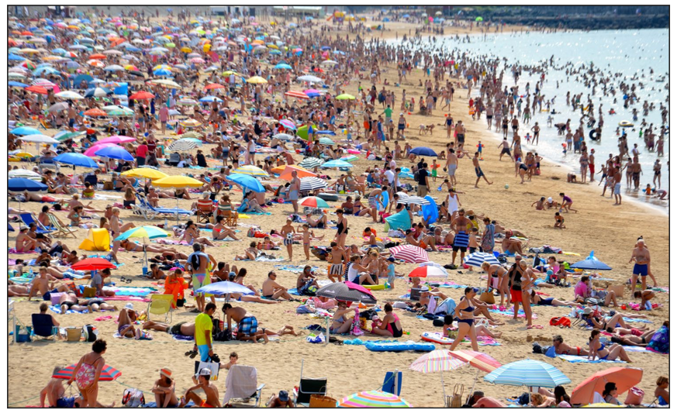

- Look at the picture. What do you see? Write 10 complete sentences describing what you see. Remember to use adjectives!
Examples:

There are many colorful umbrellas on the beach.
I can see a man wearing a yellow T-shirt and blue shorts.

- Use your imagination. What do you feel? Write 10 complete sentences describing what you feel.
Examples:

The sand feels very hot.
The sand burns my feet.
The water….
I can feel…

- Use your imagination. What do hear? Write 10 complete sentences describing what you hear.
Try to use adjectives!
Examples:

A woman is shouting at her naughty children.
I can hear noisy children playing.
Someone’s radio is playing loud music.

