A Level Sociology



Summer work

What is assessed?
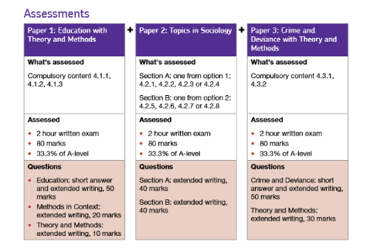

What you need:
Equipment | Checklist
3 big lever arch folders
Dividers
Lined paper
Consolidation/ revision cards
Highlighters
Green pens
AQA A Level Sociology textbook: Book One, Keith Throbe, Rob Webb, Annie Townend, Hal Westergaard (can be loaned from the department for a refundable £20 deposit)

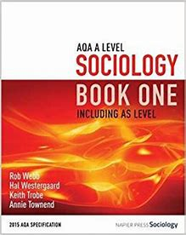

Wider reading checklist

Downloaded BBC News App on phone

Created a twitter account and follow the twitter accounts:

@TheSocReview – The Sociology Review A Level magazine
@DailySociology – sociology news every day
@SocImages – links to interesting articles and research
@TheSocyCinema – pop culture and film links with sociology
@SassySociology – a PhD student specialising in gender, ethnicity and inequalities
@LearnSoc - this is the official twitter page of one of the largest sociology website
@SociologyLens -provides links to current sociological topics, research and issues to debate
Created BBC Iplayer account using school email
Created a Tutor2U student account

https://www.tutor2u.net/login

Create an s-cool revision account

https://www.s-cool.co.uk/a-level/sociology/

Introductory tasks

Task:
Watch the following video and in 50-100 words summarising what Sociology is https://www.youtube.com/watch?v=LK5J0-cM-HE

Research task:

Street Check
View the latest demographic information for your area.
www.streetcheck.co.uk
Questions:
What are employment rates in your area?

What is the gender split in your area?

How does the median age in your area compare to the national age?

Crime statistics
View Crime Statistics on your street or within a one-mile radius
Compare crime rates for your postcode and/or future university, friends or relatives area
https://www.crime-statistics.co.uk/
What does the crime information tell you about these area?

Challenge:
What does the crime information not tell you about the respective areas?

Social Groups

A core theme of A Level Sociology is different social groups.
This section is aimed at familiarising yourselves with differences related to social groups, including class, age, gender and ethnicity.

Complete the following research tasks (read the articles) and answer the questions:
Class
Why rich kids are so good at the marshmallow test
https://www.theatlantic.com/family/archive/2018/06/marshmallow-test/561779/
Questions:
Define immediate gratification and delayed gratification.
What does the most recent research tell us about delayed gratification?
Challenge: How does delayed gratification link to family structure?

Age
NHS faces staggering increase in cost of elderly care, academics warn.
https://www.theguardian.com/society/2017/may/24/nhs-faces-staggering-increase-incost-of-elderly-care-academics-warn-dementia
Questions:
What impact is an ageing population having on public services?

Is there anything that can be done to change this?

Gender
The dark side of female empowerment: The rise ofq1 Britain's 'gangster girls' running gangs
http://www.telegraph.co.uk/women/womens-life/10857716/Britains-gangster-girls-The-darkside-of-female-empowerment-The-rise-of-women-and-females-running-gangs.html
Questions:
Are the rise of ‘girl gangs’ a direct effect of female liberation (female freedom)?
How else could they be explained?

Ethnicity
Met ‘use more force’ against black people
https://www.bbc.co.uk/news/uk-england-london-44214748
Question:
Summarise the statistics presented in this article.
Is this evidence of institutional racism (racism within the polic force) or racism in society?

Watch list

 | Watched | What have you learnt about Education in the UK?  Education and academic success?
Educating Rita

https://www.youtube.com/watch?v=4z8OcniWU-Y

Too poor for posh school

https://www.youtube.com/watch?v=c8R3Z2usQ1Q

School swap the class divide

https://www.youtube.com/watch?v=wRu0OlQ0JkY

Teachers TV: Black boys

https://www.youtube.com/watch?v=n0UI-sqA_z0

Reading list
Each article addresses the topics we will be looking at in Year 1
Task: Read each article and answer the questions
Article | Question
Private school and Oxbridge 'take top jobs'  State of the Nation report: Inequality 'entrenched from birth', 30 April 2019 | Is the education system fair? Is there a social class divide in the UK education system?
Girls 'get better GCSE results in all-girl schools' | Is there a gender divide in educational achievement? Explain your answer
Record ethnic minority students at Oxford | Why do few ethnic minority students attend the top Universities like Oxford and Cambridge?

Social Class and Education

Private school and Oxbridge 'take top jobs'
By Sean Coughlan and David Brown BBC News, 25 June 2019

A social mobility charity says top professions in the UK are still unduly dominated by people who have gone through private schools and Oxford and Cambridge universities.
The Sutton Trust and Social Mobility Commission analysed the educational background of 5,000 people in top jobs.
It found these influential people were five times more likely to be privately educated than the average population.
Trust chairman Sir Peter Lampl warned of an "increasingly divided society".
The study, Elitist Britain, looked at the schools and universities attended by 5,000 high achievers at the top of business, politics, the media, public organisations, creative industries and sport.
It does not name individuals but concludes that "power rests with a narrow section of the population - the 7% who attend private schools and the 1% who graduate from Oxford and Cambridge".
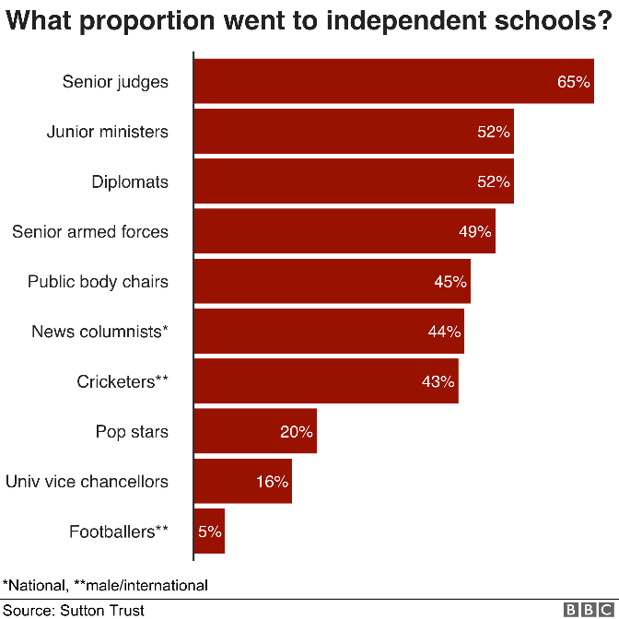
It might not be a huge surprise that the upper ranks of the judiciary, the diplomatic service, the armed forces and public bodies are stuffed by a disproportionate number of former public-school pupils.
But it might raise an eyebrow that today's pop stars are more likely to have gone to private school than university vice-chancellors - 20% compared with 16%.
For the purposes of this survey, a "pop star" is someone from the UK who has had a top 40 selling album in the past four years.
This echoes warnings that the creative industries, once an express train of social mobility, are increasingly becoming populated by the offspring of wealthy, well connected parents.
But pop stars are out-poshed by international cricketers and national newspaper columnists, defined as those covering news, politics and policy rather than other "lifestyle" writers.
In terms of the overall "power gap", the report says 39% of people in these elite groups were privately educated, compared with 7% of the population.
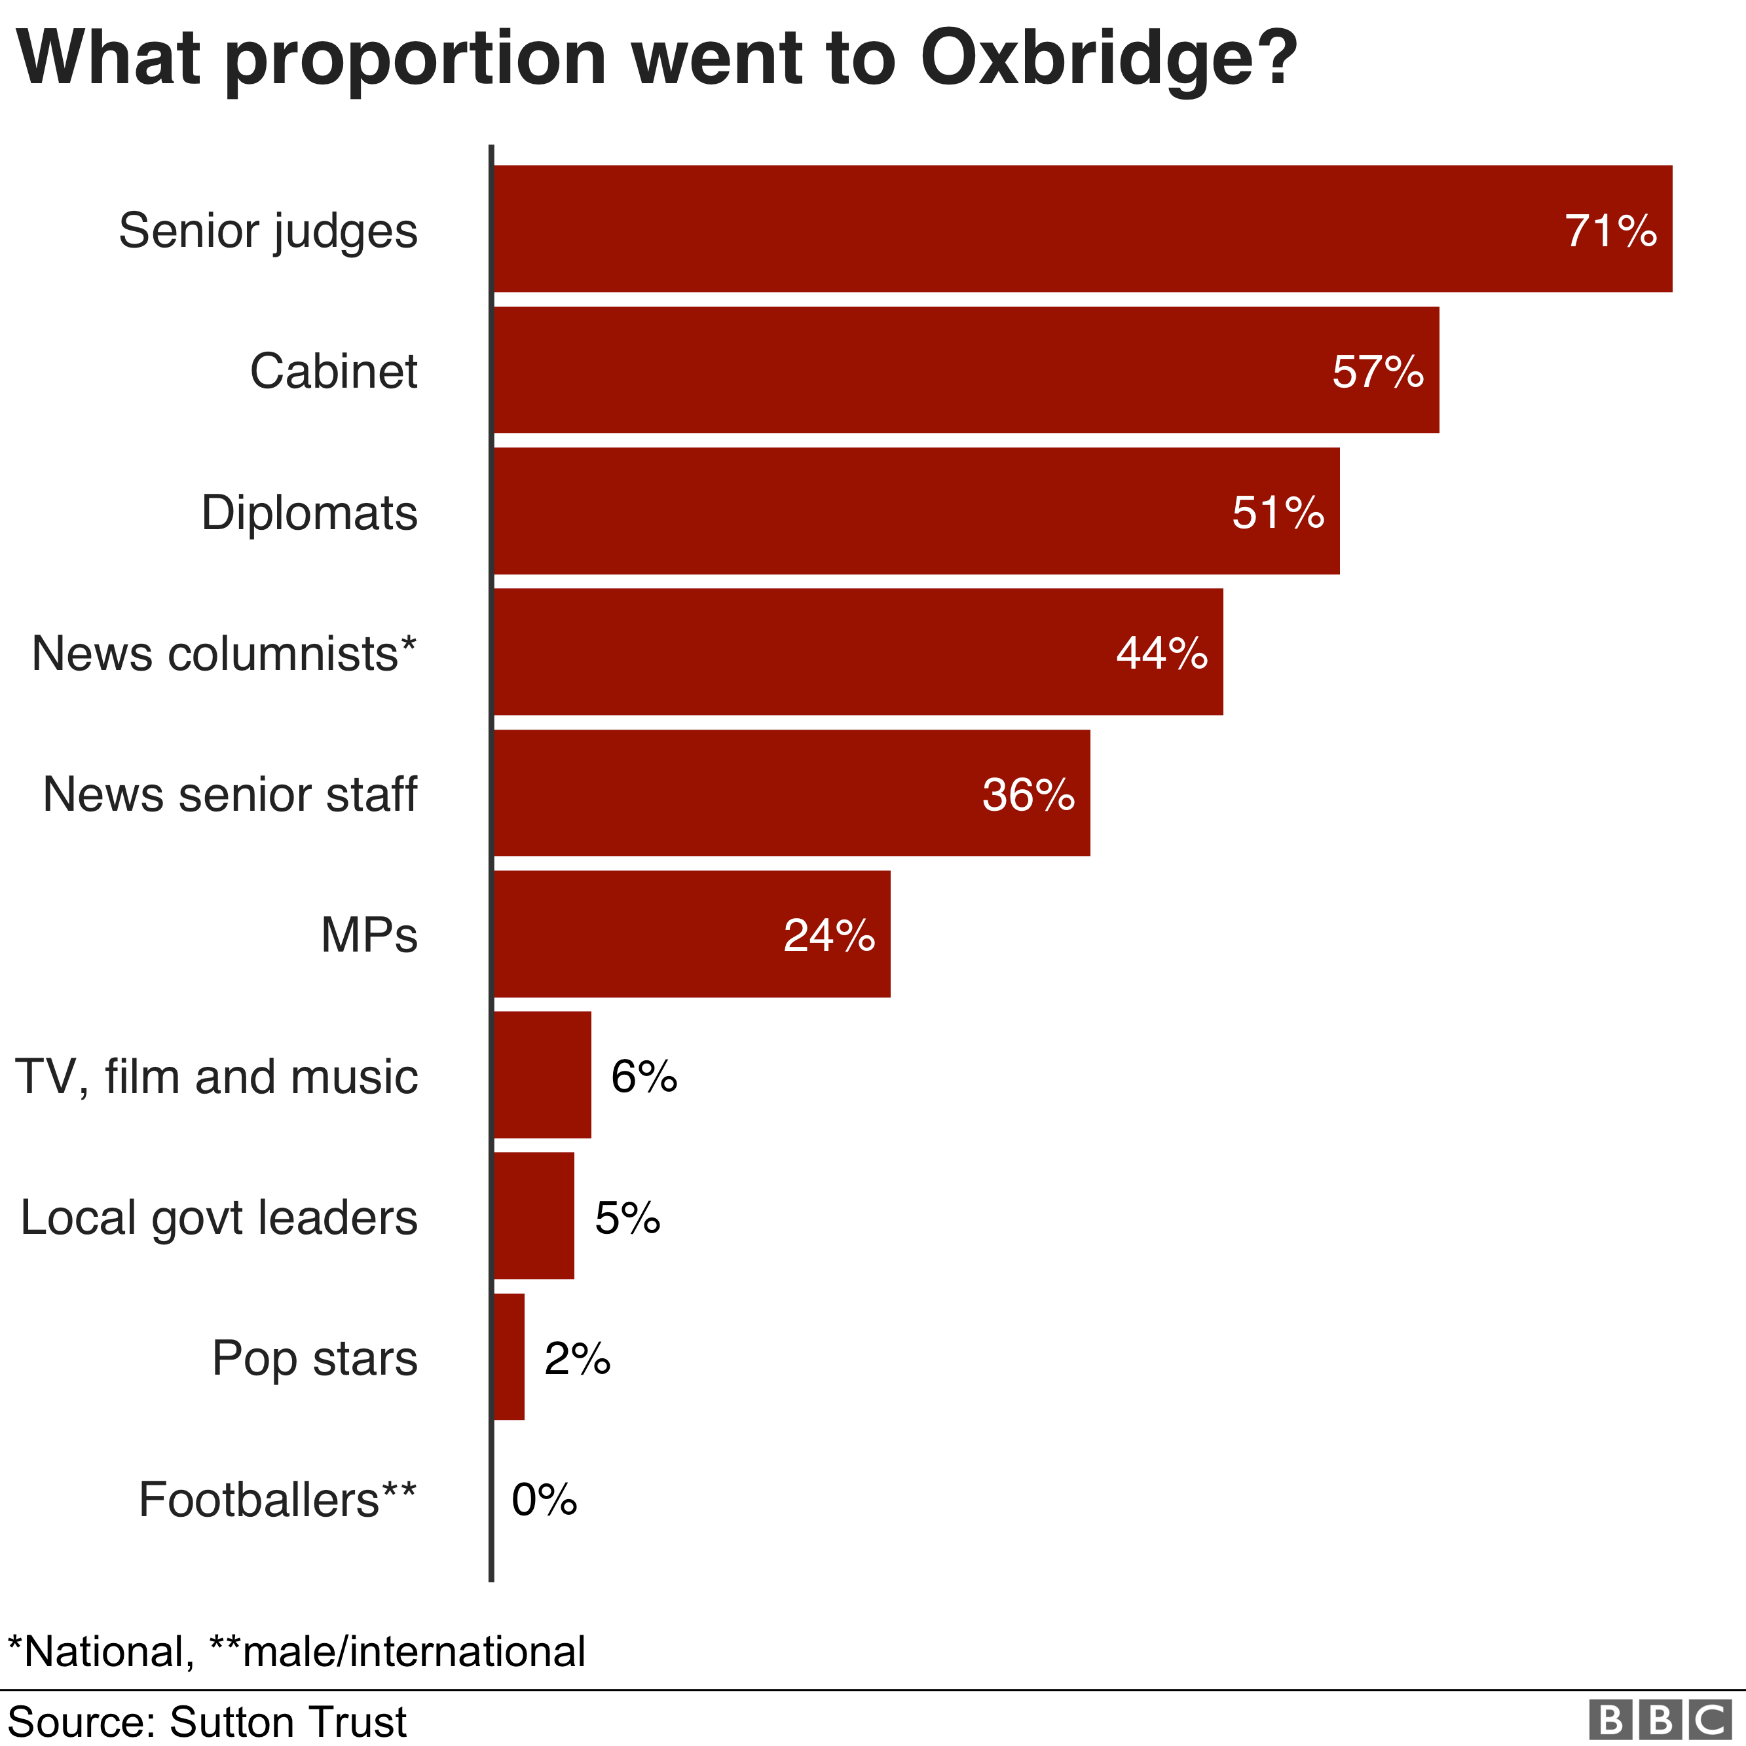
The battle for the leadership of the Conservative party is between two Oxford graduates - and these figures show that the Oxbridge contingent remains prominent in the areas around politics, the law and opinion-formers in the media.
There are 24% of MPs who are from Oxbridge - but there have been significant changes over the longer-term.
House of Commons figures show that in 1979, when Margaret Thatcher became prime minister, 73% of her Conservative MPs were privately educated - a figure that it is now 45%.
Among Labour MPs, 15% were privately educated.
But the Oxbridge influence across the House of Commons remains significant. Among the chairs of select committees, one in three is Oxbridge.
There might also be wider questions about diversity in politics - considering gender and ethnicity as well as where someone went to university.
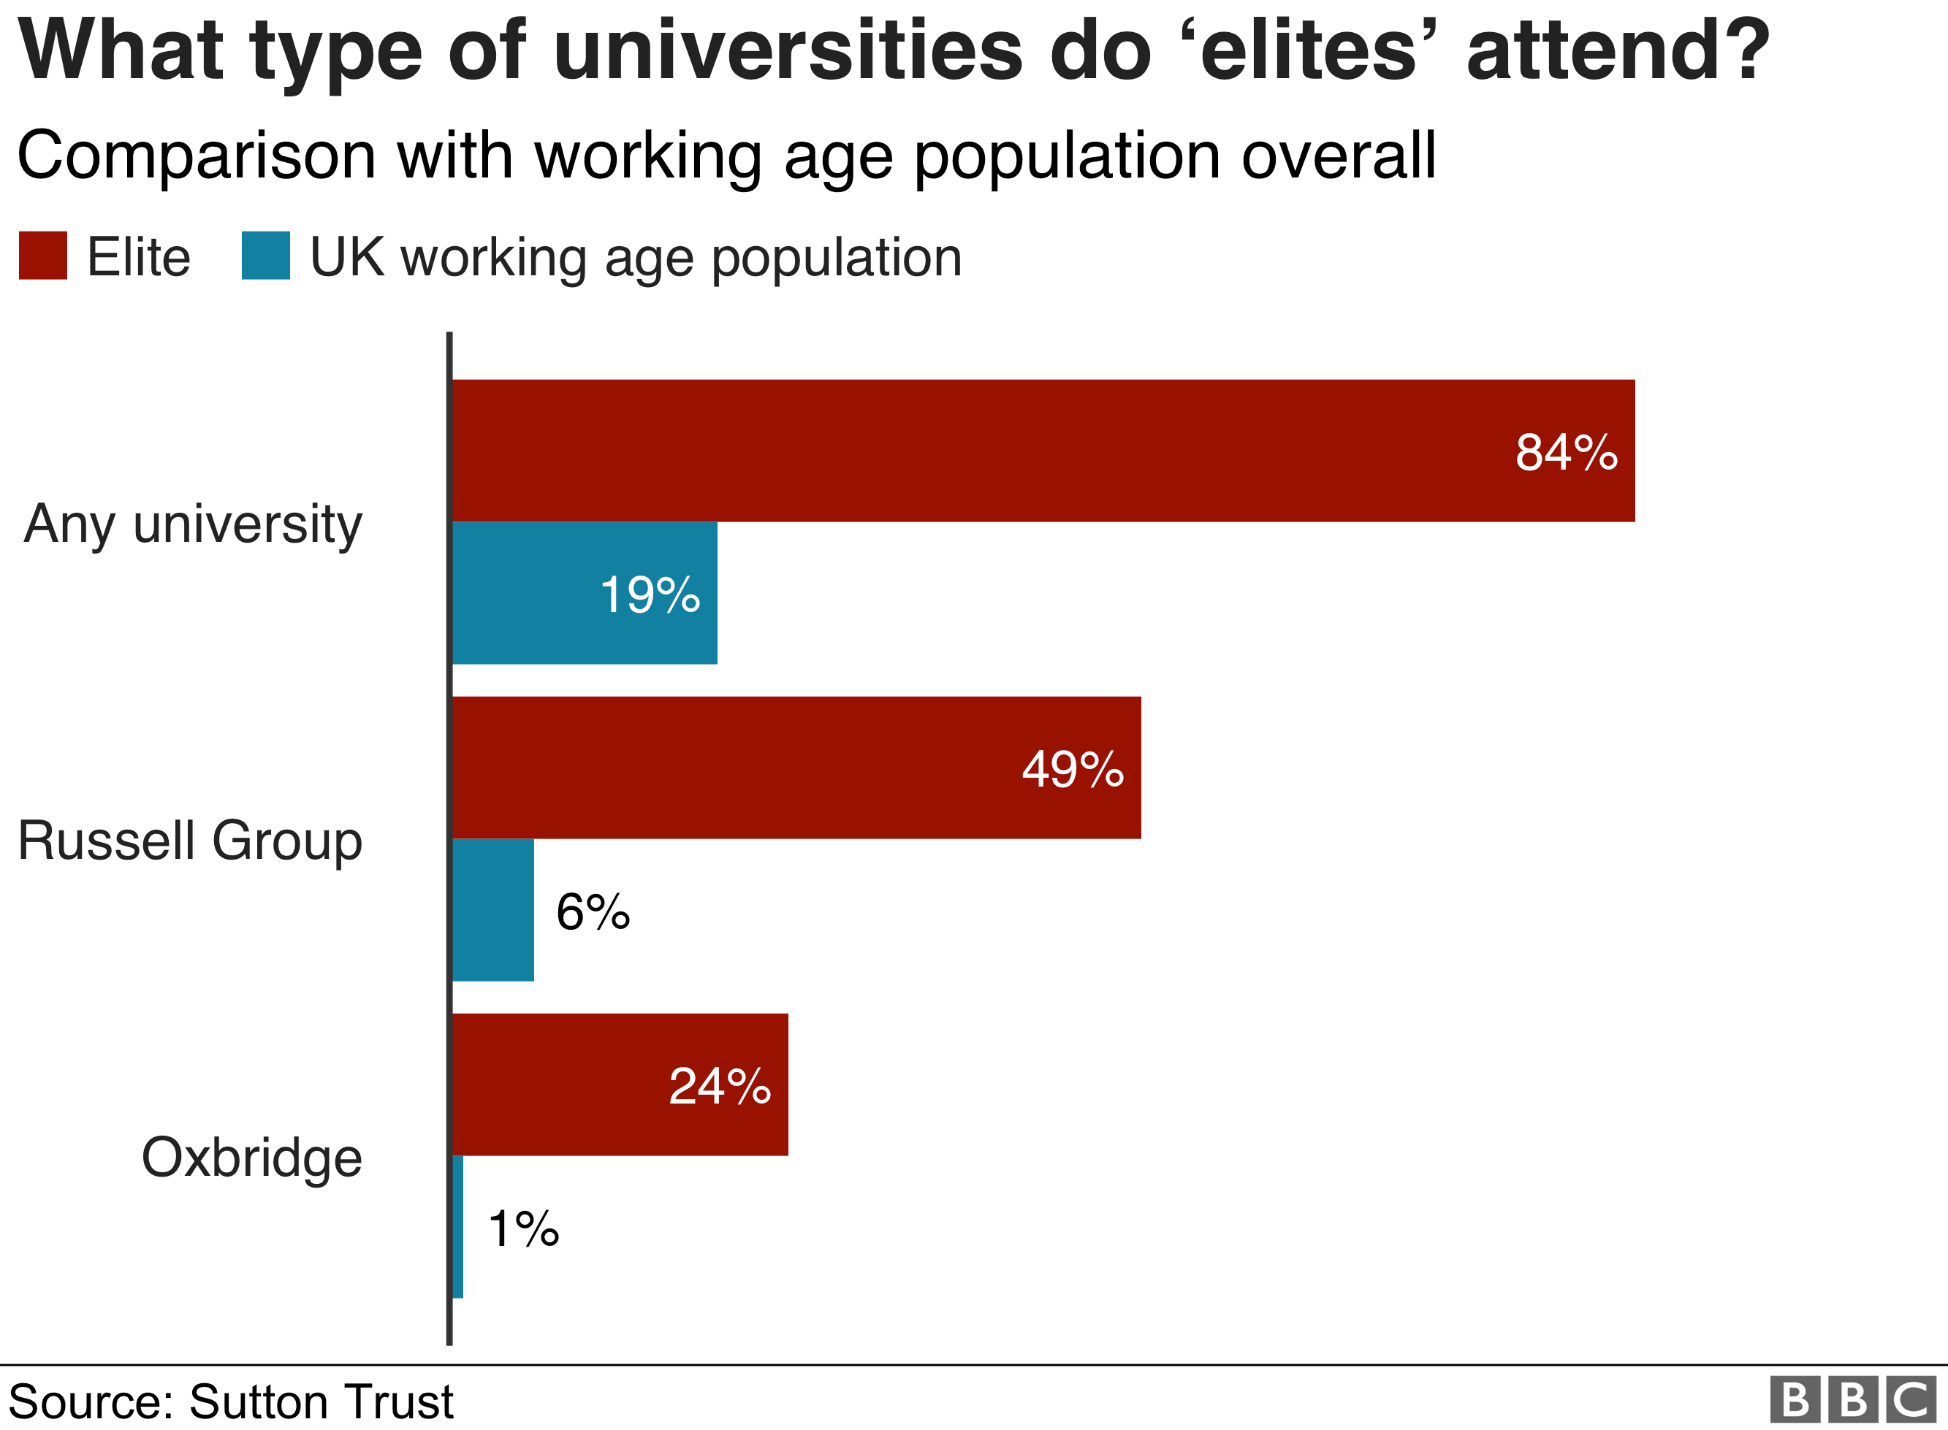
This report focuses on the dominance of Oxford and Cambridge in public life - but what might get lost in this debate is that the vast majority of the UK's working-age population didn't go to any university at all.
This shows how, in educational terms, this elite 5,000 are very different from the rest of the country.
Their question is not whether to go to university, but which university.
Perhaps the most striking statistic is that 24% of this top group have gone to Oxbridge, while only 19% of the working population have been to any university at all.
It might also suggest why university tuition fees remain such a politically charged question, when almost nine in 10 MPs have been to university themselves,
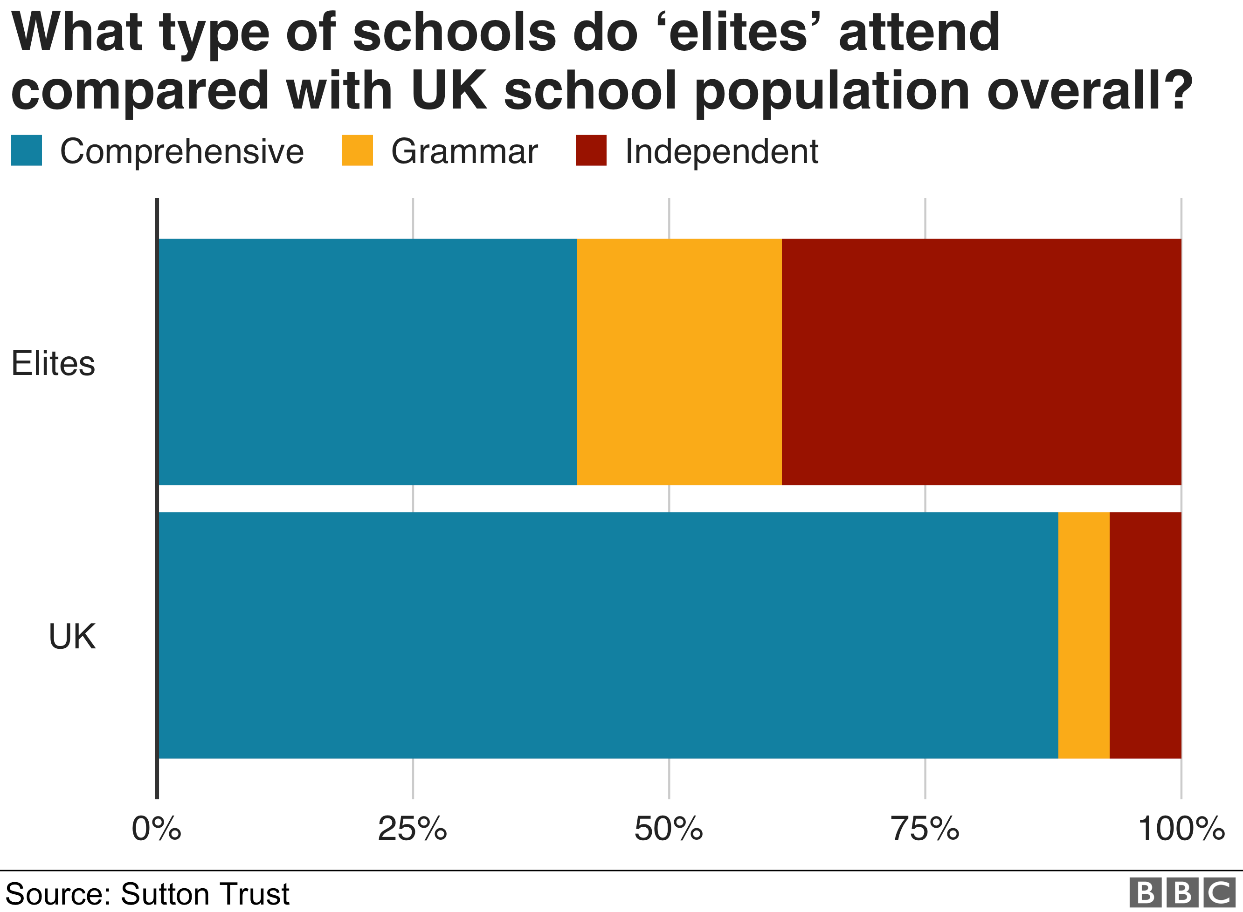
In the general population, going to a non-selective state school is by far the most typical experience.
But among the elite, the comprehensive school is a minority background, where independent and grammar schools are more usual.
The figure for private school attendance is 7% - but it's worth recognising that this changes through the school years, so that among those taking A-levels or equivalents, about 18% are in private school.
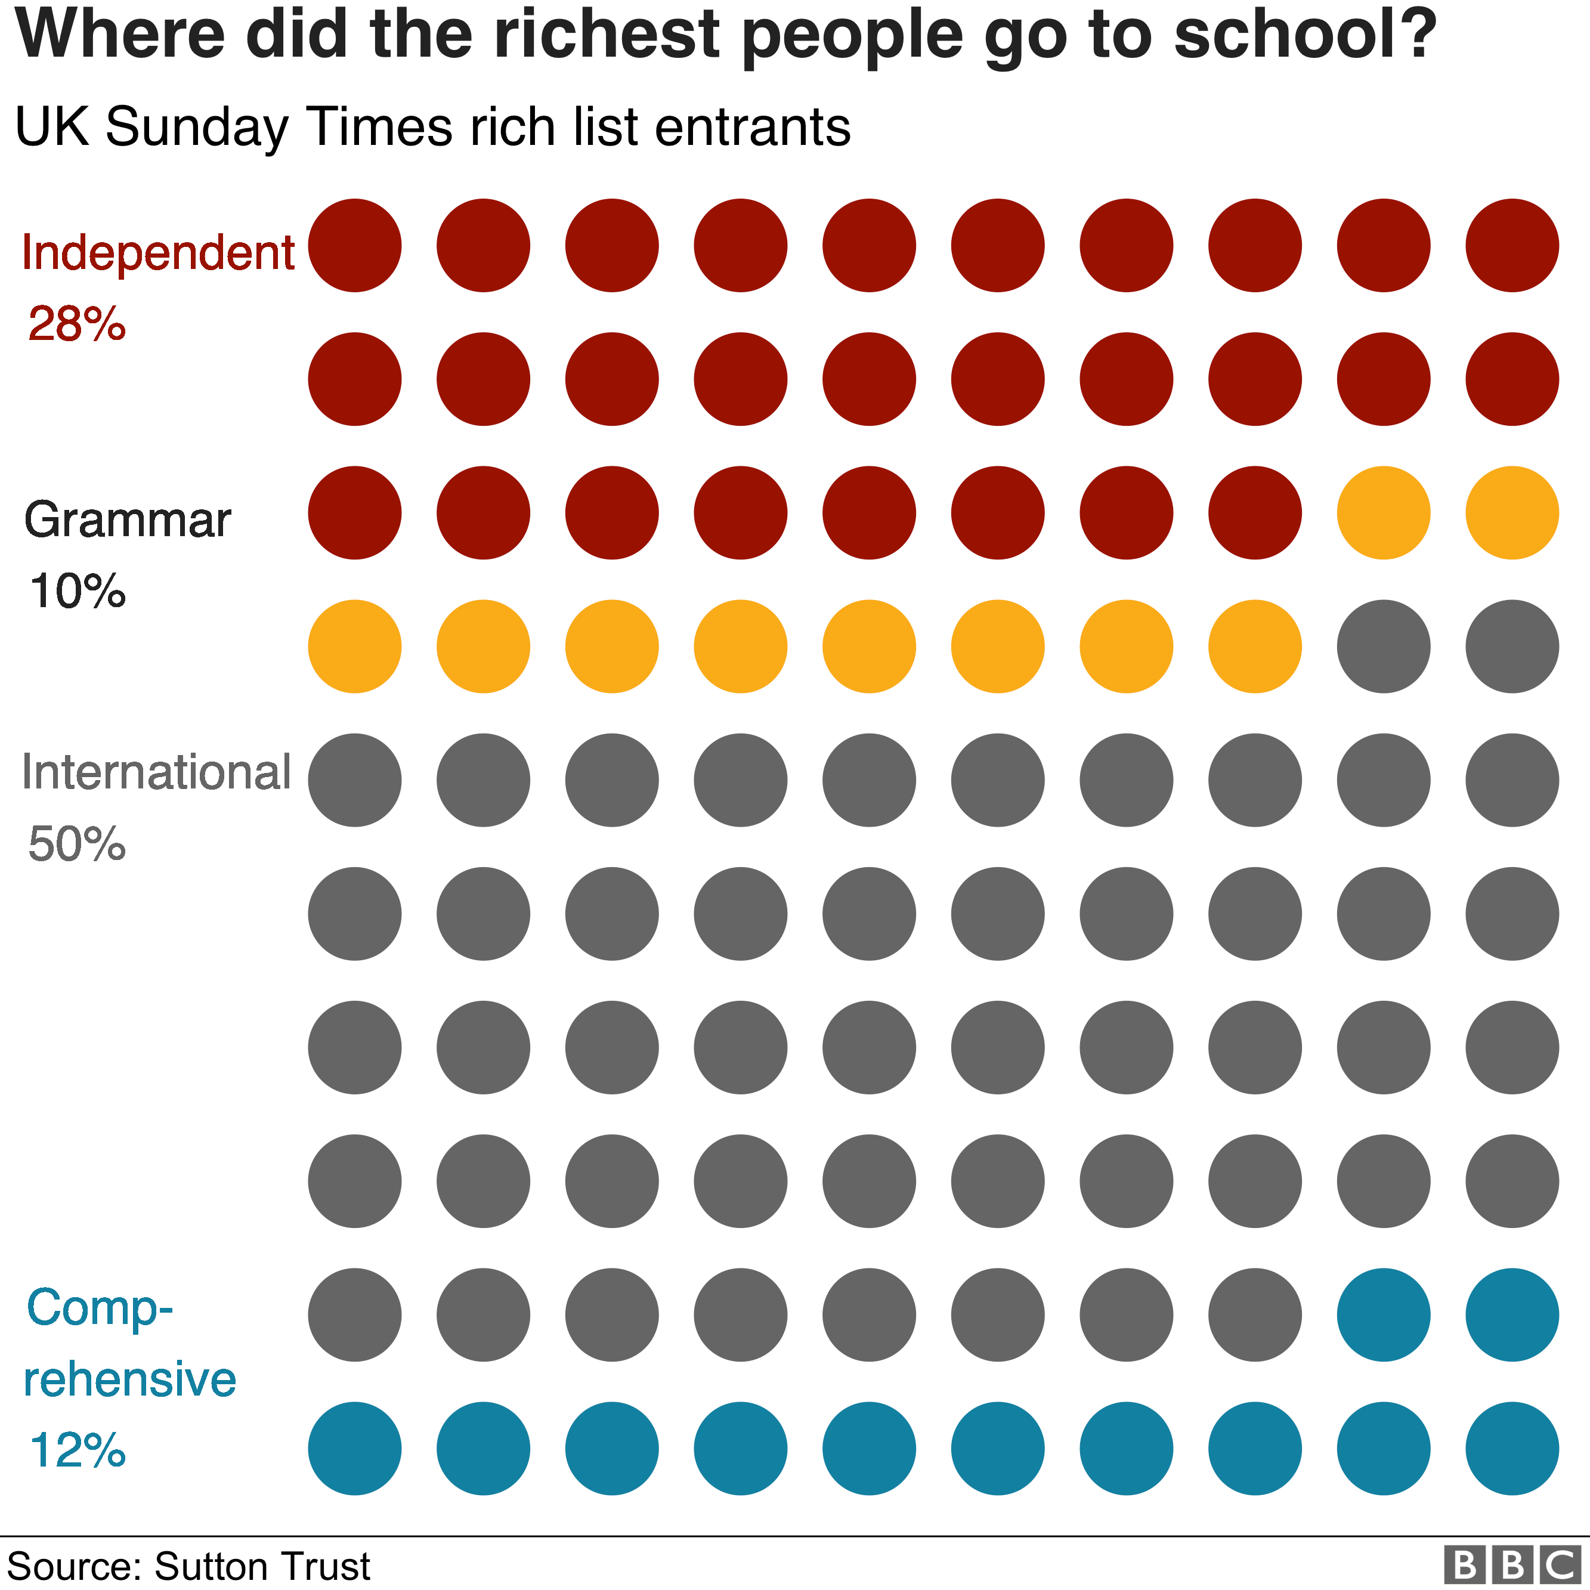
When it comes to showing us the money, this is where the comprehensive students are least represented.
Among those in the UK in the Sunday Times Rich List, there were 34% from independent schools compared with 12% from comprehensives.
The biggest group of all were not educated in the UK at all, including migrants who made their wealth after coming to the country.
Why does it matter?
The report warns that social mobility is "worryingly low" and Dame Martina Milburn, who chairs the Social Mobility Commission, questions whether "this small elite" should have "such a big say in running the country".
These are the nation's decision-makers - and this report raises the question of whether rulers and the ruled should have such different backgrounds.
It isn't only about politics. It asks whether so many opinion formers and the artists who hold up a mirror to our age should be drawn from such a narrow pool.
What are the responses?
The head teachers' leader Geoff Barton said: "State schools work tirelessly to make social justice a reality but the dice are loaded against them in a society where both privilege and disadvantage are perpetuated from one generation to the next."
"The old boys' network and the old school tie still hold back talented and hard-working people from less privileged backgrounds," said Labour's shadow education secretary, Angela Rayner.
But Julie Robinson, chief executive of the Independent Schools Council, warned about assumptions "based on misconceptions or stereotypes" and said many private schools had partnerships with state schools or offered reduced fees for low-income families.
A spokeswoman for the Department for Education said: "For too long professions like law, politics and journalism have been dominated by independently schooled people.
"By making sure that our state schools offer a comparable education to private schools, we will drive down these inequalities."

Social class and education

State of the Nation report: Inequality 'entrenched from birth', 30 April 2019

Inequality will remain entrenched "from birth to work" unless the government takes urgent action, the Social Mobility Commission has warned.
Its State of the Nation report covering England, Scotland and Wales, said the situation had remained "virtually stagnant" since 2014.
It is calling on ministers to provide additional funding for older teenagers in education and to extend free childcare to more low income families.
The government said it would take the recommendations seriously.
The findings will come as a setback to Theresa May who promised to tackle the "burning injustice" of social inequality when she entered Downing Street in 2016.
However, the following year, all of the commissioners on the Social Mobility Commission - set up in 2010 to monitor and promote social mobility - resigned, saying the government was too focused on Brexit to deal with creating a fairer Britain.

'A catch 22'
Law graduate Paris McKenzie describes the difficulty she has faced finding work
Law graduate Paris McKenzie, 25, wants to be a solicitor but said there are not enough training contracts in her home city of Nottingham.
"I have barely come across any, and I constantly search for them. There are lots in London," she said.
But the single mother said she did not "have the means" to move to the capital, where she said she would not have support and would struggle to pick up her son from nursery herself.
"It's a catch 22, my opportunities are very limited," she added.

Dame Martina Milburn, who has since been appointed as the new chairwoman, said she sensed there was now "a real commitment" from the government.
However, she said the biggest concern was not stagnation, but that the problem might actually get worse.
"There's still a big shift - if you want to be socially mobile - towards London," she told BBC Radio Four's Today programme.
"I think you're three times more likely to move to London if you're from a professional background than if you're from a working class background."
Education Secretary Damian Hinds said he welcomed the "thorough" report - the first since the new commissioners were appointed - but stopped short of saying the government would adopt all of its recommendations.
The report recommends:
- a "significant increase" in funding for all 16 to 19-year-olds in education, with a special "student premium" for the disadvantaged
- extending the offer of 30 hours of free childcare a week to cover households where one parent is working eight hours a week - currently one parent must work at least 16 hours
- the government agreeing to pay the voluntary living wage to all of its employees and contracted workers, including cleaners and catering staff
The report found those from better-off backgrounds were almost 80% more likely to be in a professional job than their working class peers.
It said the proportion of people from professional backgrounds who were in professional jobs was 60% last year.
In contrast, only 34% of those from working class backgrounds had professional jobs last year. And both figures had changed only slightly over the past four years.
"Being born privileged means you are likely to remain privileged," said Dame Martina, who is also chief executive of the Prince's Trust.
"But being born disadvantaged means you may have to overcome a series of barriers to ensure you and your children are not stuck in the same trap."
The commission said it welcomed the findings showing that Scotland and Wales were becoming more socially mobile, with a person's socio-economic status less likely to be determined by their parents' socio-economic status than in 2014. It said this was especially encouraging in light of the limited social mobility in Britain as a whole.
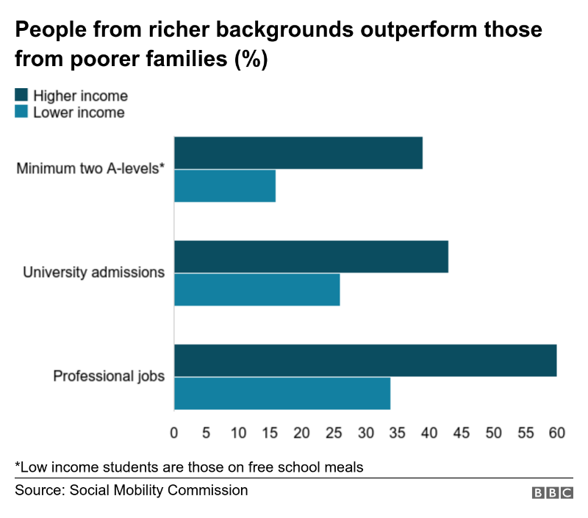
The Social Mobility Commission said an increasing number of students from low-income families were entering university by the age of 19. That proportion has now reached 26%, compared with 43% of better-off peers.
But, five years after graduating, those graduates who had been on free school meals at school were in jobs that earned 11.5% less than other graduates, the report said.
It found barriers to getting a top job were there from the start - about a half (52%) of disadvantaged teenagers leave school without basic qualifications and many get stuck in low-paid work.
Adult education could help to redress that, said the report, but almost all forms of adult education have been in decline since 2010.
There were also longer-term concerns that divisions could worsen as low-paid and low-skilled jobs were more likely to become automated in the future.
Professor Diane Reay, from the University of Cambridge told BBC Radio 4's World at One: "The expansion in the labour market is at the bottom - in the low-paid casualised jobs - rather than in the high-paid, more elite jobs.
"We need to radically change the hierarchical structure of English society, not just the social class of a few individuals."
Paul Gregg, a professor of economic and social policy at the University of Bath, who resigned from the Social Mobility Commission in 2017, told the programme: "It's still the case that Brexit is sucking all the political oxygen in government [from] any kind of social reforms."
The education secretary said employment had risen in every UK region under this government; wages were outstripping inflation; the gap between disadvantaged pupils and their peers has narrowed; and the proportion of 16 and 17-year-olds in education or apprenticeships was at its highest ever.

Gender and Education
Girls 'get better GCSE results in all-girl schools'
By Sean Coughlan Education correspondent, 28 January 2016

Girls at single-sex state schools in England get better GCSE results than those in mixed schools, according to an analysis of the most recent exams.
And the advantage for girls' schools remains even when other factors are taken into account, such as social background or a selective intake.
Girls from poorer families in single-sex schools got better GCSEs than their counterparts in mixed schools.
The study showed much less advantage for boys in single-sex schools.
The high performance of girls in single-sex schools has been identified by education data analysts SchoolDash, in a breakdown of GCSE results published last week.
In terms of overall GCSE results, single-sex state secondary schools, about 11% of the total, performed much better.
Image copyright PA Image caption Girls are more likely to get better GCSE results than boys
In mixed schools, 55% of pupils got five good GCSEs including English and maths, while in single-sex schools the proportion was 75%.
Among these single-sex schools, girls' schools got better results.
But there are some underlying factors skewing these results, such as:
- grammar schools are more likely to be single-sex
- co-educational schools have a higher proportion of poorer pupils
- girls are more likely to get good results
Better results
When these and other factors are taken into account, girls' schools still showed a clear advantage, with greater levels of "value added" in terms of pupils' progress and better results for poorer pupils.
The difference in like-for-like comparisons, the researchers say, was equivalent to girls' schools being three percentage points ahead of mixed ones.
Boys in single-sex schools were ahead of mixed schools in raw GCSE results, but they did not show a significantly better performance once other factors had been taken into account.
The analysis also showed single-sex schools were concentrated in London and the South East.
Capital benefits
London's GCSE results were the best in England - and the study showed almost a third of secondary schools in the capital were single-sex, far higher than anywhere else.
Girls' schools in London did particularly well in this year's GCSEs - with single-sex schools in the capital an average 12 percentage points higher than their counterparts
Image copyright PA Image caption London has a higher concentration of single-sex schools than anywhere else in England
The study described a "halo" of single-sex schools around the edge of London, including those in the independent sector and grammars.
There were other clusters, such as around Liverpool, but smaller numbers in northern England and the Midlands, and overwhelmingly in urban rather than rural settings.
Single-sex schools had a higher proportion of ethnic-minority pupils, but a lower than average proportion of deprived pupils, as measured by eligibility for free school meals.
Teachers in single-sex schools tended to be older, better paid and taking significantly less sick leave than their counterparts in mixed schools.
SchoolDash founder Timo Hannay said: "It would now be interesting to try and understand why girls at girls' schools tend to do better than their peers, and what the vast majority of mixed schools might be able to learn from this phenomenon."
Social 'disadvantage'?
Earlier this month, Richard Cairns, head of Brighton College, said girls at single-sex schools would be at a "huge disadvantage" if they could not feel confident talking to boys.
Single-sex schools were described as a "deeply unrealistic world".
Image caption A long-term study says women who attended all-girls' schools were no more or less likely to marry
But Caroline Jordan, president of the Girls' School Association, claimed the analysis of this year's results as a vindication of an all-girl education.
She said teachers with classes of girls could focus their teaching style on what worked best for girls.
"Girls are more collaborative, they like lessons to be more discussion-based," said Ms Jordan, who represents schools in the independent sector, where there is a long tradition of single-sex schools.
And an all-girl environment allowed them to "escape gender stereotyping", by, for example, encouraging more girls to pursue science subjects.
"Girls can be more confident in themselves, they don't have to become a particular type of girl, they're able to relax more," she said.
The claim girls in single-sex schools were more likely to study science was backed by long-term tracking studies, said Alice Sullivan, director of the Centre for Longitudinal Studies, at the UCL Institute of Education, in London.
"We found that girls from single-sex schools were more likely to take male-dominated subjects such as maths and science at school. Girls who had attended single-sex schools also had slightly higher wages than their co-ed peers in mid-life," said Prof Sullivan.
"People often make claims about the consequences of single-sex schooling for relationships between the sexes without referring to any evidence," she said.
"We found that women who attended single-sex schools were no more or less likely to marry than those in co-educational schools."

Ethnicity and Education

Record ethnic minority students at Oxford
By Sean Coughlan BBC News family and education correspondent, 6 June 2019

Oxford University's latest admissions figures show the highest ever proportion of places for ethnic minority students - at 18%.
There were also rising numbers of state school pupils, up to about 61%.
But the figures, for undergraduate entry in autumn 2018, showed more places taken by students from Singapore than from the north-east of England.
Vice-chancellor Louise Richardson said a "sea change" in admissions would "accelerate the pace of change".
Last month, Oxford University announced a target for a quarter of its UK students to come from disadvantaged backgrounds by 2023.
The university's push for a more diverse intake followed accusations that it was socially exclusive.
This detailed breakdown on admissions also highlights different trends below the headline figures - such as Asian students being much more likely to get places than other minorities.
Tougher competition
The admissions statistics show a widening of access, but also an intensification of competition.
Applications have increased significantly, up by almost a quarter in four years, with 21,000 applications for about 3,300 places.
Image copyright Getty Images
There is rising competition at home and abroad and the proportion of places going to UK students has continued to slip downwards - about 78% this year, compared with 82% four years previously.
The BBC showed earlier this year that UK student numbers at Oxford and Cambridge had fallen by more than a thousand compared with a decade ago.
Among students from overseas, China and Singapore have the biggest number of places.
The 320 students from China and 206 from Singapore compare with the 159 places for students from the north-east of England and 217 from Wales, in three-year figures for 2016 to 2018.
There were more than 3,800 places for students from London and the south-east of England, across these years - which were also the places with the highest concentrations of students with top grades.
A university spokesman said: "Every student at Oxford is chosen based on academic ability and potential alone" and that higher fees for overseas students were not a factor.

State school entry
The proportion of state school pupils getting places is at its highest in records going back about 40 years.
Among UK entrants, it has gone up from 56.3% to 60.5% over the past four years - and this translates to about 80 more places for state-educated pupils and about 120 fewer places for privately educated ones.
Image copyright Getty Images
About 18% of students taking A-levels are in private schools, so they remain significantly over-represented.
There are big differences by subject. Among those studying maths, 73% are from state schools, but for classics it is only 29%.
'Few black students'
This year's intake saw 18.3% of places taken by ethnic minority students - the highest proportion on record.
Applications from ethnic minority students have been increasing rapidly - up by almost half in four years.
The university highlights the rise in applications and admissions for Asian students. Among the UK intake, 8.3% are from an Asian background, compared with 2.6% for black African and Caribbean students.
Despite the numbers of black students rising, it means that over three years there was only one UK black student admitted for geography, two for physics and none for biological sciences.
In 12 of Oxford's colleges, fewer than five black students had been recruited over three years. No college had recruited fewer than 12 Asian students or 120 white students across this time.
The proportion of deprived pupils has moved upwards, with 11.3% of places going to students classified as facing socio-economic disadvantage.
Prof Richardson, the university's vice-chancellor, said the intake still "reflects the deep inequalities in our society along socio-economic, regional and ethnic lines".
But she said "even the most cynical observer" would have to recognise that progress was being made.
"The numbers are low, the pace is slow, but the trajectory is clear - the number of students admitted to Oxford from deprived backgrounds is steadily increasing," said Prof Richardson.

