Transition materials for A-level History
Topic: Democracy and Nazism:
Germany 1918-1945

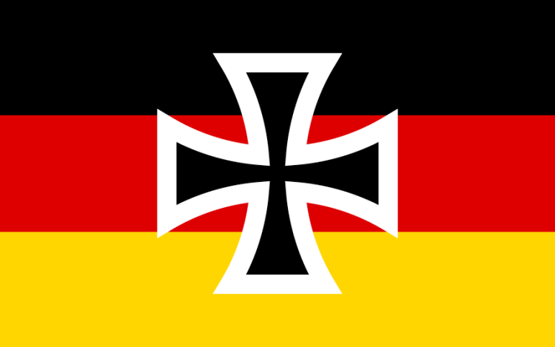

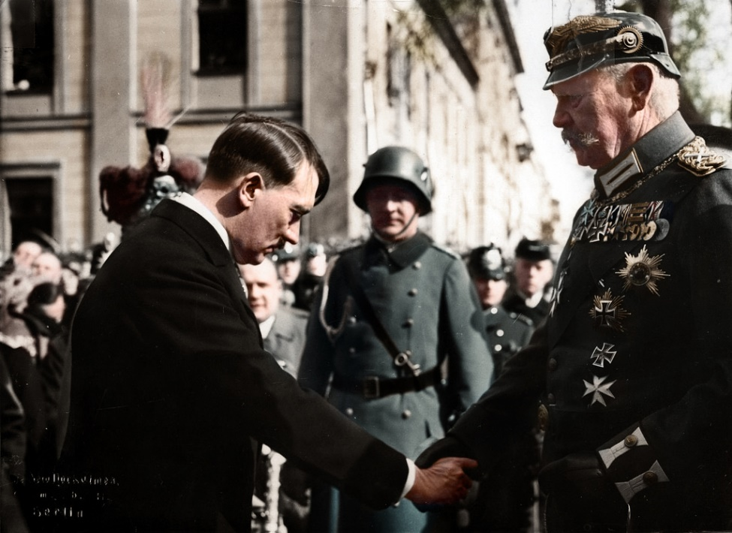

In this pack you will find plenty of materials to prepare you for studying the Germany section of your course. It is aimed for you to use once you have completed your GCSE’s before starting you’re A-Levels in September. Consider this your summer work to get you ready and up to scratch! A-Levels are tricky qualifications to achieve and you need to ensure that you are fully prepared for them. The more work you do now, the easier you will find it when you start your course.
Key things to do before starting the course:
- Get yourself a folder and dividers – there is a lot to learn so it is best to be organised from the very start.
- Ensure that you know what exam board you are studying. Germany is a topic that appears on many exam boards but it is always helpful to know what your specific board requires. You can download this from the exam board website. We study AQA History.
- Read this booklet carefully and work through the activities, this will give you the foundation knowledge needed to start your course.

If you would like to get ahead and read about the topic the following textbooks are recommended:
Robert Whitfield, Democracy and Nazism: Germany 1918-1945, Oxford AQA History (this is the textbook we use in class and if you are definitely going to study History with us you will need to buy a copy)
Geoff Layton, Democracy and Nazism: Germany 1918-45, Hodder Education
John Hite, Weimar and Nazi Germany, Schools History Project
Fictional books:
- Night - Elie Wiesel
- The Boy in the Striped Pyjamas - John Boyne
- Look who’s back – Timur Vermes
- The man in the high castle – Philip K Dick
- The tattooist of Auschwitz – Heather Morris

Things to watch:
Films
- Schindler’s list
- The Pianist
- The Book Thief
- The Zookeepers wife
- Hitler: The rise of evil - https://www.youtube.com/watch?v=B7Odc_rtn68
- Cabaret

Documentaries
- Armistice 1918 - https://www.youtube.com/watch?v=R9wgefi8lqU&list=PLL3RlSCzuoT539DYLx8AeuwFfakQjKteU
- One day in Auschwitz - https://www.youtube.com/watch?v=mZYgzW2fS0o

Task 1 – complete the pre-reading and answer the following questions. This will help you to understand how Germany was governed just before our time frame.
The constitution of the Second Reich
- What did the German unification involve?
- Find a map of Prussia so you know what countries were involved
- Who created the constitution and what did they want out of it?
- Who was the Kaiser and what powers did they have?
- What was the role of the chancellor?
- What was the Reichstag?
- What was the Bundesrat?
- Research some of the federal states of Germany
- Who were the army accountable to?

Political developments
- Which social class is growing in Germany at the time?
- What does this lead to?
- How does the right wing change?
- Who do the following parties represent and what are they campaigning for?
- The DKP
- FKP
- NLP
- The Centre Party
- The SPD
- The Agrarian League
- The Central Association of German industrialists
- The Navy League
- The German Colonial League and the Pan German League

The Second Reich by 1914
- What are the different views about where power lay during the Second Reich?
- Explain why you could argue that Germany was an autocracy
- Explain why you could argue that power lay with the conservative elite
- What evidence was there that Germany was democratic?

The impact of the First World War on Germany
- What was the economic impact of the war?
- What was the social impact of the war?
- How Germany was initially united?
- How did the political situation become more disjointed?
- What was the silent dictatorship?

Task 2 – Create a fact file on the following individuals. You must include the following details:
- Date of birth
- Job
- Key achievements
- What happened to them

Kaiser Wilhelm | Gustav Stresemann
Friedrich Ebert | Ernst Thalmann
Philipp Scheidemann | Joseph Goebbels
Paul von Hindenburg | Heinrich Himmler
General Ludendorff | Reinhard Heydrich
Wolfgang Kapp | Hermann Goering
Walter Rathenau | Albert Speer
Adolf Hitler | Rudolf Hess

Task 3 – Research Germanys’ involvement in World War One. Find information on:
- Key battles
- Leading army generals
- Why the Germans lost
- What impact did the war on Germany as a country?

Task 4: Find definitions for the list of keywords below, this will be really helpful for you when you start the course.
Annexation | Euthanasia | Putsch
Anschluss | Federal state | Reichstag
Anti-Semite | Freikorps | Reichswehr
Aryan race | Gauleiter | Reparations
Armistice | DAF | Spartacist
Article 48 | Gestapo | SS
asocial | Ghetto | Stahlhelm
Autarky | Hyperinflation | Third Reich
Authoritarian | Indoctrination | Total war
Autocracy | Junkers | Untermenschen
Bavaria | Kaiser | Volk
Blitzkrieg | Lander | Volksgemeinschaft
BDM | Lebensraum | Waffen SS
Chancellor | Mein Kampf
Coalition government | Mittlestand
Communist | Nationalism
Concordat | Paramilitary
Constitution | Plebiscite
Demilitarisation | Pogrom
Diktat | Propaganda
Eugenics | Proportional representation
Task 5: History is all about creating an argument, using facts and explanation, using counterarguments, comparisons and making links to strengthen your own argument. Creating a strong argument is the key to getting a good grade. You have been given a statement below, do some research and write a response to the question. Remember all you have learnt about writing essays so far.
Social media is having a negative effect on society. How far do you agree with this statement?

Task 6: source analysis – use the following sources to make inferences about what life was like for Germans from 1919-1930. Write a paragraph explaining what you think Germany was like whilst the Weimar Republic were in power.
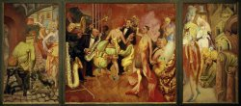

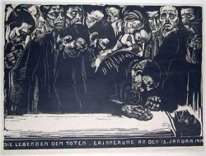

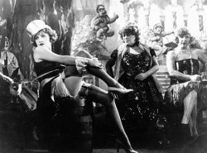

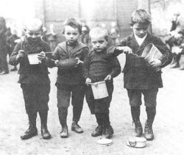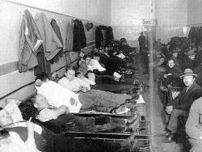

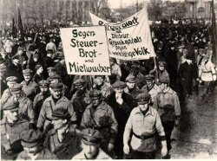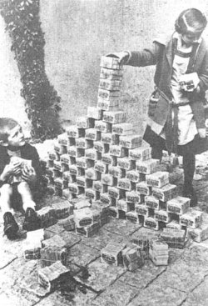

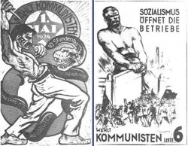

Task 7: Look at the Nazi propaganda posters. From these make conclusions about what the Nazis want their Third Reich to involve. Write a paragraph and remember to refer to what you see in the posters.

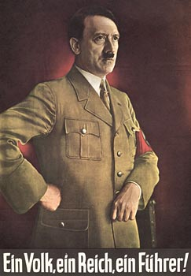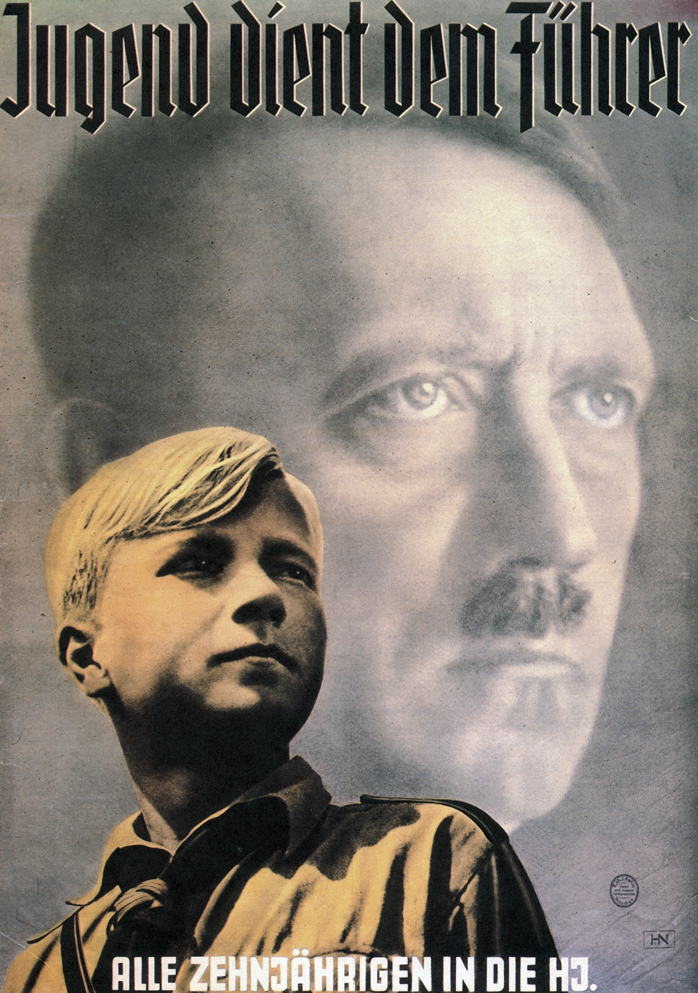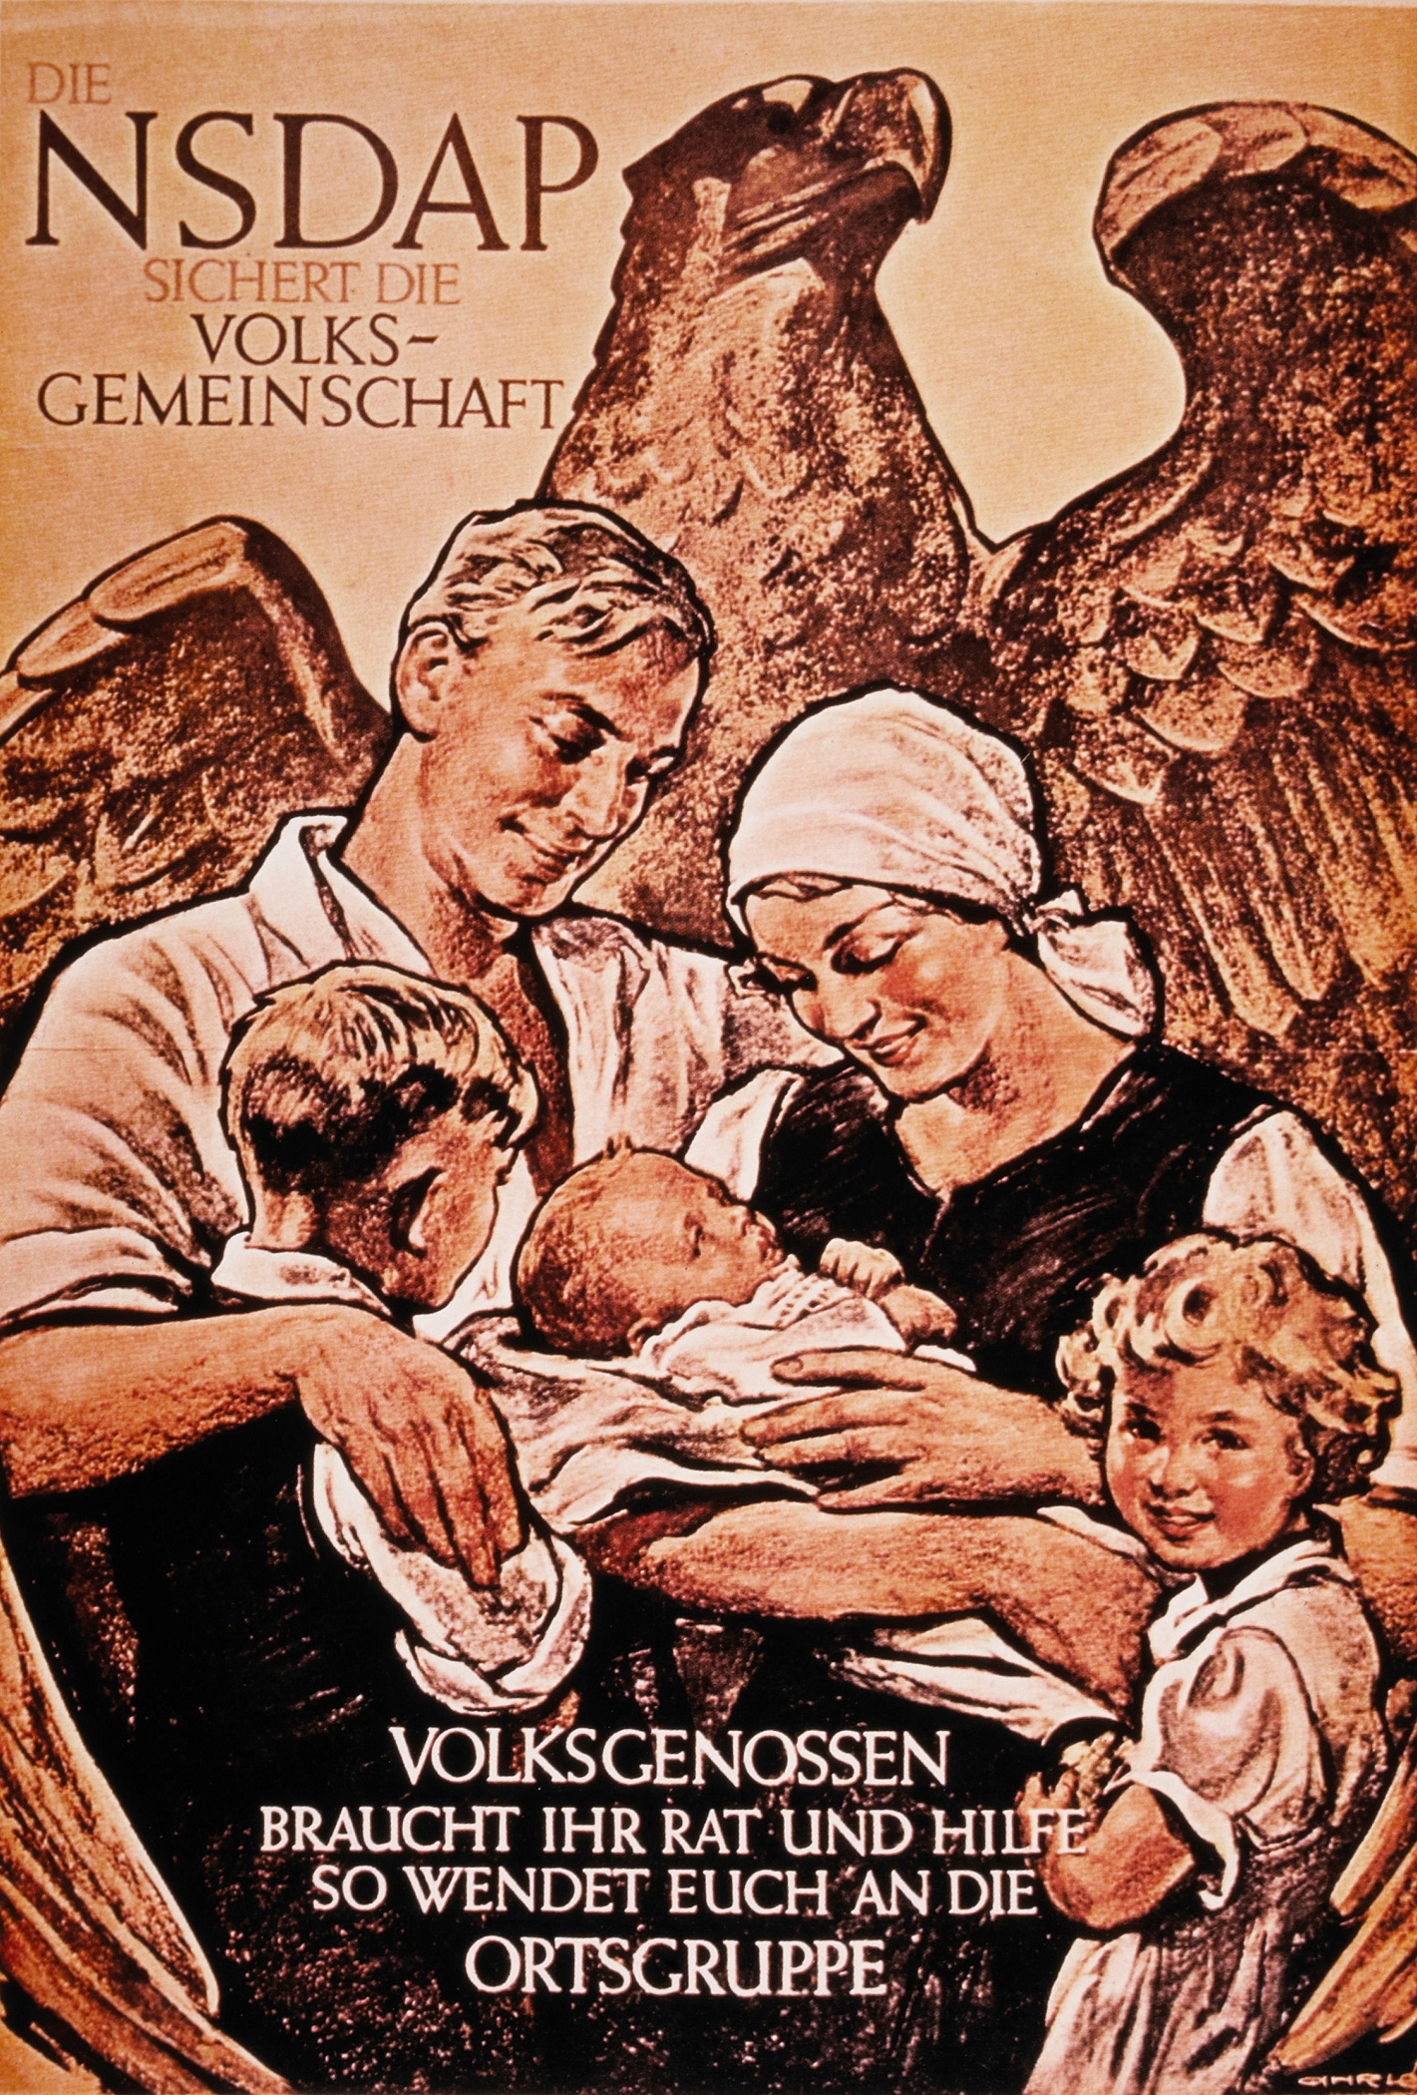

v



