Five Senses Writing Prompt

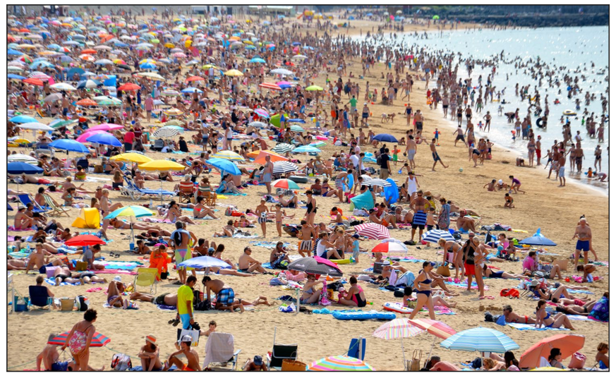

- Look at the picture. Use your imagination and five senses to describe the scene. Practise writing complex sentences that include adjective and adverbs. Write at least 5 sentences for each sense.
(Challenge: Instead of numbered sentences, write your in paragraph form and develop a short story.)

Examples:

Basic:

- Just in front of me was an enormously fat man wearing a red T-shirt and bright yellow shorts.
- I could hear an annoying woman shouting angrily to her three naughty children.
- With her arms waving about, my sister ran across the burning hot sand.

Challenge:

The hot sand soothed my muscles as I stretched out lazily on my towel. Digging my toes deep into the sand, I sighed with contentment. Ahhh… I love the beach! The sun climbed overhead and began to cook my skin. Lazily, I smeared thick sunscreen on my arms. The oily sunscreen mixed with sand as I rubbed it onto my chest. It smelled of coconuts.

As I looked around I could see….
The sea…
The waves…

