Topic 3 Qs
Explain what is meant by the word species. (2 marks)
Two organisms are said to be of the same species if they can interbreed to produce fertile offspring.
Name the two domains which contain prokaryotes. (1 mark)
Bacteria and Archaea
Using the diagram below of the amino acid sequences of apes, explain the conclusions that might be reached about the evolutionary relationships shown. (3 marks)
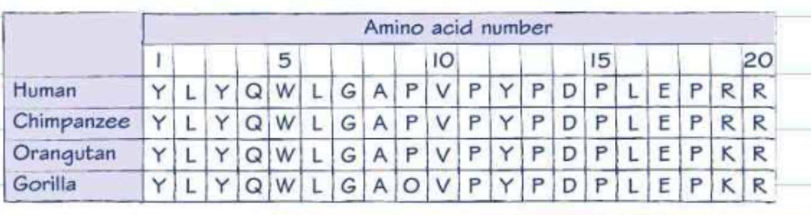The similarity of sequence indicates closeness of ancestral relationship. The human and chimp sequences are identical. So humans are more closely related to chimps than to orangutans or gorillas.
Explain how gel electrophoresis could be used to analyse the apes’ DNA. (3 marks)
Source of DNA sample, e.g. blood, saliva, semen; small samples of DNA can be amplified by PCR; reference to use of (restriction) enzymes to break DNA; reference to use of electropotential/potential difference; reference to treatment/staining; show up as bands/bars; reference to the number of bands/that match indicates the similarity of the DNA.
Carl Woese’s ideas were not accepted at first. Explain how his ideas were critically evaluated. (3 marks)
His findings were published in scientific journals and probably discussed at conferences. The papers containing the ideas were peer reviewed. Also other scientists repeated his experiments to confirm or validate the findings.
Some people still find the theory of evolution controversial. Explain why. (3 marks)
Any three from:
Conflict with religion/creationism/excludes presence of God; suggests world older than given in Bible/appears to contradict Genesis; some people believe that the evidence for evolution is unsatisfactory/not enough evidence; the idea that humans are evolved from apes/monkeys/other animals is considered particularly offensive/challenges the idea that humans are (God’s) special creation.
Explain the term niche using an organism as an example. (3 marks)
Example: Anthopleura elagantissima (sea anemone). This organism occupies a niche in a food web on rocky shores. At high tide, it feeds on a variety of small animals. It paralyses them using stinging cells on its tentacles. The food is passed into the gut for digestion. In turn the anemone forms the food of various carnivores.
At low tide, it is exposed on the shore where it remains stationary until the water returns at high tide. The tentacles and body of each anemone contract to avoid desiccation.
Answer: A niche is the role of the sea anemone in its community. It occupies two tropic levels. As a predator it controls populations of its prey and as prey it provides food for other animals.
Many varieties of nuthatches (birds) of the species Sitta europaea (Eurasian nuthatch) can be found throughout Europe. In the colder regions of Corsica, S. whiteheadi (Corsican nuthatch) is found. For most of the year, they feed on pine seeds. During the summer breeding season they also feed on small invertebrates. Why might global warming cause extinction of S. whiteheadi and not S. europaea? (2 marks)
S. whiteheadi adapted to colder/mountainous regions; if climate warms, food supply (pine seeds/invertebrates) less available.
Explain what happens during allopatric speciation. (3 marks)
Some sort of physical mechanism, such as a mountain range or a river; separates two halves of a population. If the two halves change in different ways, due to natural selection, they may become reproductively isolated and hence separate species.
A new species of mosquito has evolved in the London Underground. Explain whether this is sympatric or allopatric speciation. (2 marks)
Sympatric because they are in the same place.
Explain why extinction will reduce biodiversity. (3 marks)
Biodiversity depends on the number of species. Extinction will reduce the number of species as well as ones that depend on them.
What further data, apart from species richness, is needed to compare the biodiversity of two sites? (4 marks)
Any four from:
Species richness gives no indication of abundance of each species; idea that biodiversity refers to variety of organisms; ref to use of a calculated biodiversity index, e.g. Simpson’s; using species richness value/number of different species; number of individuals in each species recorded; ref to genetic diversity.
Explain the advantages of selecting seeds of different sizes for long-term storage. (3 marks)
A large gene pool should be maintained to increase chance of future survival. Different sized seeds are likely to have more chance of having different alleles. Variety means there is less chance of all being susceptible to the same disease.
Describe how zoos use captive breeding programmes to help conserve rare species. (5 marks)
Any five from:
To increase numbers/population size; to {maintain/increase} genetic diversity/reduce genetic drift; protect from predators/poachers.
For captive breeding: inter-zoo animal movement; selection of mates/use of stud books/records kept of breeding programme; process involved described e.g. IVF/AI/use of surrogates/DNA profiling.
For reintroduction: preparation for reintroduction described, e.g. idea of reinforcing wild behaviour/idea of hacking out/reduce food intake to encourage hunting; select habitat/reserves; raise awareness/education of local population.
What is the difference between conservation and preservation? (2 marks)
Conservation is the wise use of a resource, preservation is the non-use of that resource.
The large blue butterfly (Maculinea arion) was declared extinct in the UK in 1979. Studies to find out why this happened showed that the larvae first feed on the flower heads of wild thyme (Thymus polytrichus) but from their fourth larval stage they feed on red ant grubs (Myrmica sabuleti). Turf must be of the correct height for Myrmica sabuleti to form nests, which requires livestock grazing and rabbits.
Eggs may be laid on wild marjoram (Origanum marjoram) but this usually flowers too late at most British sites to be used. This species is only found in warm and well-drained unimproved acidic coastal or limestone grassland.
Using the information above and your own knowledge about conservation, give three methods that could be used to conserve the large blue butterfly. (3 marks)
Restore the habitat by implementing grazing and rabbit reintroduction. Alternatively, suitable natural sites might be located. The species maybe be bread in offsite facilities where ants are maintained for this purpose.
(a) Which of the following shows the correct sequence describing speciation? (1 mark)
A geographical isolation - selection – reproductive isolation – allopatric speciation
B selection – geographical isolation – reproductive isolation – allopatric speciation
C geographical isolation – selection – reproductive isolation – sympatric speciation
D selection – geographical isolation – reproductive isolation – sympatric speciation
Answer: A
(b) It is not always easy to distinguish two organisms as separate species. Criticise the morphological and the reproductive species concepts. (4 marks)
The morphological species concept relies on the observable differences between two organisms. This does not work very well in cases of sexual dimorphism, such as the peacock and peahen. In many species there is also enormous variation within individuals of the same sex. However, it is simple to use as you can decide what species an organism is just by looking at it.
The reproductive species concept relies on the idea that members of the same species can reproduce to produced fertile offspring. However, many plants of different species interbreed to give fertile offspring. The concept works well for animals but it does not apply so well to plants.
(c) A method that can help with he problem of distinguishing between species is DNA profiling. The diagram shows the results of running DNA profiling on digested DNA (using restriction endonucleases) from six species of clown fish (lanes 1-6) and the undigested DNA (lane 7).
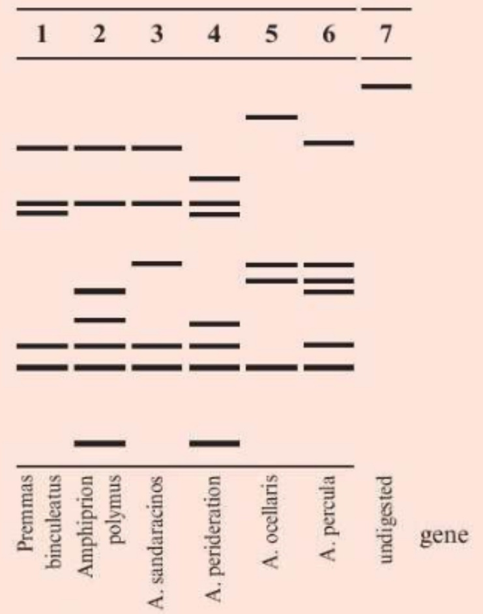
Analyse the information to comment on the DNA profiling method for species recognition in these fish. (5 marks)
Lane 1 is currently classified in a different genus from all the others but its sequence shows no obvious bigger difference, giving no support to it being a different genus. It has 5 bands, as do lanes 3 and 6 of a different genus. By the same token, the Amphiprion species have no obvious similarity to each other which gives no support to them being in the same genus. However, the patterns of bands are different for all six species studied, so this supports the existing view that they are separate species. The data may suggest that A. polymnus and A. perideraion are the most closely related as they are the only ones with the lowest band and, of the other 6 bands, they have 4 in common.

