Classification and Biodiversity
- 30 minute pairs revision activity
- Each pair of students has a different question on a different sheet.
- They must both add a contribution to the answer in their own coloured pens.
- After 1 min, they pass the sheet to the pair on their right.
- They receive the answer from the students to their left, read the next question and answer and continue. They may annotate or ask questions.

1. The classification system consists of a hierarchy starting with domain. List the taxonomic groups in order from largest to smallest.

2. A species is often defined as: ‘a group of organisms with similar characteristics that interbreed to produce fertile offspring’. Describe some limitations of this definition.

3. Give reasons why it is often difficult to assign organisms to any one species or to identify new species.

4. Explain how DNA sequencing or DNA profiling and/or gel electrophoresis can be used to distinguish between species and determine evolutionary relationships.

5. Give three ways in which scientists validate new evidence supporting the accepted scientific theory of evolution.

6. Describe some of the evidence for the three-domain model of classification as an alternative to the five-kingdom model.

1. Explain how evolution can come about through natural selection acting on variation bringing about adaptations.

2. Explain how organisms occupy niches according to physiological, behavioural and anatomical adaptations.

3. Explain the evolutionary race between pathogens and the development of medicines to treat the diseases they cause.

4. Explain how reproductive isolation can lead to allopatric and sympatric speciation.

1. Use the formula$D= \frac{N(N-1)}{\sum{n(n-1)}}$ to calculate the index of diversity for each to compare the biodiversity of species in these two habitats.
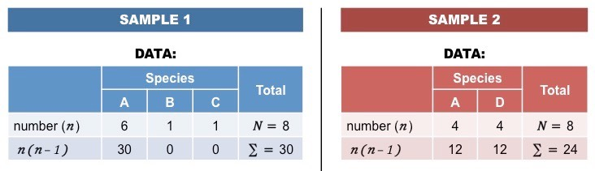

2. Explain how biodiversity can be assessed within a species at the genetic level by looking at the variety of alleles in the gene pool of a population.

3. Explain the ethical and economic reasons (ecosystem services) for the maintenance of biodiversity.

4. Explain the principles of ex-situ (zoos and seed banks) conservation and the issues surrounding the methods.

5. Explain the principles of in-situ conservation (protected habitats), and the issues surrounding the method.

