Classification and Biodiversity Revision – Biodiversity
1. Use the formula$D= \frac{N(N-1)}{\sum{n(n-1)}}$ to calculate the index of diversity for each to compare the biodiversity of species in these two habitats.
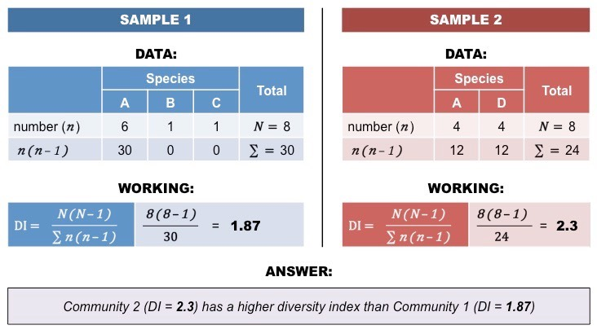

2. Explain how biodiversity can be assessed within a species at the genetic level by looking at the variety of alleles in the gene pool of a population.

3. Explain the ethical and economic reasons (ecosystem services) for the maintenance of biodiversity.

4. Explain the principles of ex-situ (zoos and seed banks) and in-situ conservation (protected habitats), and the issues surrounding each method.

Classification and Biodiversity Revision – Biodiversity
1. Use the formula$D= \frac{N(N-1)}{\sum{n(n-1)}}$ to calculate the index of diversity for each to compare the biodiversity of species in these two habitats.
2. Explain how biodiversity can be assessed within a species at the genetic level by looking at the variety of alleles in the gene pool of a population.
- A population is a group of individuals of the same species living in an area.
- All the alleles of all the genes in a population make up a gene pool.
- Different alleles make up the biodiversity within the gene pool.
- Genetic diversity can be assessed by analysing the DNA and comparing particular regions of the genome for similarities and differences.
- If there are different alleles for a gene at a locus then this locus is polymorphic. The % of polymorphic loci can be calculated and compared.
- If individuals are heterozygous they have different alleles for that particular gene. Heterozygosity is also a measure of genetic diversity.
3. Explain the ethical and economic reasons (ecosystem services) for the maintenance of biodiversity.
- Ethical – responsibility to maintain ecosystems, species and habitats for future generations. Natural ecosystems are healthy areas for recreation and leisure.
- Economic – goods, services and resources are provided for people by different species.
4. Explain the principles of ex-situ (zoos and seed banks) and in-situ conservation (protected habitats), and the issues surrounding each method.
- Ex-situ – seed banks conserve plant species and zoos maintain breeding populations of species.
- Seed banks store seeds in cold, dry conditions and take samples to germinate to check for viability.
- Zoos maintain stud books for inter-zoo breeding programmes and also prevent inbreeding by sharing semen for artificial insemination/IVF. This maintains some diversity of an endangered species.
- Seed banks and zoos have a role in education and research.
- Zoo animals can be reintroduced into the wild but may need to learn wild behaviour/survival skills.
- In-situ – national parks and nature reserves prevent the loss of rare, natural habitats. The communities of species are conserved in their natural habitat.
- Conserved habitats/protected areas are monitored for poaching & felling and other banned activities.

