Molecular Phylogeny
- Similarities and differences are used to classify species into higher taxa, such as orders
and kingdoms. Since Darwin’s theory of evolution became widely accepted, taxonomists
have attempted to achieve phylogenic classifications.

Explain what is meant by a phylogenic classification.

- What is molecular phylogeny?

- Explain how gel electrophoresis could be used to analyse DNA from different species. (3 marks)

- Using the diagram below of the amino acid sequences of apes, explain the conclusions that might be reached about the evolutionary relationships shown. (3 marks)

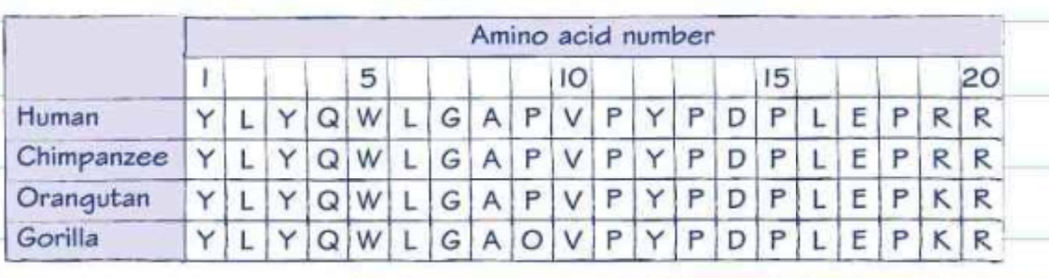

- Look at the electrophoretogram below and explain how the information from the pattern in the DNA profiles from these different species has been used to produce the evolutionary tree.
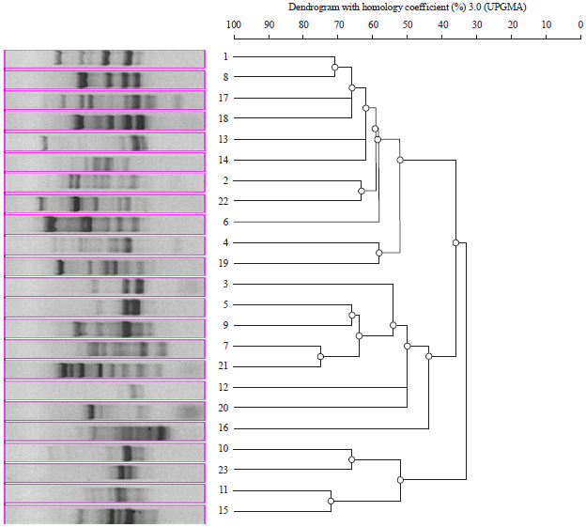

- What is DNA sequencing?

- How can DNA sequencing be used to determine evolutionary relationships?

- Draw an evolutionary tree using these DNA sequences:
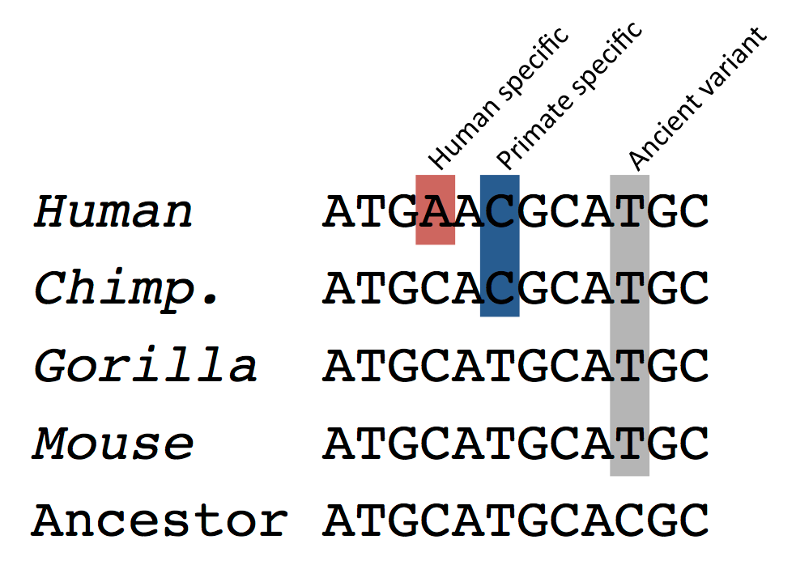

- What is DNA profiling?

- A method that can help with the problem of distinguishing between species is DNA profiling. The diagram shows the results of running DNA profiling on digested DNA (using restriction endonucleases) from six species of clown fish (lanes 1-6) and the undigested DNA (lane 7).
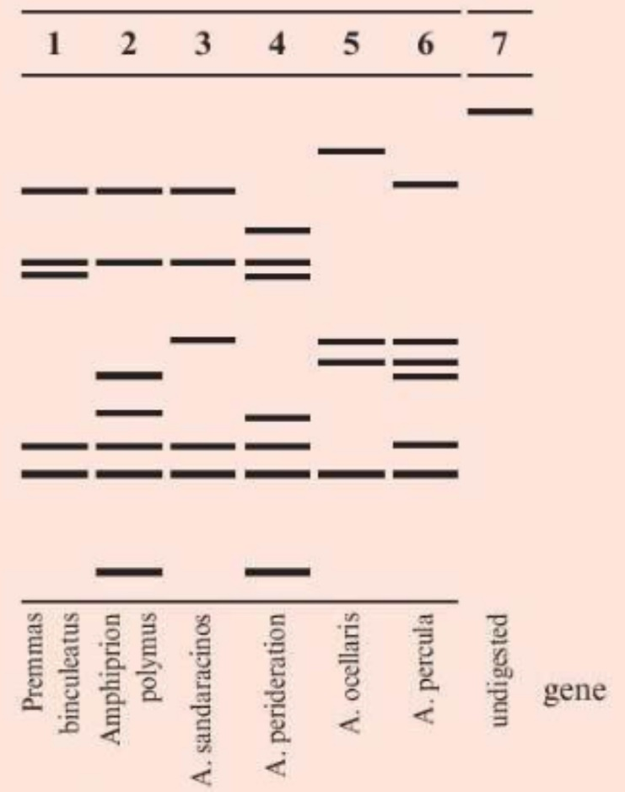
Analyse the information to comment on the DNA profiling method for species recognition in these fish. (5 marks)

- What is bioinformatics and why is it useful when using molecular techniques to establish evolutionary relationships?

Molecular Phylogeny
- Similarities and differences are used to classify species into higher taxa, such as orders
and kingdoms. Since Darwin’s theory of evolution became widely accepted, taxonomists
have attempted to achieve phylogenic classifications.

Explain what is meant by a phylogenic classification.
- Phylogenic classification shows the (genetic) relationship between, organisms / species /
taxa.
- The hierarchy of the classification shows closeness of the relationship
- Species with a recent common ancestor are in the same genus
- Higher taxa are groups of organisms that have common ancestors in the increasingly remote past.
- Some characteristics are believed to be more important indication of relationship than others
- Similarities in DNA are (especially) important
- Similar nucleotide sequences show a close relationship
- Other biochemical similarities / differences are used by taxonomists / named example.

2. What is molecular phylogeny?
Analysis of the genetic material or amino acid sequences of organisms to establish their evolutionary relationships.

3. Explain how gel electrophoresis could be used to analyse DNA from different species. (3 marks)
- Source of DNA sample, e.g. blood, saliva, semen
- Small samples of DNA can be amplified by PCR
- Reference to use of (restriction) enzymes to break DNA
- Reference to use of electropotential/potential difference
- Reference to treatment/staining.
- Show up as bands/bars.
- Reference to the number of bands/that match indicates the similarity of the DNA.

- Using the diagram below of the amino acid sequences of apes, explain the conclusions that might be reached about the evolutionary relationships shown. (3 marks)
- The similarity of sequence indicates closeness of ancestral relationship.
- The human and chimp sequences are identical.
- So humans are more closely related to chimps than to orangutans or gorillas.

- Look at the electrophoretogram below and explain how the information from the pattern in the DNA profiles from these different species has been used to produce the evolutionary tree.
- Species which are genetically similar have a similar band pattern: number, position/size.
- The more similar the pattern the more closely related they are.
- On the tree, individuals that are most closely related have the most recent common ancestor as shown by the points at which the tree splits into two.
- The more similar the DNA, the more recently the species have diverged from each other.

- What is DNA sequencing?
Process by which the base sequences of all or part of the genome of an organism is worked out.

- How can DNA sequencing be used to determine evolutionary relationships?
Order of bases (sequence) can be compared. The more similar their DNA, the more recently the species are considered to have diverged from one another.

- Draw an evolutionary tree using these DNA sequences:

Tree drawn should show a branch between humans and chimps – most closely related. Then chimps and gorilla, then mouse and then ancestor.

- What is DNA profiling?
Process by which the non-coding areas of DNA are analysed to identify patterns.

- A method that can help with the problem of distinguishing between species is DNA profiling. The diagram shows the results of running DNA profiling on digested DNA (using restriction endonucleases) from six species of clown fish (lanes 1-6) and the undigested DNA (lane 7).
Analyse the information to comment on the DNA profiling method for species recognition in these fish. (5 marks)
- Lane 1 is currently classified in a different genus from all the others but its sequence shows no obvious bigger difference, giving no support to it being a different genus.
- It has 5 bands, as do lanes 3 and 6 of a different genus.
- By the same token, the Amphiprion species have no obvious similarity to each other which gives no support to them being in the same genus.
- However, the patterns of bands are different for all six species studied, so this supports the existing view that they are separate species.
- The data may suggest that A. polymnus and A. perideraion are the most closely related as they are the only ones with the lowest band and, of the other 6 bands, they have 4 in common.

- What is bioinformatics and why is it useful when using molecular techniques to establish evolutionary relationships?
The development of the software and computing tools needed to organise and analyse raw biological data, including the development of algorithms, mathematical models and statistical tests that help us to make sense of the enormous quantities of data being generated.

It’s useful as the data can be analysed and organised to allow scientists to better distinguish between species and work out their evolutionary relationships.

