Endosymbiosis

1. (a) What is an endosymbiont?

(b) Label the diagram below to show the endosymbionts.

2. Which organelles in eukaryotic cells are thought to have originated from prokaryotic cells?

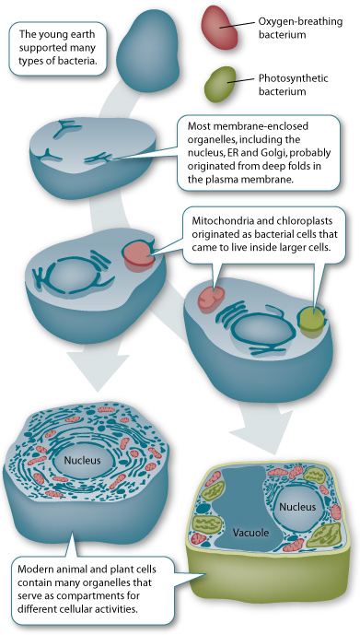
3. Complete the paragraph using the words from the box.
- Bacteria
- Division
- DNA
- Evidence
- Membrane
- Nucleus
- Proteins
- Reproduce
Mitochondria and chloroplasts have striking similarities to ________________________ cells. They have their own _____________, which is separate from the DNA found in the _________________ of the cell. And both organelles use their DNA to produce many __________________ and enzymes required for their function. A double ____________________ surrounds both mitochondria and chloroplasts, further ________________________ that each was ingested by a primitive host. The two organelles also ________________ like bacteria, replicating their own DNA and directing their own _______________.
Endosymbiosis

1. (a) What is an endosymbiont?
An organism that lives inside cells or the body of another organism.

(b) Label the diagram below to show the endosymbionts.
Oxygen-breathing and photosynthetic bacteria.

2. Which organelles in eukaryotic cells are thought to have originated from prokaryotic cells?
Chloroplasts and mitochondria.
3. Complete the paragraph using the words from the box.
- Bacteria
- Division
- DNA
- Evidence
- Membrane
- Nucleus
- Proteins
- Reproduce
Mitochondria and chloroplasts have striking similarities to _____bacteria________________ cells. They have their own _____DNA_____, which is separate from the DNA found in the ____nucleus__________ of the cell. And both organelles use their DNA to produce many ____proteins______ and enzymes required for their function. A double _______membrane_______ surrounds both mitochondria and chloroplasts, further _____evidence____________ that each was ingested by a primitive host. The two organelles also ____reproduce_______ like bacteria, replicating their own DNA and directing their own _____division_____.

