Phase 3
Year 9 – Work to be completed at home.
Islam
- Read pages 10 & 11 of the text book
- Create key cards for the following words:
- Sunni
- Shi’a

- Using the worksheet to help you, complete the table. Explain in your own words how Sunni / Shi’a Islam differs.

Sunni Islam | Shi’a Islam

- Using a page and colours in your RE book draw out / use bubble writing the six articles of Sunni faith and the five roots of Shi’a Islam.
Challenge: Next to the key beliefs write a definition of what they mean.

- Explain two contrasting beliefs between Sunni and Shi’a Muslims. ( 5 marks)
- Explain two similar beliefs that Sunni Muslims and Shi’s Muslims share. ( 5 marks)

‘Deeper learning / Interleaving Activities for Year 9

If you copy this into your books it will give you more space to write and draw and image.
Word | Image to signify the event | What happened?
Palm Sunday

The Last Supper

Crucifixion

Resurrection

Ascension
(to help you remember this comes from a Latin word to move up.)

Deeper Learning
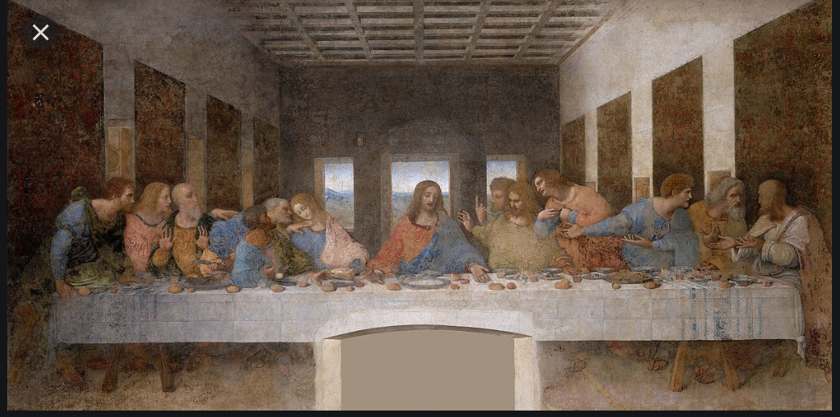

Look at this image. It’s called ‘The Last Supper’ by Da Vinci.
Quietly sit down and listen to an art historian’s view on the painting. Follow the link:
https://www.bbc.co.uk/sounds/play/w3csz571 (listen to 21:00 mins)

Obviously you don’t need to know all the art but it shows that significance of the picture and the impact of the last supper.

Think
- Why did Da Vinci use three windows in the background?
- Significance of image of Jesus? Why is he portrayed in this way?
- Significance of the red wine and the bread?
- What did Jesus say during the last supper that was so significant?
- Who is everyone around Jesus?

Mark 14:12-25 New International Version (NIV) Read account and annotate.
Note to help you. The phrase Son of Man is used as a term for God in the Old Testament.

The Last Supper
¹² On the first day of the Festival of Unleavened Bread, when it was customary to sacrifice the Passover lamb, Jesus’ disciples asked him, “Where do you want us to go and make preparations for you to eat the Passover?”
¹³ So he sent two of his disciples, telling them, “Go into the city, and a man carrying a jar of water will meet you. Follow him. ¹⁴ Say to the owner of the house he enters, ‘The Teacher asks: Where is my guest room, where I may eat the Passover with my disciples?’ ¹⁵ He will show you a large room upstairs, furnished and ready. Make preparations for us there.”
¹⁶ The disciples left, went into the city and found things just as Jesus had told them. So they prepared the Passover.
¹⁷ When evening came, Jesus arrived with the Twelve. ¹⁸ While they were reclining at the table eating, he said, “Truly I tell you, one of you will betray me—one who is eating with me.”
¹⁹ They were saddened, and one by one they said to him, “Surely you don’t mean me?”
²⁰ “It is one of the Twelve,” he replied, “one who dips bread into the bowl with me. ²¹ The Son of Man will go just as it is written about him. But woe to that man who betrays the Son of Man! It would be better for him if he had not been born.”
²² While they were eating, Jesus took bread, and when he had given thanks, he broke it and gave it to his disciples, saying, “Take it; this is my body.”
²³ Then he took a cup, and when he had given thanks, he gave it to them, and they all drank from it.
²⁴ “This is my blood of the^{[a]} covenant, which is poured out for many,” he said to them. ²⁵ “Truly I tell you, I will not drink again from the fruit of the vine until that day when I drink it new in the kingdom of God.”

