Year 8 phase 3 science - 8L Earth and Space

INSTRUCTIONS:
This is to reinforce the work you did in Phase 1.
Work through each lesson and complete as much as you can. To access the videos and other links you need just click on the blue writing.
There is also a quiz at the end - don’t forget to complete it.

Lesson 1 - Gathering the Evidence

- What we know about Space has changed a lot.
Have a look at the textbook pages here and write about:
- what we knew at different times
- and how this has developed as technology has improved.

Very early astronomers

Ptolemy
(90-168)
Nicolaus Copernicus (1473 - 1543)
Johannes Kepler
(1571 - 1630)

- Describe how we are able to investigate planets.
Watch this video that summarises space exploration since World War 2.

Telescopes –

Spacecraft –

- Watch this video
- using the poem ‘My Very Easy Method Just Speeds Up Naming Planets’.
List the order of the planets from the Sun below.
- One of these is not classes as a planet anymore do you know which one?

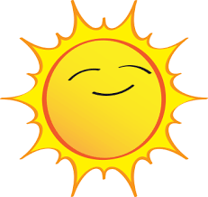
Sun
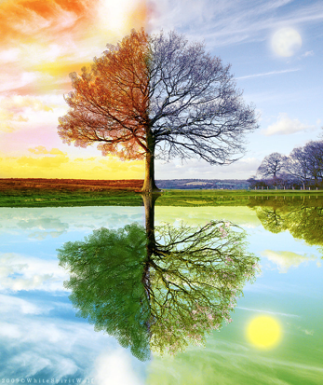
Lesson 2 – Seasons

- Watch the video here to introduce you to the seasons.

Name the 4 seasons.
1.
2.
3.
4.

- Complete the word fill below to describe what causes the seasons.

Tilt, Summer, Seasons, Hemisphere, Winter, Sun

The ……………… are caused by the Earth’s ……………… and a place's position relative to the ………………. The hemisphere that is tilted towards the Sun will have ………………. The ……………………… that is tilted away from the Sun will have ……………….

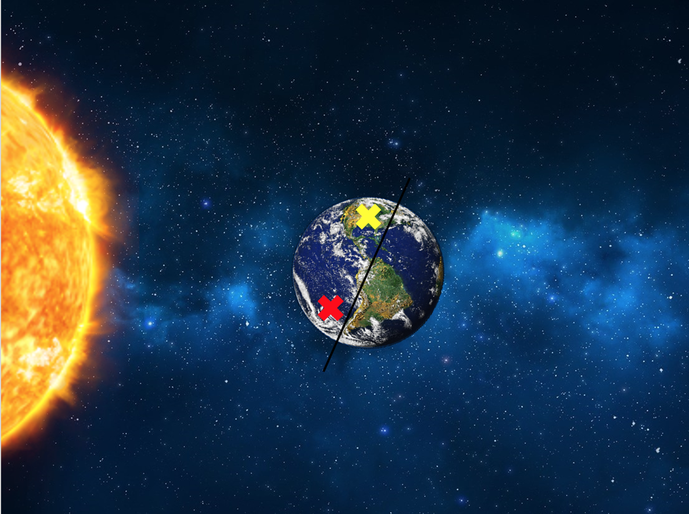
- Using what you have learnt, which of the coloured crosses on the image would represent summer?

- Which of the coloured crosses here would represent winter?

Challenge Factor -
Complete some research into the Land of the Midnight Sun.

What is it? Where is it? Why does it occur?

Lesson 3 - Magnetic Earth

- How does a compass work?
Watch this video to help you answer.

- Compass needles are small magnets.
In the following examples, write in the box if the magnets will attract or repel?

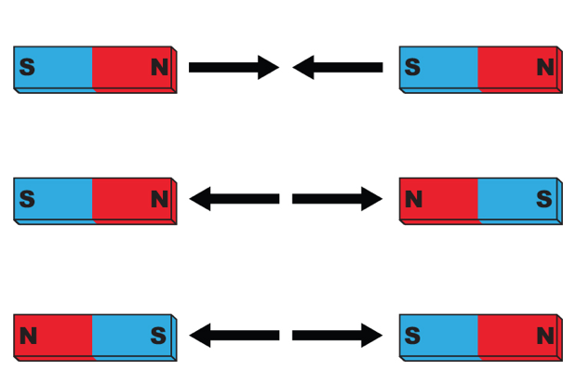

- This video gives some more theory behind the Earth’s magnetic field. The ‘North’ of a compass needle points to the geographic north pole (i.e. the geographic North pole is a magnetic south pole!). Label the magnetic poles in the table below.

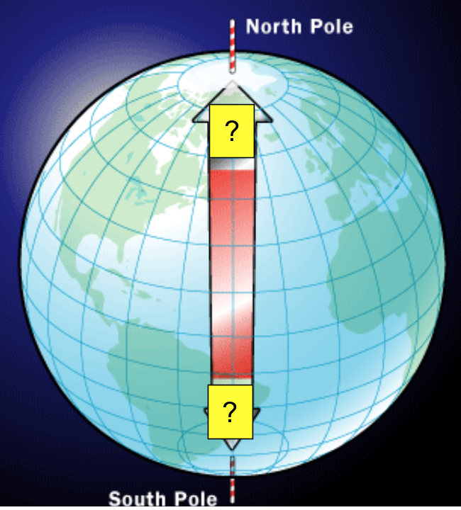

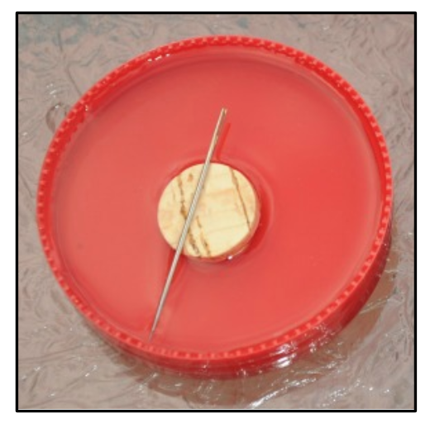
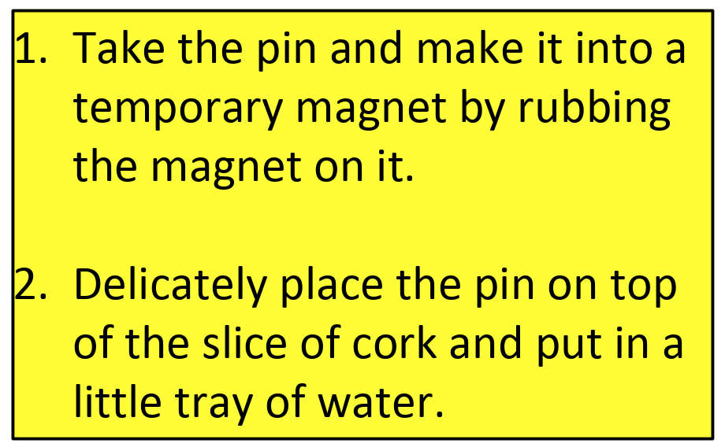
Challenge Factor -
If you have a pin, a cork and a container.

You can make your own compass by following the instructions on the right.

Lesson 4 - Gravity in Space

- Definitions, what is the difference between mass and weight?
This video will help https://www.youtube.com/watch?v=ToMs7RaL11U

Definition
Mass
Weight

- You may have heard a lot about Satellites in the News recently as they have been clearly visible, particularly the Starlink satellites. But what are satellites?

A satellite is anything that orbits the Earth. The Moon is an example of a natural satellite. Artificial satellites can be put into orbit around the Earth or around other planets or moons. Their uses include photographing the Earth and transmitting TV programmes.

- What is the Starlink satellite used for?

- Use the information on the BBC bitesize page here.
- describe the difference between an asteroid and a comet.
Asteroid | Comet

What is a meteor?

Lesson 5 - Beyond the Solar System
- Use this website to look into the scale of the universe.
- Match the key words up with its definition below, you can use the second slide of the textbook pages to help.
Keywords:
Milky Way, Light Year, Sun, Galaxy, Universe, Star, Solar System, Satellite

Keyword | Definition
 | The star the Earth orbits.
 | A collection of Stars.
 | An object which orbits a planet used for communication.
 | A huge, bright ball of burning gas.
 | Made up of billions of galaxies and empty space.
 | The galaxy that Earth is in.
 | A collection of planets orbiting around the same star.

- What is meant by the term ‘light year’?

Lesson 6 – Eclipses

Watch this video to learn more about eclipses https://www.youtube.com/watch?v=rVE8PFYlwSM

Solar Eclipses:

The sun, moon and Earth all line up with the moon in the middle. Although the sun is much bigger than the moon, it is much further away, so looks the same size. Therefore, the Moon can completely cover the Sun for a few minutes.
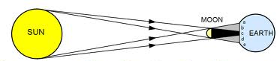
Lunar Eclipses:
A Lunar Eclipse happens when the Sun, Earth and Moon are all lined up with the Earth in the middle. The Earth blocks the Sun’s light to the Moon.
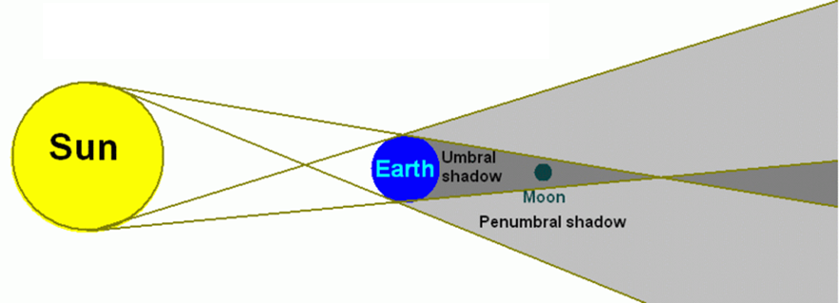
 | What is blocked from view? | How often do these occur?
Lunar Eclipse
Solar Eclipse

QUIZ TIME

When you have completed this work have a go at the Earth and space test by clicking this link below.

Part 2 8L Earth and Space quiz

