Year 8 - Phase 3 English Work
This work will focus on Chapter 5 and the end of the novella.
Here is the link for the full text.
https://www.nhc.ac.uk/media/2840/steinbeck-john-of-mice-and-men.pdf
Please e-mail Ms Ansar, if you are having trouble accessing the text.

- Altered Impressions: Curley’s Wife

- Write down this key definition-
Altered Impression: When our view or impression of a character changes.

- List 2 quotations that influence how the reader views Curley’s Wife’s character at the beginning of the text.
- Find 2 quotations that influence how the reader views Curley’s Wife’s character in Chapter 5.
- Why do you think that Steinbeck has altered our impression of Curley’s Wife?
What effect does this create?

Pages 127-130 – Curley’s Wife’s Death
Use iceberg analysis to explode these two quotations.

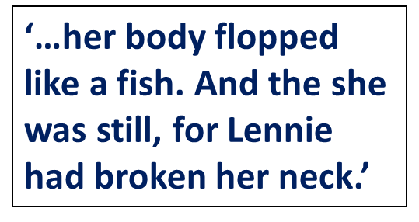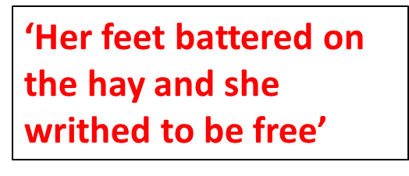
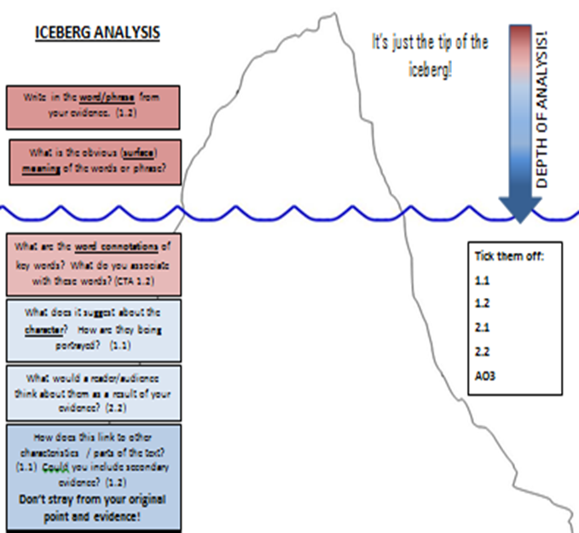
FIND THIS IN YOUR LEARNING PASSPORT.

Challenge: At this point in the novella, which characters do we sympathise with? Explain your response in two PEE’s and use evidence from the text to support your response.

- Circular Narrative

- Summarise the key events in the last chapter in 5 bullet points. The first one has been done for you.
  - Lennie kills Curley’s wife.

- Write down the definition for this key term.

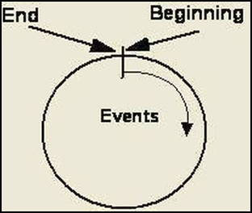
Circular Narrative: A story that ends in the same place it began is commonly called a circular or cyclical narrative.

Refer to the text and complete the chart to explain what is happening in each section. How has the circular narrative been used to show how things have changed from Section 1 to Section 6?

The water snake has been done for you, as an example.

Beginning of the novella. | End of the novella.
The water snake represents nature and a calm, natural setting. | The water snake now has a sinister and dangerous meaning. We see a predatory nature and we link this with the theme of death.
The description of the way Lennie moves at the beginning…. | The description of the way Lennie moves at the end….
How the reader reacts to the story of the farm in section one… | How the reader reacts to the story of the farm in section one…

Challenge: Find a new example and explain how a circular narrative is created.

Coming full circle…
All the repetition creates a circular narrative which reinforces the atmosphere of inevitability. George and Lennie have come full circle and are back where they started – except that this time, Lennie is going to die.
Keyword: Inevitability- When it is certain that something is going to happen.
Questions:
- What might Steinbeck’s overall message be about life in the 1930’s as a result of the circular narrative?
- How does George and Lennie’s relationship change?
- Was this change inevitable?
- Was the reader expecting it?

- The End

Building atmosphere, foreboding and foreshadowing are used to create an inevitable and climatic ending.

- Use your Learning Passports to find the definitions for the key terms – foreboding and foreshadowing.

In Section 2, Lennie tells George that he is feeling uncertain about the ranch. He says- “I don’t like this place George. This ain’t no good place.”

- How does Lennie’s comment create a sense of foreboding?
- Why is it significant that he recognises this more than George?

Dramatic Tension
- Find three quotations in the final section, which link to the points below.

The story of the ‘dream farm’ is repeated again. This time, though, the reader knows that there is no chance of George and Lennie fulfilling their dream.

George must shoot Lennie rather than allow the men to hurt him - he is forced to kill his closest friend.

The other men are getting closer, and George must shoot Lennie before they arrive. The sound of the men approaching increases the tension, leading to the climax of the section.

Creative Writing Task

Write a letter to a friend, in which you comment on the end of the novel.

- How did the ending make you feel?
E.g, Outraged? Angry? Guilty?
Redeeming? Uplifted? Hopeful?

- Would you change anything about the ending? Explain why.

Challenge: Comment on Steinbeck’s use of structural techniques. E.g, circular narrative, and the effect that this created.

