Copy the key words into your book
Key words : Messiah – the promised deliverer of the Jewish nation prophesied in the Old Testament
Oppression: - unjust treatment
Leadership : - the action of leading a group of people

Year 7
Objective – to understand how Jesus led people

Task 1
Brainstorm all the characteristics that you can think of that make a good leader.
listener

Task 2 Read
In the Old Testament (the first 39 books in the Bible), God promises that He will send a King / Messiah to the Jewish nation to save them from their sins and make them right with God.
The Jews believed ( and still believe) that the Messiah / King would be like an earthly King and would rescue them from earthly oppression.
Jesus leadership was very different.

Task 3 Watch the extract – Jesus leads those in society who were not in high positions
https://www.bing.com/videos/search?q=Cartoon+about+Jesus+calling+the+fisherman&&view=detail&mid=43F707C63F378F5251E943F707C63F378F5251E9&&FORM=VRDGAR&ru=%2Fvideos%2Fsearch%3Fq%3DCartoon%2Babout%2BJesus%2Bcalling%2Bthe%2Bfisherman%26FORM%3DHDRSC4

Or you can read the following:
Matthew 4:18–22
Jesus Calls the First Disciples
18 ªWhile walking by ^{b}the Sea of Galilee, he saw two brothers, Simon (who is called Peter) and Andrew his brother, casting a net into the sea, for they were fishermen. 19 And he said to them, “Follow me, and I will make you ^{c}fishers of men.”² 20 Immediately they left their nets and followed him. 21 And going on from there he saw two other brothers, James the son of Zebedee and John his brother, in the boat with Zebedee their father, mending their nets, and he called them. 22 Immediately they left the boat and their father and followed him.

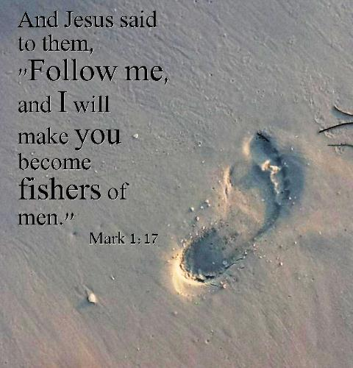

Task 4 Read
- Jesus told 4 men to follow him. What was their job?

- Can you name any of the men Jesus talked to?

- Who are brothers?

Fisherman in 1st Century AD would be tough! They would definitely be exceptionally strong and work very long hours. Jesus starts by leading 12 disciples and now today there are billions of Christians all over the world.
Challenge :What could this account show us about Jesus’ character / leadership skills?
Task 5 Jesus’ key message


Task 6
Can you think of any ways that Jesus shows love to people in the Bible?
Use the sentence frame if you wish.

Jesus shows love to ______________________________when he ______________________________________________
Additionally Jesus shows love to people when _________________________________________________

Feedback
I wonder what example you used?
Did you pick out a miracle that Jesus did?
Perhaps when Jesus fed the 5000 with 5 loaves of bread and two fishes? Or did you pick the example when Jesus told the parable of the Good Samaritan? Or perhaps you used the example of Jesus dying on the cross for sins.


Extension
Can you give your opinion on the following statements:
- Christians believe Jesus was a strong man, a decisive leader. He confronted what was wrong or harmful and led by action.

- They also believe Jesus was truthful, gentle, kind, sensitive, compassionate, loving and strong. He was perfect in every way. He had real charisma and people would flock to him (especially children) to hear him speak and to learn from him.

- As well, Christians believe Jesus spoke sincerely of the need for human equality in a time when the concept was unheard of.

Deeper Learning
- Research / find out other ways Jesus helped / led people. Create a poster / power point slide illustrating his leadership qualities.

