YEAR 7 PHASE 3: English Home-Learning (4th May – 17th May 2020)
Recap: Phase 2
- In Phase 2, you completed a range of activities about King Claudius. Without looking at your notes, write 4-5 sentences explaining whether you think he is a good or bad king and why. Read back through your previous notes to check your understanding.
- Reflect on your two paragraphs you wrote for Task 2. How did you feel they went? Fill in your PLC (make sure you have filled in your PLC for phase 1 paragraphs too!) Write a WWW and EBI for yourself. Did you:
  - make a clear point?
  - use good evidence (quotations)?
  - mention a technique used by Shakespeare to support your point e.g. simile, adjective?
- Ensure you are continuing to read every day. Read a novel that is appropriate for your Accelerated Reader Level. If you do not have books at home, you could read novels online at www.bibliomania.com.
Audible (https://stories.audible.com/start-listen) has free audio books at the moment so have a look and listen/read something new!
There are also lots of places online to access free books and plays. A list of where to find these is on: https://nothingintherulebook.com/2017/01/10/55-places-you-can-download-tens-of-thousands-books-plays-and-other-literary-texts-completely-legally-for-free/

Phase 3: Reading Tasks
Complete one task per English lesson you would have had each day (four a week including your SPaG lessons). You can complete them in any order and email your English teacher if you are unsure.
Task 1 – Introduction to ‘Alice’s Adventures in Wonderland’ by Lewis Carroll :
Key words:
- Connotation: Feelings/emotions associated with a word but goes beyond the actual meaning.
- Inference: using clues from the text and your own knowledge to read between the lines.
- Deduction: take facts/information based on what you can see/read.
This term you are moving from Shakespeare to ‘Alice in Wonderland.’ Complete the following tasks to build up some predictions for the novel.
- Write the words ‘adventure’ and ‘wonder’ and ‘land’ in the middle of half a page each. Write around the outside all the connotations (things that come to mind, ideas, thoughts, feelings) based on each word.
- What would you have in your ‘wonderland’? Either draw/list/create your wonderland. Email anything through to your teachers!
- Look at the following book covers, what inferences and deductions can you make based on the images, colours and layouts? You could also Google and find some more covers to help with your predictions and interpretations.
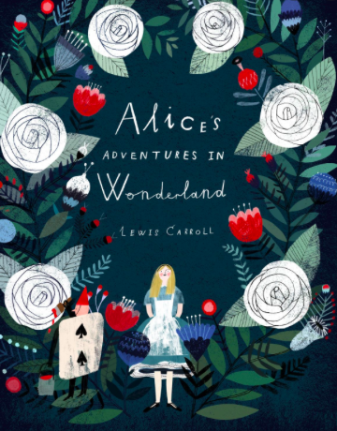
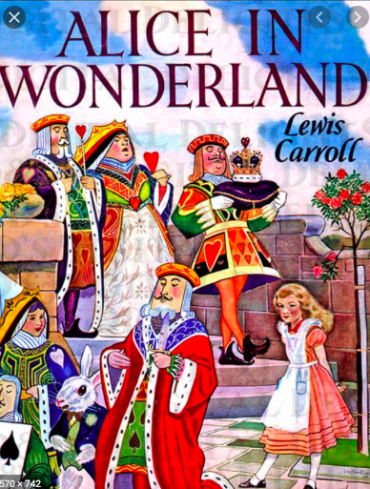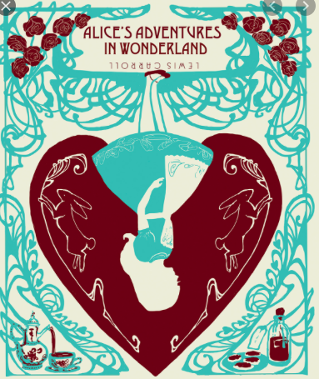
Task 2 – Research the author:
Lewis Carroll was the pseudonym of Charles Lutwidge Dodgson who wrote ‘Alice’s Adventures in Wonderland’ and many other stories.
On July 4, 1862, Dodgson and his friend Robinson Duckworth, fellow of Trinity, rowed the three children up the Thames from Oxford to Godstow, picnicked on the bank, and returned to Christ Church late in the evening: “On which occasion,” wrote Dodgson in his diary, “I told them the fairy-tale of Alice’s Adventures Underground, which I undertook to write out for Alice.” Much of the story was based on a picnic a couple of weeks earlier when they had all been caught in the rain; for some reason, this inspired Dodgson to tell so much better a story than usual that both Duckworth and Alice noticed the difference, and Alice went so far as to cry, when they parted at the door of the deanery, “Oh, Mr. Dodgson, I wish you would write out Alice’s adventures for me!”
The above is an extract from the article on the website below about Lewis Carroll, who he was and why he wrote ‘Alice’s Adventures in Wonderland.’ Using the above, the website and any other extra research you would like to complete, create a fact file about him. You must include:
- Where he lived.
- Who was in his family
- Why he wrote the novel
- What other stories/novels he wrote
- Some interesting facts.
Task 3 – Structural techniques used by Carroll:
- An omniscient narrator is the voice in which the story is written that is outside the story and that knows everything about the characters and events in the story.
- Free indirect speech is a style of third-person narration which uses some of the characteristics of third-person along with the essence of first-person direct speech.
Write your own definitions of the above in your own words. If you are still unsure, try researching what they mean. As we read the novel together, this will make more sense!
Task 4 – First three chapters of ‘Alice’s Adventures in Wonderland’:
- Read ‘Down the Rabbit Hole,’ ‘The Pool of Tears’ and ‘ A Cacus-Race and a Long Tale.’
  - Listen on this link for free with Scarlett Johansson: https://stories.audible.com/pdp/B015D78L0U?ref=adbl_ent_anon_sc_pdp_pc_0
  - Read online: http://www.literatureproject.com/alice/alice_1.htm
  - Buy your own copy of the book for around £3 on Amazon: https://www.amazon.co.uk/Alices-Adventures-Wonderland-Lewis-Carroll/dp/B0857CG8KC/ref=sr_1_9?keywords=alice+in+wonderland+book&qid=1585829043&sr=8-9

Phase 3: Writing/Creative Tasks
Task 1 – Diary of Home Learning:
Complete your next two weeks of diary entries as your ongoing writing task. Ensure you are using exciting vocabulary, thinking about paragraphs and sentence types.
You should write at least one entry a week of at least one A4 page (normal book size). You should have at least 2 entries so far.
Questions to consider:
- What were the Easter ‘Holidays’ like?
- What have you learnt?
- What do you need more help with?
- What have you enjoyed? Not Enjoyed?
- What new skills/hobbies/activities have you done?
- Anything that has worked well to help you to manage your time?
- Anything that you miss?
Task 2 – Beginning of the You in Wonderland Project:
You are going to start an English Alice Project! How exciting!
- Your task is to complete the activities as you read through the book. Make sure that you are creative, as this is supposed to be something fun and engaging for you as you progress through the novel.
- You can complete the tasks by hand, on the computer or any other way you like! Just check in with your teacher. You may want to create a scrapbook/notebook to have all of your tasks in.
- Don’t forget: the novel’s genres, the character’s personalities and settings within the novel when completing tasks.
- House points given for marvellous and amazing effort and completion of tasks.
Creative Task:
Who was Alice?
  - What are your first impressions?
  - How would you describe her (adjectives)?
  - What do you think are key quotations she says?

Toilet Roll Alice: Create a toilet roll version of Alice. If you can’t do this, create a picture of her based on your first impressions, or any other creation of your choice.



