Name Class Date
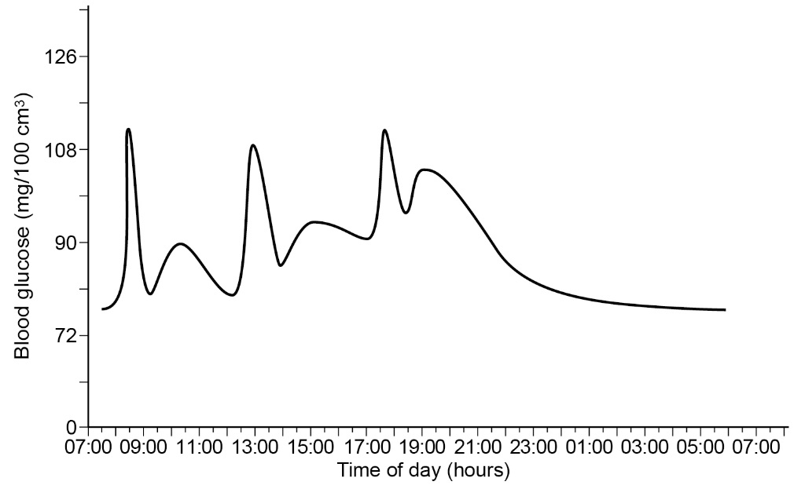
Homeostasis means keeping
conditions constant inside the
body, for example blood glucose
concentration. The graph shows
the variation in blood glucose
concentration over one day of
a person who does not have
type 1 diabetes.

- a On the graph, mark and label the times when the person had breakfast, lunch and dinner.
b Explain why you chose those times.

- Explain how insulin causes blood glucose concentration to decrease when it is high.

- a Using the graph, state the highest and lowest blood glucose concentration in a person without diabetes.

b What might happen if blood glucose concentration increased above or fell below this range?
Tick one box.
- organ damage
- blood becomes too thick to be pumped through capillaries
- person gets a sweet taste in the mouth
- person starts to put on a lot of weight
S1 Using an example, explain why homeostasis is important.
- a Sketch a line on the graph above to show what would happen to blood glucose concentration for a diabetic person after eating a meal at 12:00.
b Explain the shape of your line.

- Describe how people with type 1 diabetes control their blood glucose concentration.

Name Class Date
- Insulin causes certain cells to take glucose out of the blood.
- What sort of substance is insulin?
- Name the endocrine gland that releases insulin.
- Name a target organ for insulin.
- When insulin is present, which substance is formed from glucose in the target cells?
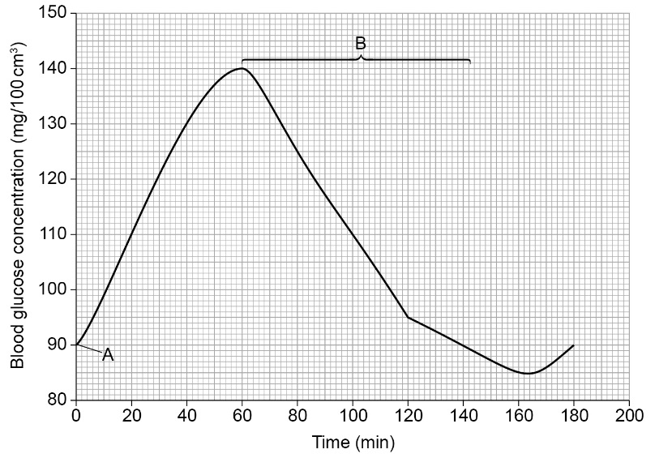
- The graph shows Jacob’s blood glucose concentration measured over three hours.
a What do you think happened at
point A? Tick one box.
- Jacob went for a run.
- Jacob fell asleep.
- Jacob ate lunch.
- Jacob had a drink of water.
b What was Jacob’s glucose concentration at
80 minutes? Include the units.

c How many hours after point A was Jacob’s glucose concentration highest?
d Explain the change in section B of the graph.

- The graph shows an example of homeostasis, where the internal environment is controlled to keep it relatively constant.
Explain why blood glucose concentration must be controlled like this.

- a Some people suffer from type 1 diabetes. What is the cause of this condition? Tick one box.
- Their insulin-producing cells release too much insulin.
- Their insulin-producing cells have been destroyed, so they do not release insulin.
- The target cells stop responding when insulin concentration increases in the blood.
- Their insulin-producing cells release insulin at the wrong times.
b Describe a treatment that controls type 1 diabetes.

