Forename Surname
Personal Exam Plan

Personal Targets:

X

X

X

7 ways to relax, keep calm and achieve your best!

- Create a routine:
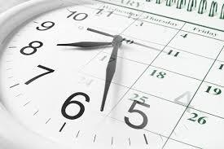
Find a time in the day that you feel most comfortable studying and make sure you stick to it! Find a space to study that you like and is quiet. Make sure that you get up and go to bed at the same time and eat meals on a regular basis. A routine will improve your readiness to focus and ability to get working quickly.

- Keep an eye on your sleep:
Winding down and giving yourself the chance to switch off before going to sleep is essential to get a good rest. Sleep is vital when you are preparing for revision and exams because tiredness damages our ability to concentrate and remember and that then makes us anxious! Make sure that you turn off all electronic devices 20 minutes before you go to sleep as the illuminating light on the screens supresses melatonin; a chemical in the brain that allows us to relax and prepare for sleep.


- Think about what you eat and drink!
Our brain needs fuel to function at its very best. The brain prefers complex carbohydrates (whole grains, pasta, rice and cereals) along with small amounts of protein and healthy fats. The brain needs foods that are rich in vitamin B (whole grains, nuts, eggs, and dairy products) this really helps to calm our mood.
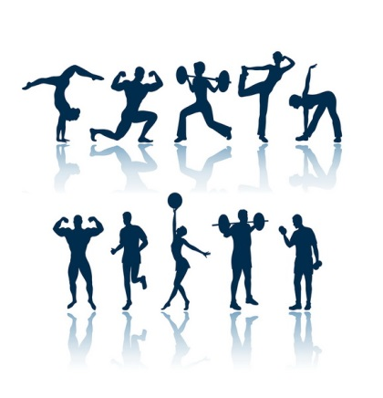
- Keep Active!
Try doing some kind of exercise each day for 20-30 minutes, preferably just before you sit down to study. Exercise increases the blood flow to our brain so that we can think much more clearly. You could do: walking, jogging, running, swimming, cycling, sports or anything else that keeps you moving. If possible make sure that you go outside because the natural light will stimulate the production of endorphins and improve your mood.


- De-clutter the brain:
Physical clutter = mental clutter. A messy workspace can make it more difficult to relax and make it seem like our work is never-ending. So take 15 minutes or so to tidy up ’brain workspace’, and then make a habit of keeping things clean and anxiety-free. It will help us think rationally, and there won’t be as much room for anxiety.


- Plan ahead!
Fight anxious thoughts in advance by preparing for the day ahead. Try making a schedule or a to-do list and develop habits that increase productivity. So instead of spending 10 extra minutes every morning frantically looking for you revision books, make a habit of always putting them in the same place when you come home. Get your revision out the night before, pack a bag and leave it by the door, or make lunch ahead of time. Focus on how to think more positively (PAT’S) by catching your anxiety-producing beliefs (NAT’s) before they pop up.


AND FINALLY………
- Make sure you take time to smile…..
When school work has got us down, it’s a good idea to take a quick break to get some giggles on. Research suggests that laughter can reduce symptoms of anxiety, so consider checking out a funny YouTube clip to calm those jittery nerves!
Good Luck ☺
Breathing Exercises should be done twice a day or whenever you find your mind dwelling on upsetting thoughts or when you are feeling tense or anxious.

START BY…..
Placing one hand on your chest and the other on your stomach. When you take a deep breath in, the hand on the stomach should rise higher than the one on the chest. This insures that the diaphragm is pulling air into the bases of the lungs.
After exhaling through the mouth, take a slow deep breath in through your nose imagining that you are sucking in all the air in the room and hold it for a count of 4 (or as long as you are able, not more than 7).
Slowly exhale through your mouth for a count of 8. As all the air is released with relaxation, gently contract your stomach muscles to completely remove the remaining air from the lungs.
Repeat the cycle 4 more times!
In general, exhalation should be twice as long as inhalation. The use of the hands on the chest and stomach are only needed to help you train your breathing.
Abdominal breathing is just one of many breathing exercises the more it is practiced, the more natural it will become improving the body's internal rhythm.

