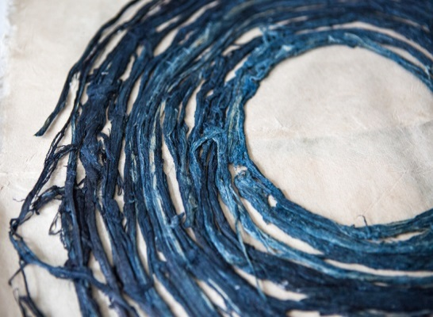
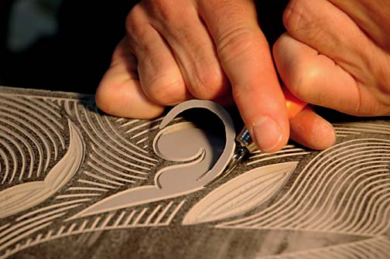
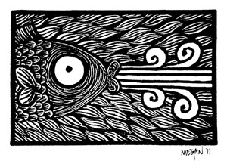
000

Within this project you will look at objects and artefacts from different countries and record your observations. The main focus is building new skills by using a variety of materials, techniques and processes. Your lessons will sometimes take the form of ‘workshops’ where you will learn these skills. The preparatory work for these sessions will come from drawing activities.
- In order for you to make the most progress in this project and be able to consider different objects and images, you can begin your project in advance. Any object, patterned material, artefacts, beads etc can be grouped together and drawn using pencil, a paint brush and ink or a stain (things from your home food colouring/coffee/beetroot juice/clothes die) – you can get some great effects! You could use a candle to draw and then wash the stain over the drawing.

- A large part of your course at the beginning will be based on printmaking. Research:
- Collagraph
- Chincole
- Screen printing
- Mono printing
- Lino Printing
Collect examples which you like with the printmakers name and any information you can find on the printing technique/ printmaker.
- You will need to visit galleries and museums throughout your course look for examples of the above techniques. You can write notes, draw, collect postcards or take photographs (if you are allowed). You may also want to collect patterned wallpaper, wrapping paper, brown paper, cardboard, net (the one which apples or oranges come in is good) – these can be used as the background for prints or the material for collagraph.
(You could visit the British Museum and draw things from different cultures or visit any other museum but you must draw and write notes about the work).
- When drawing, remember to look at the light – dark, medium and light tone A minimum of 3 tones must be used in every drawing. You can shade with pencil cross-hatch with any type of pen. These are just ideas, what is important is that you are creating work! If you are going to another country just follow the above ideas about recording. Draw things from that particular culture, look at still life/ architecture, and the things which you feel represent that culture. Collect newspapers, magazines, postcards, take photographs and draw.

