A Level Sociology

ACTIVITY 1

- Watch the video: https://www.youtube.com/watch?v=4rxiU826ysk
- Work through the PowerPoint and
- Fill in the glossary of key terms

Key terms | Definition |  |  | Example
Socialisation
 | Primary socialisation
 | Secondary socialisation
 | Agents of socialisation
Norms
Values
Roles
Status
 | Ascribed status
 | Achieved status
Status quo
Social stratification

Socially constructed
Life chances

ACTIVITY 2- Read the story and answer the question below

Elephant and the Blind Men
Once upon a time, there lived six blind men in a village. One day the villagers told them, "Hey, there is an elephant in the village today."
They had no idea what an elephant is. They decided, "Even though we would not be able to see it, let us go and feel it anyway." All of them went where the elephant was. Every one of them touched the elephant.
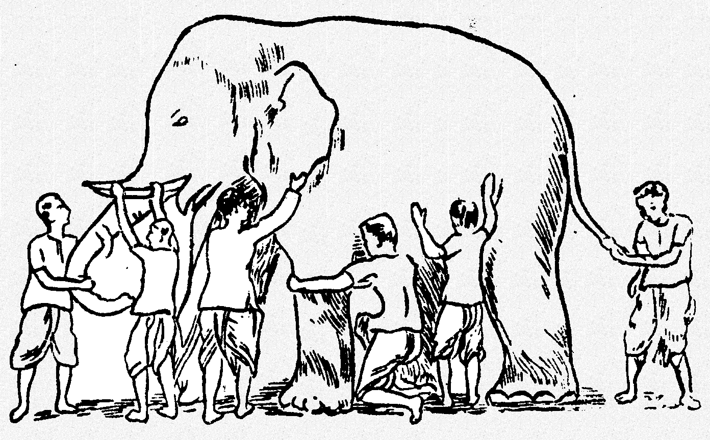
"Hey, the elephant is a pillar," said the first man who touched his leg.
"Oh, no! it is like a rope," said the second man who touched the tail.
"Oh, no! it is like a thick branch of a tree," said the third man who touched the trunk of the elephant.
"It is like a big hand fan" said the fourth man who touched the ear of the elephant.
"It is like a huge wall," said the fifth man who touched the belly of the elephant.
"It is like a solid pipe," Said the sixth man who touched the tusk of the elephant.
They began to argue about the elephant and every one of them insisted that he was right. It looked like they were getting agitated. A wise man was passing by and he saw this. He stopped and asked them, "What is the matter?" They said, "We cannot agree to what the elephant is like." Each one of them told what he thought the elephant was like. The wise man calmly explained to them, "All of you are right. The reason every one of you is telling it differently because each one of you touched the different part of the elephant. So, actually the elephant has all those features what you all said."
"Oh!" everyone said. There was no more fight. They felt happy that they were all right.

What is the moral of this story?

ACTIVITY 3

Visit:
- www.podology.org.uk
- Select Sociology
- Top tab- select videos
- Select sociological theory
- Watch the following videos and make a note of the key assumptions for each sociological perspective

- Introduction to Functionalism
- Introduction to Marxism
- Interactionism

Sociological Perspective | Summary of key features/ points
Functionalism | - Do functionalist have a positive or negative view of society?  - Define consensus  - Summarise the organic analogy  - Define collective conscience
Marxism | - Do Marxist have a positive or negative view of society?  - Which two social groups are in conflict? Why are they in conflict?
Interactionism/  Labelling Theory | - Define verstehen  - What is the consequence of labelling someone/ a group of individuals? What is this called?
ACTIVITY 4- Read the text and answer the questions

The Functionalist Stance
As a consensus theory, functionalism maintains that the socialisation role performed by education is primarily positive - both for society, and for the individuals within it.

Emile Durkheim
Central to Durkheim’s perspective is the idea that society can only exist if its members subscribe to a shared set of norms and values. Without this common culture, no collective action would be possible - and society would dissolve into chaos, or anomie.

As a result, Durkheim places emphasis on the importance of both primary and secondary agencies of socialisation - as it is through these institutions that this shared culture is internalised.

In addition, Durkheim's argues that education fosters a sense of integration, and thus produces social solidarity. He argued that both the official and hidden curriculums transmit a sense that the individual belongs to, and has a stake in, something larger than themselves. He pointed, for instance, to the teaching of history and literature, and the emphasis on team sport and membership of houses. All of these, he maintained, function to instil in individuals a sense of commitment to the larger social group.

A final important theme in Durkheim’s analysis of education is that the institution provides a socialisation experience which is different to that provided by the family. Indeed, he argues that it is vital that the experience is different; as it prepares children to interact outside of the cozy comfort of the family – and in the harsher, and more formal reality of adult life.

For Durkheim, therefore, education is vital in that it gradually acclimatises children to this form of relationship - preparing them to operate in adult society.

Key terms
Official curriculum | The National Curriculum- which is a set of subjects and standards which all students must be taught/ must learn.
Hidden curriculum | The “unofficial” learning which occurs within school - for instance, obedience to authority and appropriate and inappropriate gender roles
Social solidarity | The social ties that bind a group of people together such as kinship, shared location, and religion

- According to Durkheim what are the two main purpose of education
1.

2.

