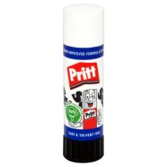
Head start day 2015: Photography
Suggested list to buy for September:
- Glue stick
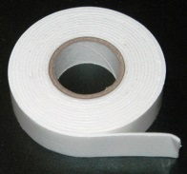
- Double sided tape

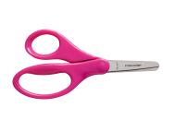
- Scissors
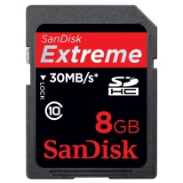
- Memory card (for camera)

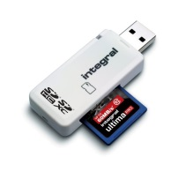
- Card reader (for your memory card for your camera, to transfer photographs onto the computer)
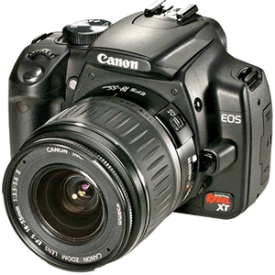
- Camera – not essential (If you are going to buy one buy an SLR if possible)

- Photo paper – not essential

