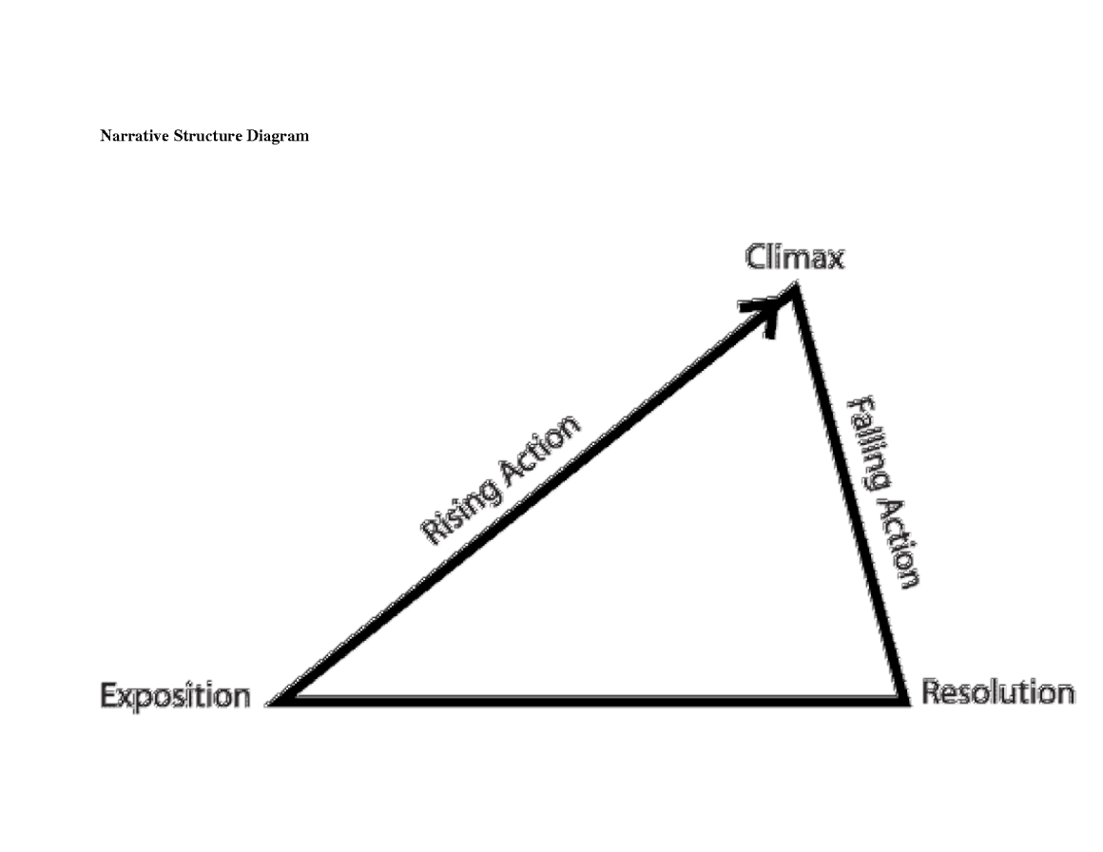
King Lear Summer Work | A Level English Literature

Use Google or a dictionary to find definitions for each of the terms on the diagram.
Read King Lear – or listen to the BBC 3 radio version (https://www.youtube.com/watch?v=1JylxvHvdtA) – and plot the events of the play onto the diagram.

